R821R1/LEDW45S

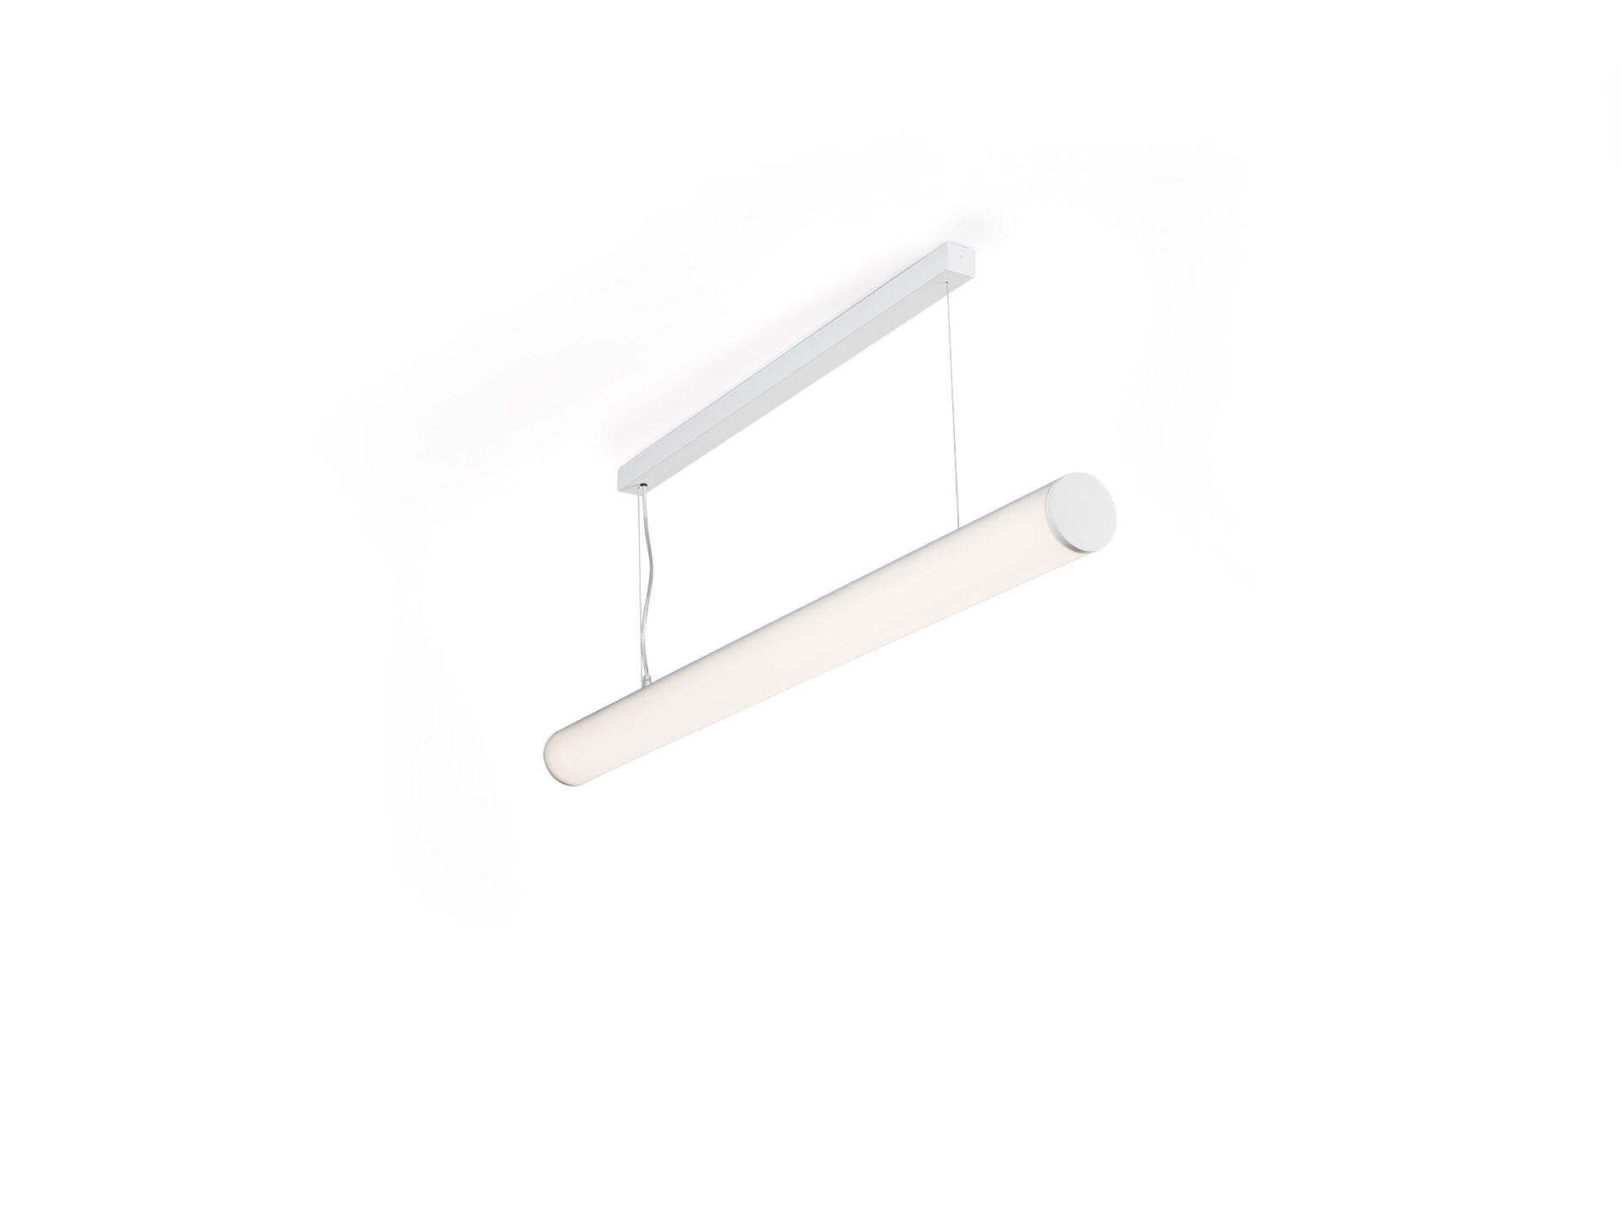
- Surface-mounted and suspended diffusor luminaire.
- Halooptics diffuser optics, polycarbonate (PC) HaloOptics®, wide-angle light distribution.
- 80 mm diameter, white end-caps, can be mounted in-line with optional endcap accessory.
- Dimensions: 1162 mm x 80 mm x 121 mm.
- Tubular HaloOptics diffuser™ for bright and uniform illumination.
- Luminous flux: 4550 lm, Luminous efficacy: 111 lm/W.
- Power: 41.0 W, not dimmable.
- Frequency: 50-60Hz AC.
- Voltage: 220-240V.
- Electrical isolation class: class I.
- LED with very good light maintenance; at 50000 hrs the luminaire retains 92% of it's initial flux (Tq=25°C).
- Correlated colour temperature: 3000 K, Colour rendering ra: 80.
- Standard deviation colour matching satisfy 3 SDCM.
- Photobiological safety IEC/TR 62778: RG0.
- RAL9003 - white (textured).
- IP protection level: IP20.
- Glowwire: 850°C.
- 5 years warranty on luminaire and driver.
- Certifications: CE, ENEC.
- Luminaire with halogen free leads.
- The luminaire has been developed and produced according to standard EN60598-1 in a company that is ISO9001 and ISO14001 certified.

