R821R1/LEDW45S

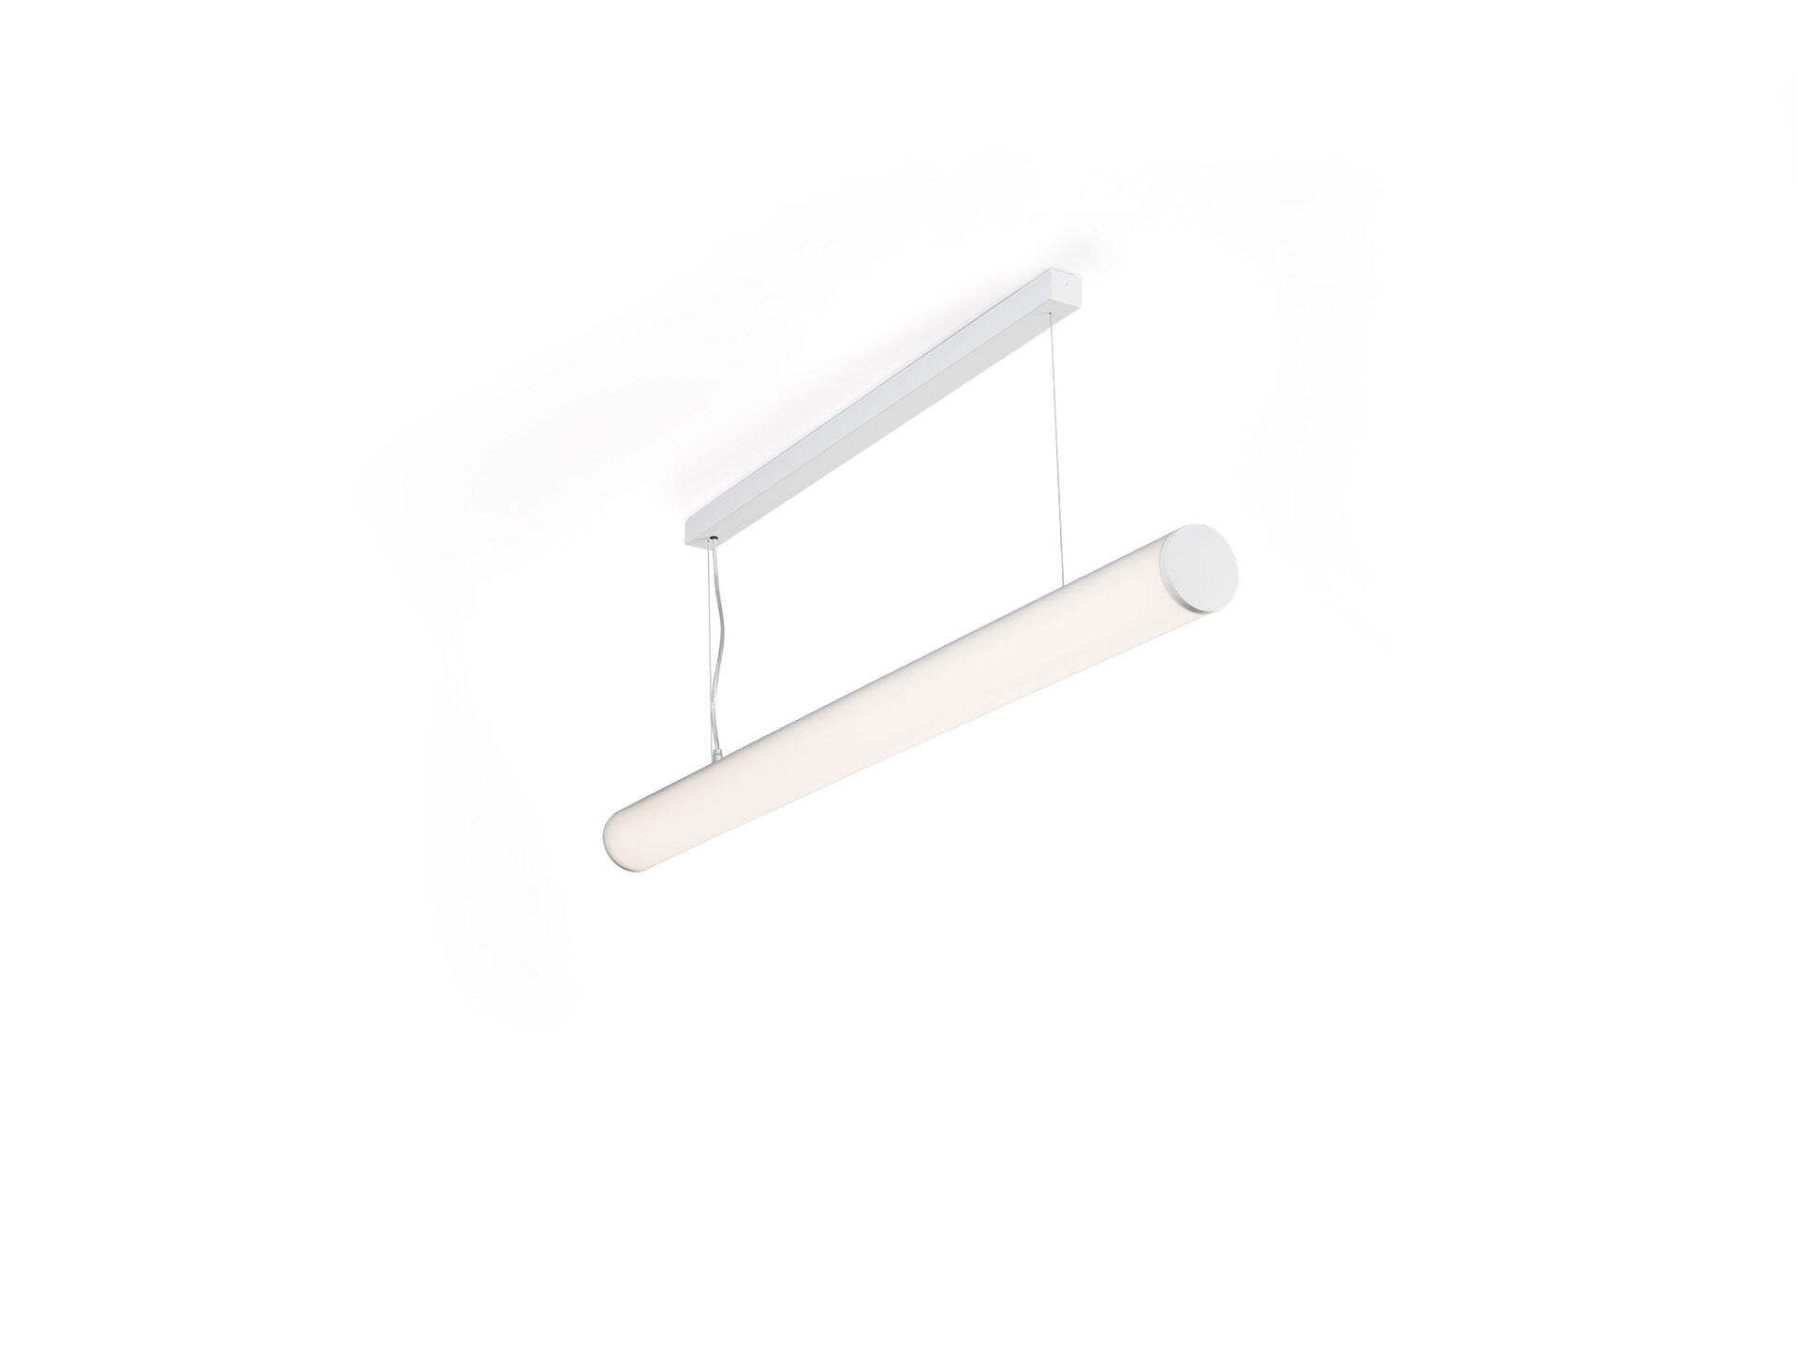
Surface-mounted and suspended diffusor luminaire. Halooptics diffuser optics, polycarbonate (PC) HaloOptics®, wide-angle light distribution. 80 mm diameter, white end-caps, can be mounted in-line with optional endcap accessory. Dimensions: 1162 mm x 80 mm x 121 mm. Tubular HaloOptics diffuser™ for bright and uniform illumination. Luminous flux: 4550 lm, Luminous efficacy: 111 lm/W. Power: 41.0 W, not dimmable. Frequency: 50-60Hz AC. Voltage: 220-240V. Electrical isolation class: class I. LED with very good light maintenance; at 50000 hrs the luminaire retains 92% of it's initial flux (Tq=25°C). Correlated colour temperature: 3000 K, Colour rendering ra: 80. Standard deviation colour matching satisfy 3 SDCM. Photobiological safety IEC/TR 62778: RG0. RAL9003 - white (textured). IP protection level: IP20. Glowwire: 850°C. 5 years warranty on luminaire and driver. Certifications: CE, ENEC. Luminaire with halogen free leads. The luminaire has been developed and produced according to standard EN60598-1 in a company that is ISO9001 and ISO14001 certified.

