D11R1/LEDN10DX1

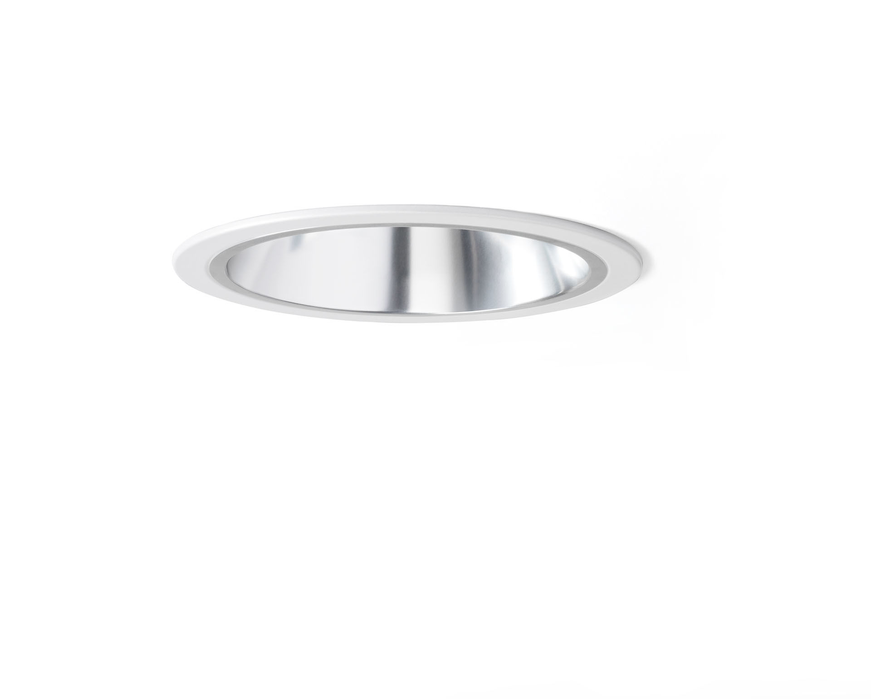
- Recessed downlight with aluminium reflector.
- Reflector optics, aluminium, satin anodised, wide-angle light distribution.
- Metal trim 1 mm thickness, other RAL colours possible on demand.
- Dimensions: Ø 220 mm x 120 mm.
- Ceiling cut-out: Ø 205 mm.
- Reflector shields the light source thus preventing glare from the LED source. Wide-angle light distribution.
- Luminous flux: 1250 lm, Luminous efficacy: 125 lm/W.
- Power: 10.0 W, DALI dimmable.
- Frequency: 50Hz AC.
- Voltage: 230-240V.
- Electrical isolation class: class II.
- LED with very good light maintenance; at 50000 hrs the luminaire retains 99% of it's initial flux (Tq=25°C).
- Correlated colour temperature: 4000 K, Colour rendering ra: 80.
- Standard deviation colour matching satisfy 3 SDCM.
- Photobiological safety IEC/TR 62778: RG1.
- Injection-moulded aluminium housing, RAL9003 - signal white.
- 5 years warranty on luminaire and driver.
- Certifications: CE, ENEC.
- Luminaire with halogen free leads.
- The luminaire has been developed and produced according to standard EN60598-1 in a company that is ISO9001 and ISO14001 certified.

