D21R1/LEDW10DX2

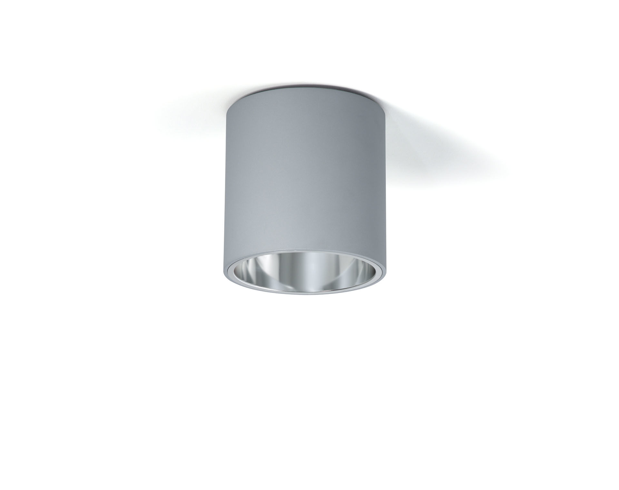
- Surface-mounted downlight with aluminium reflector.
- Reflector optics, aluminium, satin anodised, wide-angle light distribution.
- Aluminium cylindrical housing, other RAL colours possible on demand.
- Dimensions: Ø 200 mm x 212 mm.
- Reflector shields the light source thus preventing glare from the LED source. Wide-angle light distribution.
- Luminous flux: 1200 lm, Luminous efficacy: 120 lm/W.
- Power: 10.0 W, DALI dimmable.
- Frequency: 50Hz AC.
- Voltage: 230-240V.
- Electrical isolation class: class I.
- LED with very good light maintenance; at 50000 hrs the luminaire retains 99% of it's initial flux (Tq=25°C).
- Correlated colour temperature: 3000 K, Colour rendering ra: 80.
- Standard deviation colour matching satisfy 3 SDCM.
- Photobiological safety IEC/TR 62778: RG1.
- Lacquered aluminium housing, RAL9006 - white aluminium (textured).
- 5 years warranty on luminaire and driver.
- Certifications: CE, ENEC.
- Luminaire with halogen free leads.
- The luminaire has been developed and produced according to standard EN60598-1 in a company that is ISO9001 and ISO14001 certified.

