D42R1/LEDN1820S

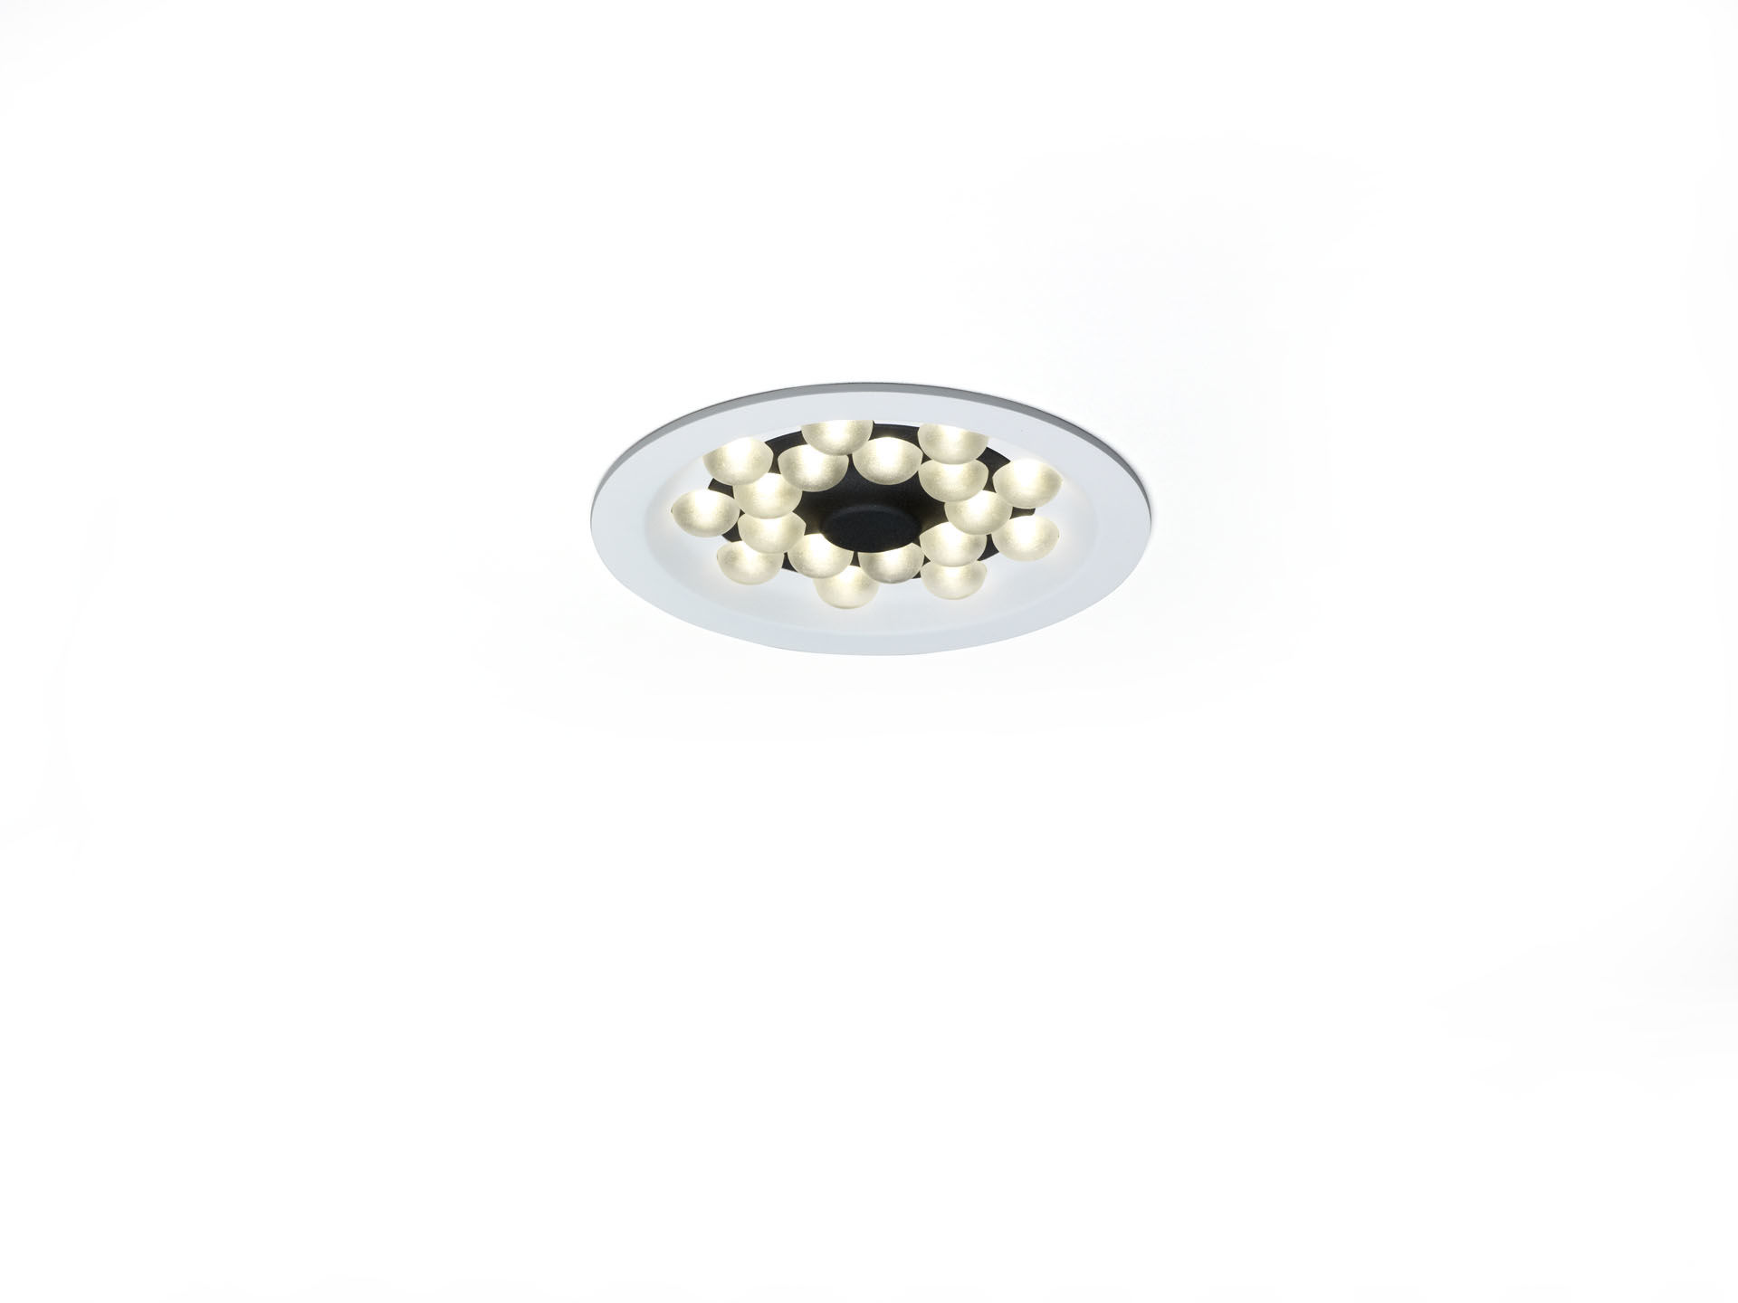
- Downlight with LED+LENS technology.
- Led+lens™ optics, polycarbonate (PC) lens, wide-angle light distribution.
- White trim (RAL9003) and black (RAL9005) inner part; other colour combinations possible on demand.
- Dimensions: Ø 200 mm x 70 mm.
- Ceiling cut-out: Ø 180 mm.
- LED+LENS™, a combination of high performance LEDs and individual lenses with a patented surface structure. The lenses are recessed in small cups for a comfortable light experience.
- Luminous flux: 2250 lm, Luminous efficacy: 132 lm/W.
- Power: 17.0 W, not dimmable.
- Frequency: 50-60Hz AC.
- Voltage: 220-240V.
- Electrical isolation class: class II.
- LED with very good light maintenance; at 50000 hrs the luminaire retains 98% of it's initial flux (Tq=25°C).
- Correlated colour temperature: 4000 K, Colour rendering ra: 80.
- Standard deviation colour matching satisfy 3 SDCM.
- LED+LENS™ with UGR <= 22 conform norm EN 12464-1 for moderate visual and concentration demands.
- Photobiological safety IEC/TR 62778: RG1.
- Lacquered aluminium housing, RAL9003 - signal white.
- IP protection level: IP20.
- Glowwire: 850°C.
- 5 years warranty on luminaire and driver.
- Certifications: CE, ENEC.
- Luminaire with halogen free leads.
- The luminaire has been developed and produced according to standard EN60598-1 in a company that is ISO9001 and ISO14001 certified.

