D7R3RBW/N1CHS

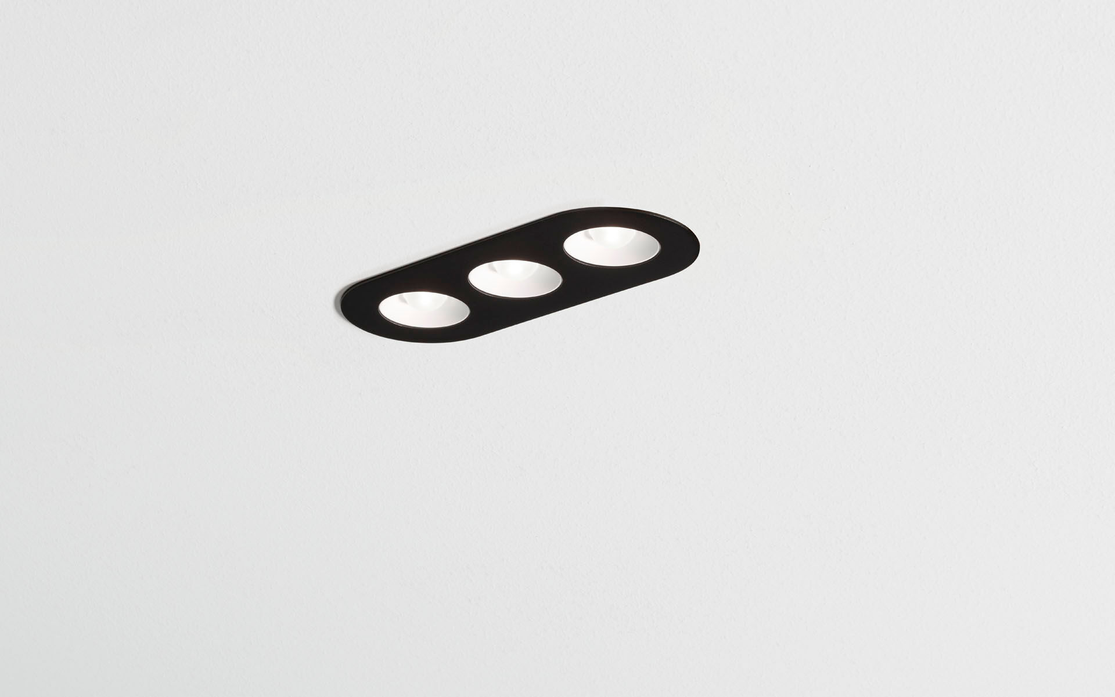
- Linear downlight with round edges, black housing.
- Led+lens™ optics, white cups, polycarbonate, medium wide-angle light distribution.
- 3 lenses recessed in circular lens cups.
- Dimensions: 235 mm x 95 mm x 40 mm.
- LED+LENS™, a combination of high performance LEDs and individual lenses with a patented surface structure. The lenses are recessed in small cups for a comfortable light experience.
- Luminous flux: 1100 lm, Luminous efficacy: 96 lm/W.
- Power: 11.5 W, not dimmable.
- Frequency: 50-60Hz AC.
- Voltage: 220-240V.
- Electrical isolation class: class II.
- LED with very good light maintenance; at 50000 hrs the luminaire retains 94% of it's initial flux (Tq=25°C).
- Correlated colour temperature: 4000 K, Colour rendering ra: 80.
- Standard deviation colour matching satisfy 3 SDCM.
- LED+LENS™ for glare-free light distribution with UGR <= 19 and luminances @ 65° 3000 Cd/m² conform norm EN 12464-1 for high visual demands, e.g. display screen equipment.
- Photobiological safety IEC/TR 62778: RG1.
- RAL9005 - jetblack (textured).
- IP protection level: IP20.
- Glowwire: 850°C.
- 5 years warranty on luminaire and driver.
- Certifications: CE, ENEC.
- Luminaire with halogen free leads.
- The luminaire has been developed and produced according to standard EN60598-1 in a company that is ISO9001 and ISO14001 certified.

