D7R3SBB/N3CHS

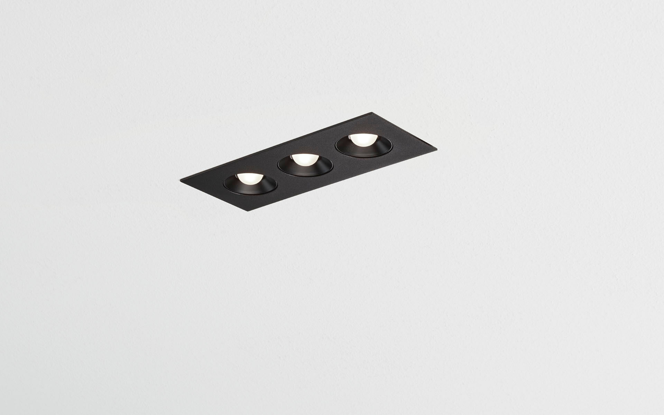
- Linear downlight with square edges, black housing.
- Led+lens™ optics, black cups, polycarbonate, very wide-angle light distribution.
- 3 lenses recessed in circular lens cups.
- Dimensions: 235 mm x 95 mm x 40 mm.
- Individual square
- LED+LENS™, a combination of high performance LEDs and individual lenses with a patented surface structure. The lenses are recessed in small cups for a comfortable light experience.
- Luminous flux: 1100 lm, Luminous efficacy: 92 lm/W.
- Power: 12.0 W, not dimmable.
- Frequency: 50/60Hz AC.
- Voltage: 220-240V.
- Electrical isolation class: class II.
- LED with very good light maintenance; at 50000 hrs the luminaire retains 96% of it's initial flux (Tq=25°C).
- Correlated colour temperature: 4000 K, Colour rendering ra: 80.
- Colour consistency (McAdam ellipse): ≤ 3 SDCM.
- LED+LENS™ with UGR <= 22 conform norm EN 12464-1 for moderate visual and concentration demands.
- Photobiological safety IEC/TR 62778: RG1.
- RAL9005 - black.
- IP protection level: IP20.
- Replaceable (LED only) light source by a professional. Replaceable control gear by a professional.
- Energy efficiency class of the light source according to EU regulation 2019/2015: E.
- Glowwire: 650°C.
- 5 years warranty on luminaire and driver.
- Certifications: CE, ENEC.
- Luminaire with halogen free leads.
- The luminaire has been developed and produced according to standard EN60598-1 in a company that is ISO9001 and ISO14001 certified.

