D7R6RWW/N2CHS

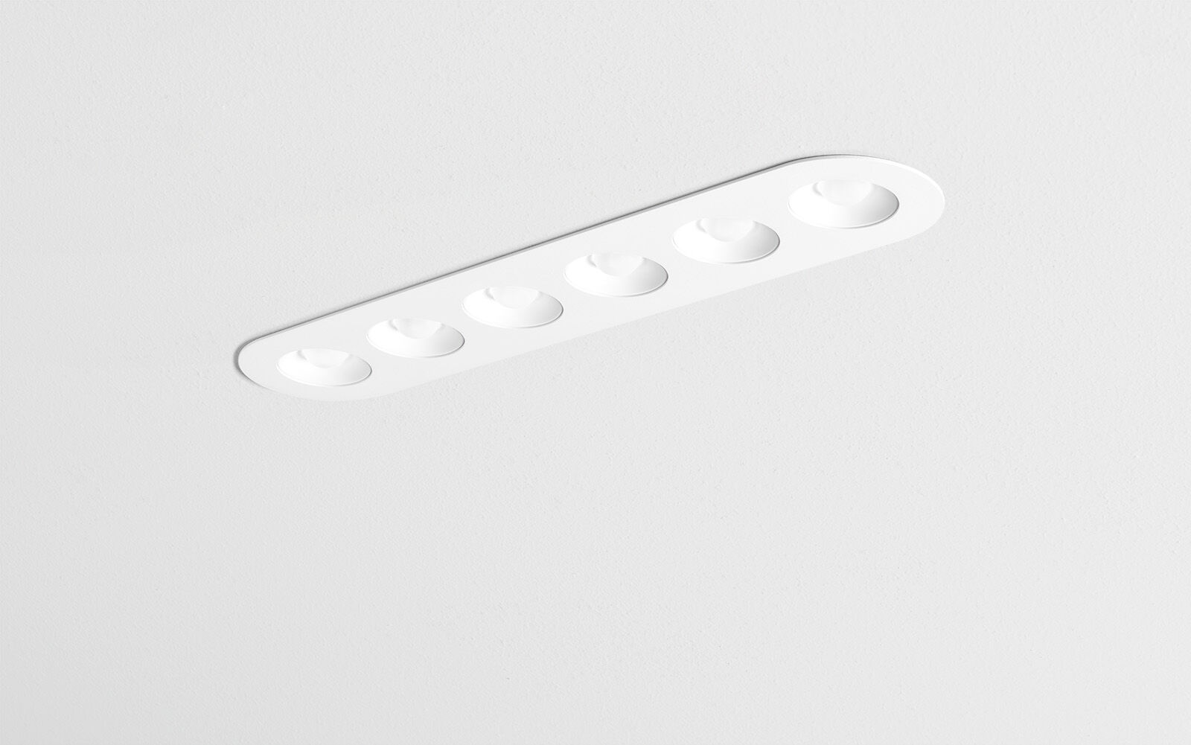
- Linear downlight with round edges, white housing.
- Led+lens™ optics, white cups, polycarbonate, wide-angle light distribution.
- 6 lenses recessed in circular lens cups.
- Dimensions: 445 mm x 95 mm x 40 mm.
- LED+LENS™, a combination of high performance LEDs and individual lenses with a patented surface structure. The lenses are recessed in small cups for a comfortable light experience.
- Luminous flux: 2200 lm, Luminous efficacy: 100 lm/W.
- Power: 22.0 W, not dimmable.
- Frequency: 50-60Hz AC/DC.
- Voltage: 220-240V.
- Electrical isolation class: class II.
- LED with very good light maintenance; at 50000 hrs the luminaire retains 93% of it's initial flux (Tq=25°C).
- Correlated colour temperature: 4000 K, Colour rendering ra: 80.
- Standard deviation colour matching satisfy 3 SDCM.
- LED+LENS™ with UGR <= 22 conform norm EN 12464-1 for moderate visual and concentration demands.
- Photobiological safety IEC/TR 62778: RG1.
- RAL9003 - white (textured).
- IP protection level: IP20.
- Glowwire: 850°C.
- 5 years warranty on luminaire and driver.
- Certifications: CE.
- Luminaire with halogen free leads.
- The luminaire has been developed and produced according to standard EN60598-1 in a company that is ISO9001 and ISO14001 certified.

