D9B-R310-15-830-015D

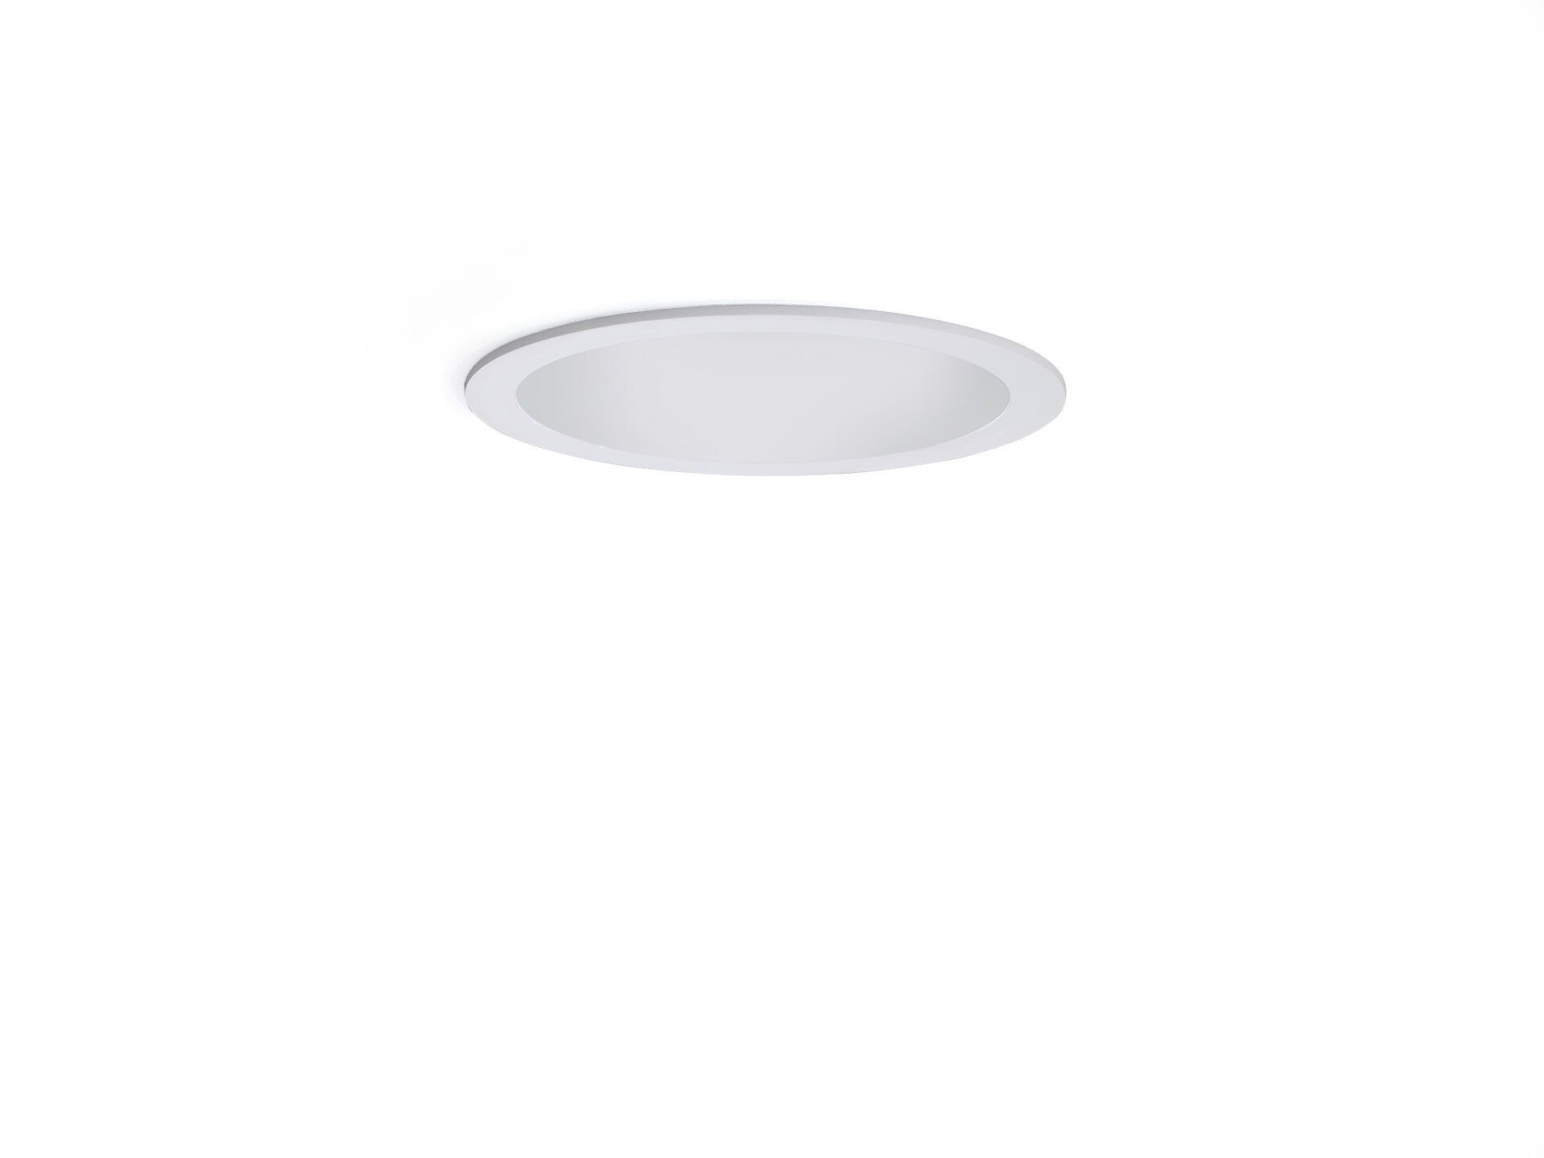
- Seamless polycarbonate downlight.
- Reflector and lens optics, white polycarbonate (PC), medium wide-angle light distribution.
- White polycarbonate trim and reflector form one unit, without visible seams.
- Dimensions: Ø 190 mm x 100 mm.
- Individual round, Ceiling cut-out: Ø 175 mm.
- Reflector shields the light source and a lens prevents glare.
- Luminous flux: 1550 lm, Luminous efficacy: 155 lm/W.
- Power: 10.0 W, DALI dimmable.
- Frequency: 50/60Hz AC.
- Voltage: 220-240V.
- Electrical isolation class: class II.
- LED with very good light maintenance; at 50000 hrs the luminaire retains 96% of it's initial flux (Tq=25°C).
- Correlated colour temperature: 3000 K, Colour rendering ra: 80.
- Colour consistency (McAdam ellipse): ≤ 3 SDCM.
- Photobiological safety IEC/TR 62778: RG1.
- Polycarbonate housing, RAL9003 - white.
- IP protection level: IP20.
- Energy efficiency class of the light source according to EU regulation 2019/2015: D.
- Glowwire: 850°C.
- 5 years warranty on luminaire and driver.
- Certifications: CE, ENEC.
- Luminaire with halogen free leads.
- The luminaire has been developed and produced according to standard EN60598-1 in a company that is ISO9001 and ISO14001 certified.

