E21/LED2N030S-ATEX1

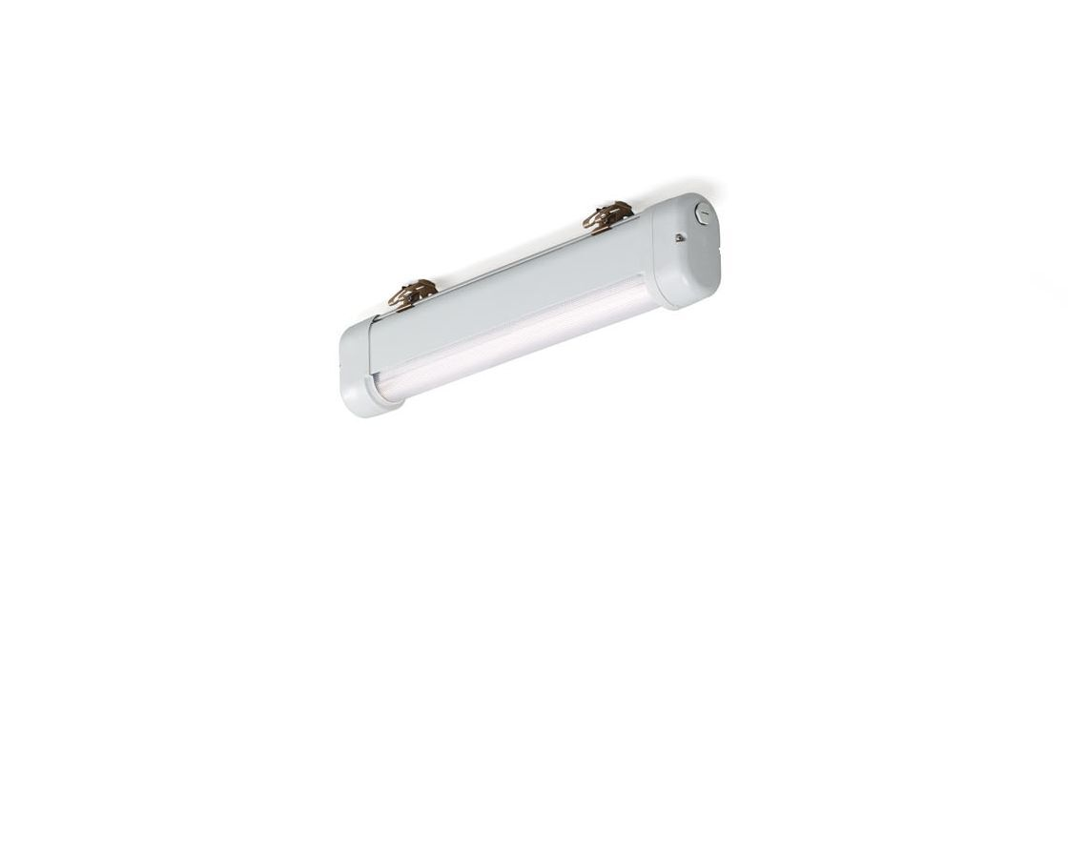
- Industrial dust- and waterproof ATEX luminaire.
- Linear lens optics, polycarbonate (PC), medium wide-angle light distribution.
- Suitable for ATEX zone 2, zone 21, zone 22 (2014/34/EU).
- Dimensions: 620 mm x 80 mm x 135 mm.
- Luminous flux: 3300 lm, Luminous efficacy: 122 lm/W.
- Power: 27.0 W, not dimmable.
- Frequency: 50-60Hz AC.
- Voltage: 220-240V.
- Electrical isolation class: class I.
- LED with very good light maintenance; at 50000 hrs the luminaire retains 96% of it's initial flux (Tq=25°C).
- Correlated colour temperature: 4000 K, Colour rendering ra: 80.
- Standard deviation colour matching satisfy 3 SDCM.
- Photobiological safety IEC/TR 62778: RG1.
- Lacquered aluminium housing, RAL7035 - light grey.
- IP protection level: IP66.
- IP from below: IP69K.
- Non-replaceable light source. Replaceable control gear by a professional.
- Ambient temperature: -20°C - 40°C.
- ATEX classification: II 2D Ex tb IIIC T80°C Db, II 3G Ex ec IIC T4 Gc.
- Glowwire: 850°C.
- 5 years warranty on luminaire and driver.
- Certifications: CE, ATEX, ENEC.
- Luminaire with halogen free leads.
- The luminaire has been developed and produced according to standard EN60598-1 in a company that is ISO9001 and ISO14001 certified.

