E22/LED2N030D

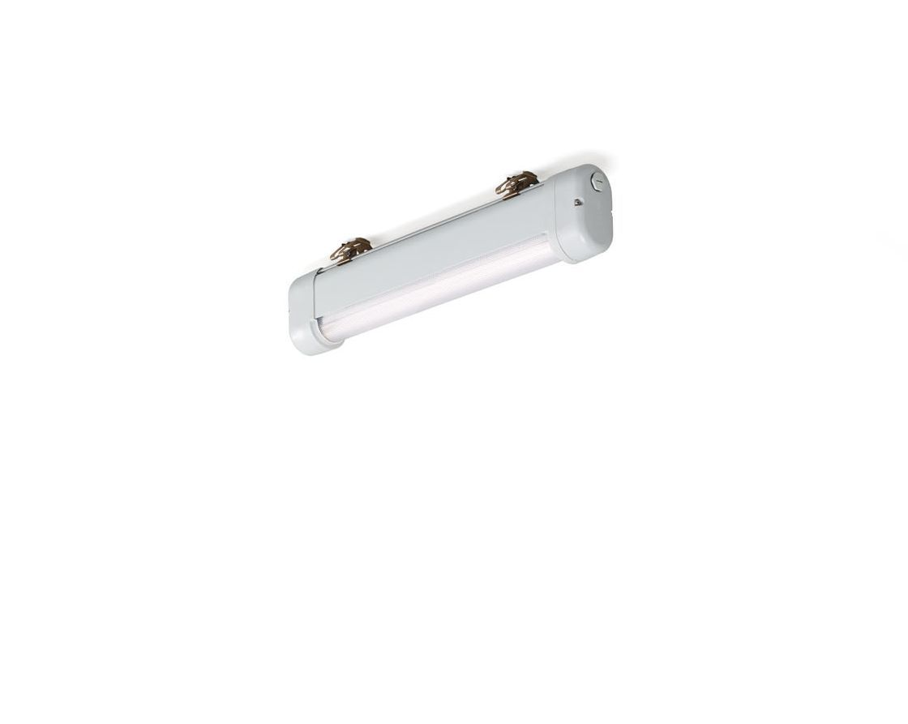
- Industrial dust- and waterproof luminaire.
- Linear lens optics, polycarbonate (PC), wide-angle light distribution.
- For use in demanding environments. For use in corrosive environments (category C1 to C4 according to EN ISO 12944) with electrochemically polished and coated treated mounting brackets. Tested on complinace with EN 60068-2-60 for corrosive gases.
- Dimensions: 620 mm x 80 mm x 135 mm.
- Luminous flux: 2900 lm, Luminous efficacy: 121 lm/W.
- Power: 24.0 W, DALI dimmable.
- Frequency: 50-60Hz AC.
- Voltage: 220-240V.
- Electrical isolation class: class I.
- LED with very good light maintenance; at 50000 hrs the luminaire retains 97% of it's initial flux (Tq=25°C).
- Correlated colour temperature: 4000 K, Colour rendering ra: 80.
- Standard deviation colour matching satisfy 3 SDCM.
- Lacquered aluminium housing, RAL7035 - light grey.
- IP protection level: IP66.
- IK protection level: IK07.
- IP from below: IP69K.
- Ambient temperature: from -25°C to 35°C.
- Glowwire: 850°C.
- 5 years warranty on luminaire and driver.
- Certifications: CE, ENEC.
- Luminaire with halogen free leads.
- The luminaire has been developed and produced according to standard EN60598-1 in a company that is ISO9001 and ISO14001 certified.

