E2A-S106-4P-840-100S

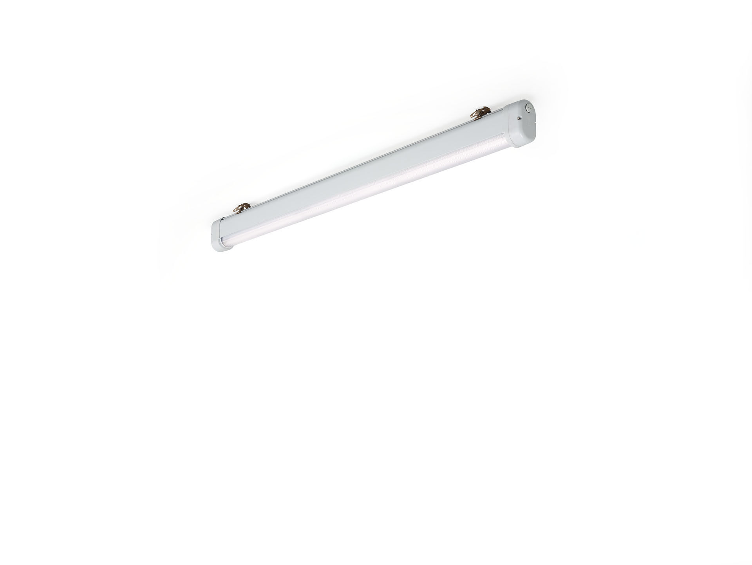
- Industrial dust- and waterproof luminaire, , with surge protection (LN/PE) 2kV/4kV.
- Linear lens optics, acrylic (PMMA), asymmetric light distribution.
- For use in demanding environments. For use in corrosive environments (category C1 to C4 according to EN ISO 12944) with electrochemically polished and coated treated mounting brackets. Tested on compliance with EN 60068-2-60 for corrosive gases.
- Dimensions: 1620 mm x 80 mm x 135 mm.
- Individual linear
- Luminous flux: 10000 lm, Luminous efficacy: 155 lm/W.
- Power: 64.5 W, not dimmable.
- Frequency: 50/60Hz AC.
- Voltage: 220-240V.
- Electrical isolation class: class I.
- LED with very good light maintenance; at 50000 hrs the luminaire retains 95% of it's initial flux (Tq=25°C).
- Correlated colour temperature: 4000 K, Colour rendering ra: 80.
- Colour consistency (McAdam ellipse): ≤ 3 SDCM.
- Photobiological safety IEC/TR 62778: RG1.
- Lacquered aluminium housing, RAL7035 - light grey.
- IP protection level: IP66.
- IK protection level: IK06.
- IP from below: IP69K.
- Energy efficiency class of the light source according to EU regulation 2019/2015: C.
- Ambient temperature: -25°C - 60°C.
- Glowwire: 650°C.
- 5 years warranty on luminaire and driver.
- Certifications: CE, ENEC.
- Luminaire with halogen free leads.
- The luminaire has been developed and produced according to standard EN60598-1 in a company that is ISO9001 and ISO14001 certified.

