E4001/LED1W030D

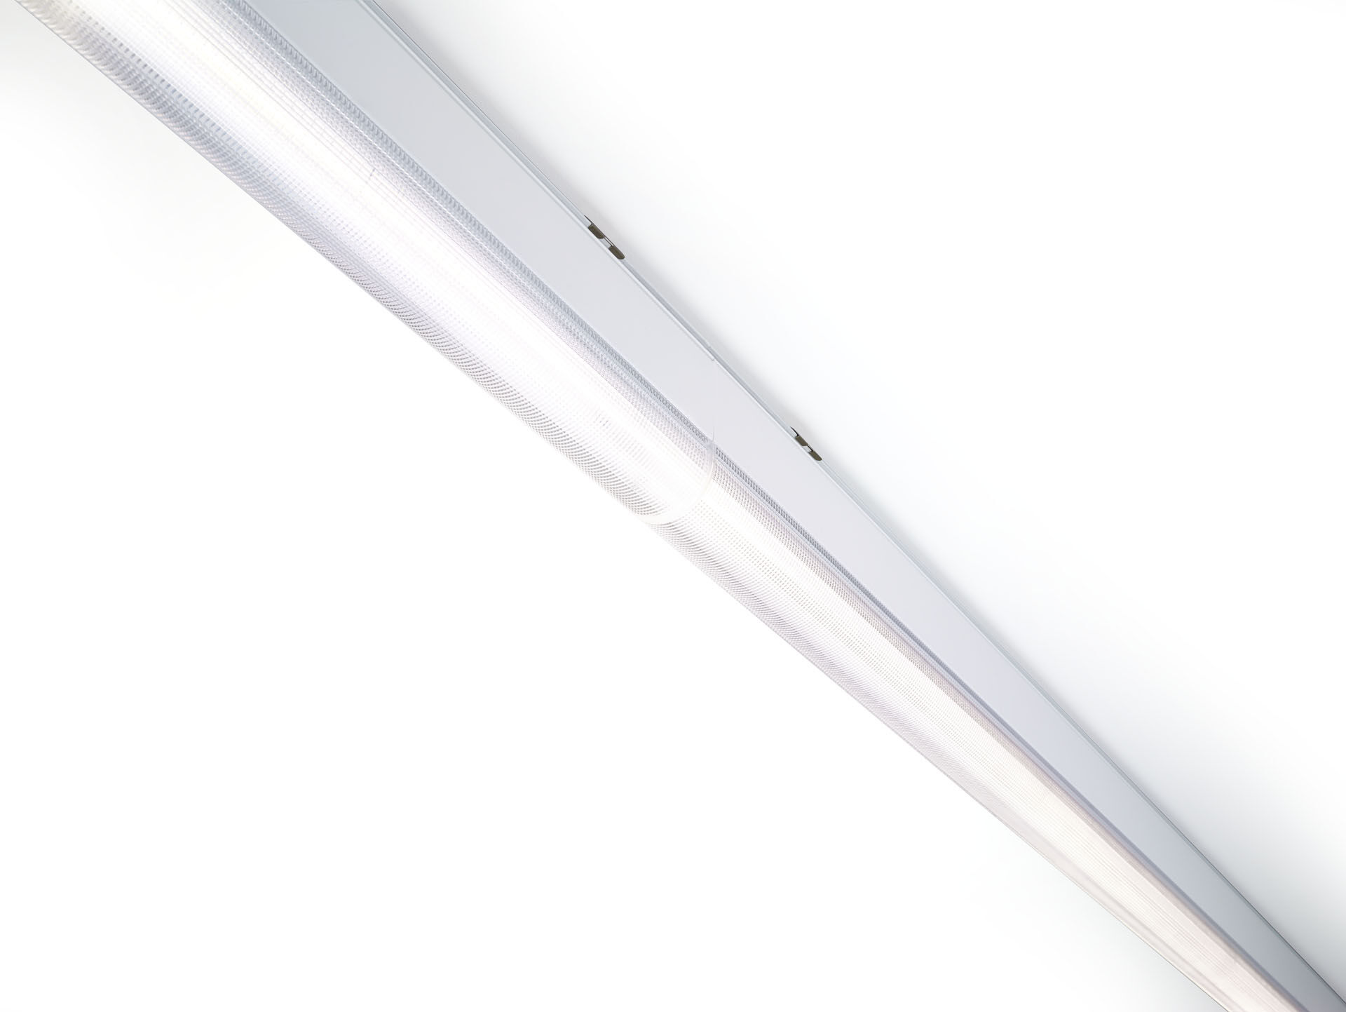
- Industrial line luminaire with sleek design.
- Dual●lens optics, polycarbonate (PC), narrow-angle light distribution.
- Dimensions: 1000 mm x 60 mm x 135 mm.
- Luminous flux: 3000 lm, Luminous efficacy: 111 lm/W.
- Power: 27.0 W, DALI dimmable.
- Frequency: 50-60Hz AC.
- Voltage: 220-240V.
- Electrical isolation class: class I.
- LED with very good light maintenance; at 50000 hrs the luminaire retains 96% of it's initial flux (Tq=25°C).
- Correlated colour temperature: 3000 K, Colour rendering ra: 80.
- Standard deviation colour matching satisfy 3 SDCM.
- DUAL●LENS™ with UGR <= 22 conform norm EN 12464-1 for moderate visual and concentration demands.
- Lacquered aluminium housing, RAL9016 - traffic white (textured).
- IP protection level: IP40.
- IK protection level: IK06.
- Glowwire: 850°C.
- 5 years warranty on luminaire and driver.
- Certifications: CE, ENEC.
- Luminaire with halogen free leads.
- The luminaire has been developed and produced according to standard EN60598-1 in a company that is ISO9001 and ISO14001 certified.
- Mandatory accessoires for mounting the luminaire: E7H301, E4H1000, E4H111, E4H112, E4H121, E4H122, E4H131, E4H141, E4H142, .

