E4215/LED4N080D

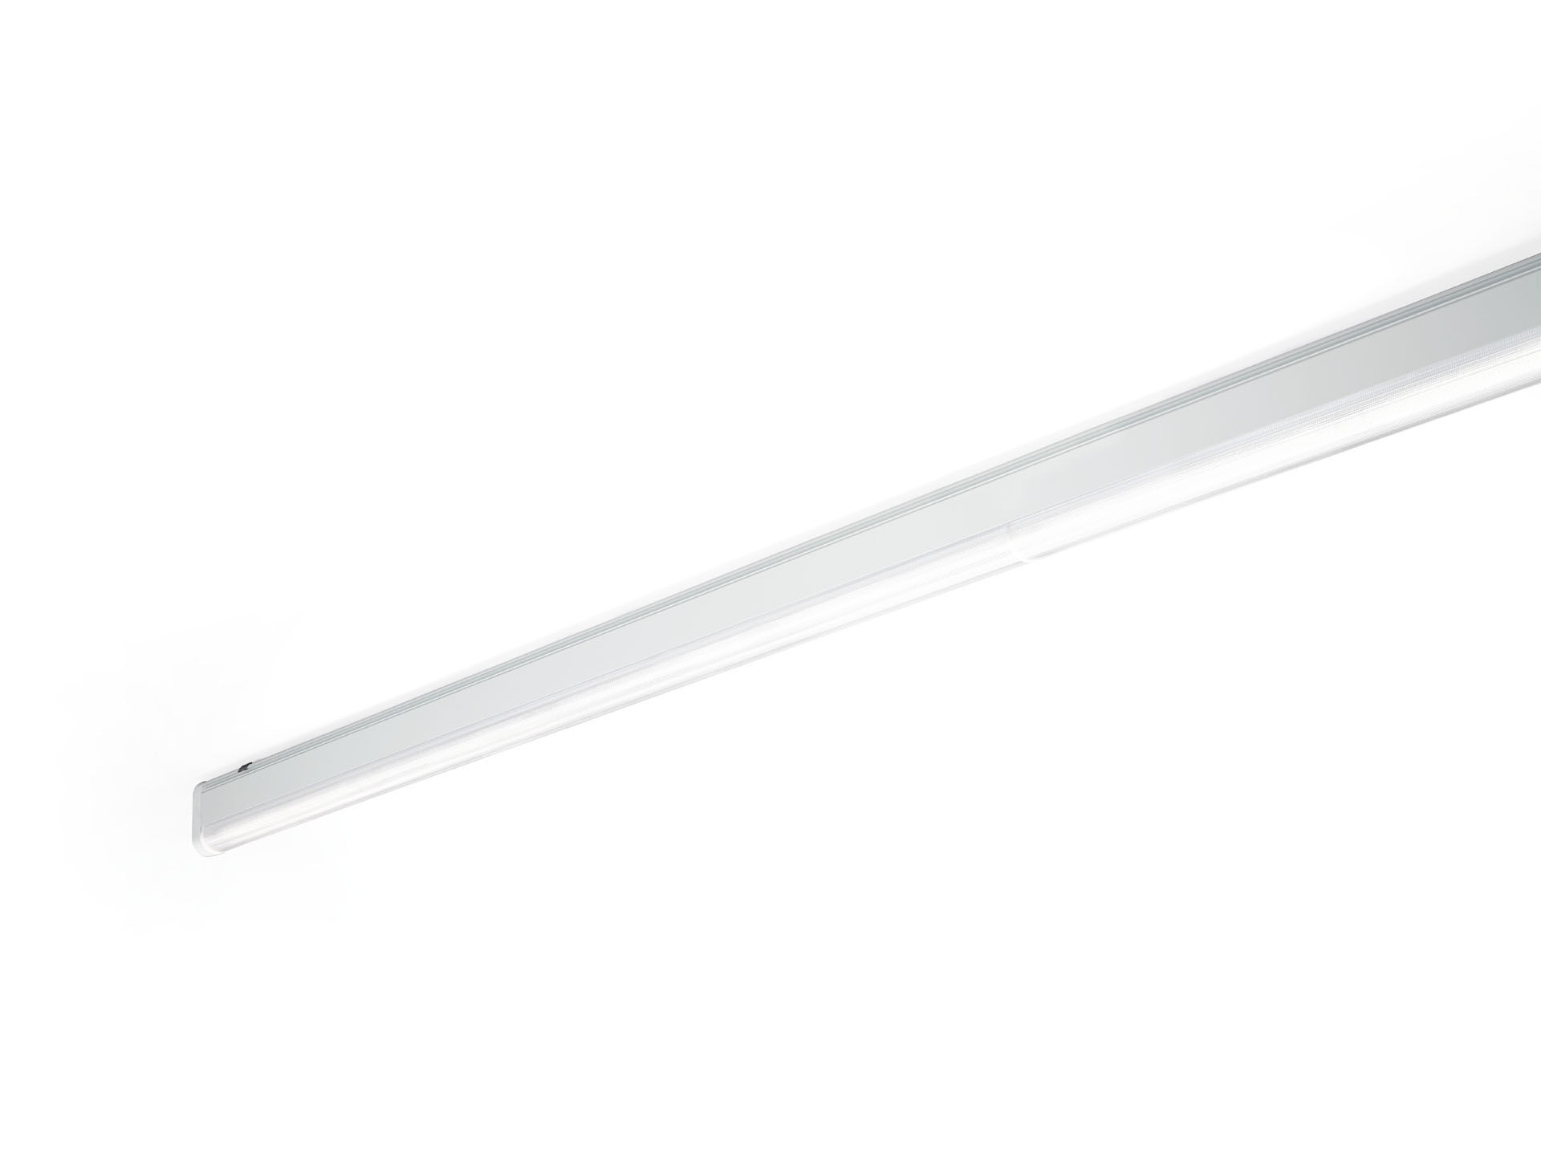
- Industrial line luminaire with sleek design. Surge protection (LN/PE): 1kV/2kV (for light industrial environments).
- Dual●lens optics, polycarbonate (PC), wide-angle light distribution.
- Dimensions: 4000 mm x 60 mm x 135 mm.
- Luminous flux: 10300 lm, Luminous efficacy: 137 lm/W.
- Power: 75.0 W, DALI dimmable.
- Frequency: 50-60Hz AC.
- Voltage: 220-240V.
- Electrical isolation class: class I.
- LED with very good light maintenance; at 50000 hrs the luminaire retains 99% of it's initial flux (Tq=25°C).
- Correlated colour temperature: 4000 K, Colour rendering ra: 80.
- Colour consistency (McAdam ellipse): ≤ SDCM.
- DUAL●LENS™ with UGR <= 25 conform norm EN 12464-1 for low visual and concentration demands, frequent mobility.
- Lacquered aluminium housing, RAL9016 - traffic white.
- IP protection level: IP40.
- IK protection level: IK06.
- Replaceable (LED only) light source by a professional. Replaceable control gear by a professional.
- Glowwire: 850°C.
- 5 years warranty on luminaire and driver.
- Certifications: CE, ENEC.
- Luminaire with halogen free leads.
- The luminaire has been developed and produced according to standard EN60598-1 in a company that is ISO9001 and ISO14001 certified.
- Mandatory accessoires for mounting the luminaire: E7H301, E4H1000, E4H111, E4H112, E4H121, E4H122, E4H131, E4H141, E4H142, .

