E5B-S714-3A-840-050S

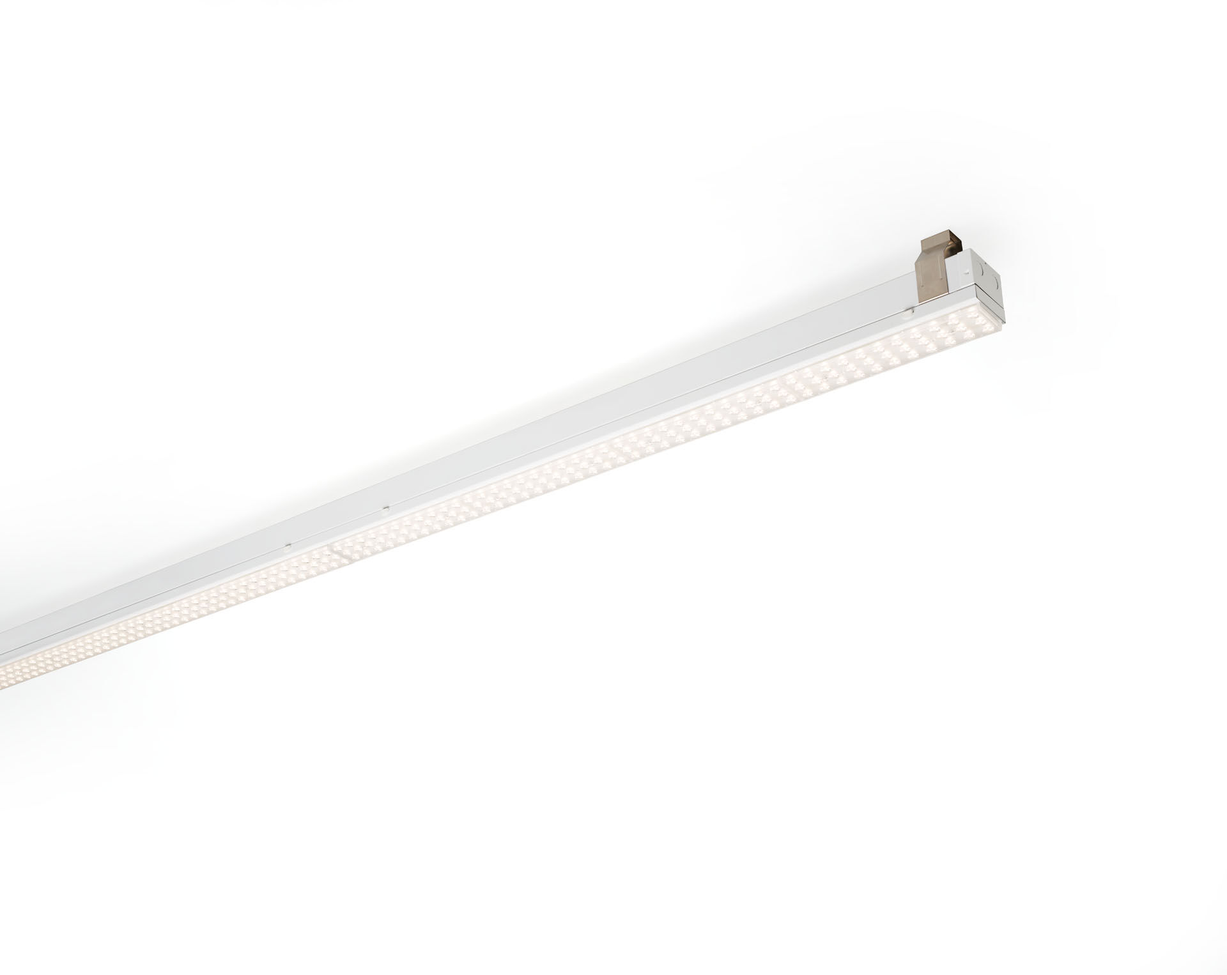
- Industrial line luminaire. Surge protection (LN/PE): 1kV/2kV (for light industrial environments).
- Multilens optics, acrylic (PMMA), very wide-angle light distribution.
- Module for mounting on base profile. Base profile in strong and rigid 0,8 mm steel. Module in coated sheet steel. Tool-free mounting of module on base. Suitable for retrofit on ETAP E3/E5 fluo systems. Electrical connection in base with phase selector plug.
- Dimensions: 1152 mm x 78 mm x 31 mm.
- Luminous flux: 5000 lm, Luminous efficacy: 161 lm/W.
- Power: 31.0 W, not dimmable.
- Frequency: 50-60Hz AC.
- Voltage: 220-240V.
- Electrical isolation class: class I.
- LED with very good light maintenance; at 50000 hrs the luminaire retains 95% of it's initial flux (Tq=25°C).
- Correlated colour temperature: 4000 K, Colour rendering ra: 80.
- Standard deviation colour matching satisfy 3 SDCM.
- Photobiological safety IEC/TR 62778: RG1.
- Lacquered sheet steel housing, RAL9003 - signal white.
- IP protection level: IP20.
- IK protection level: IK03.
- Replaceable (LED only) light source by a professional. Replaceable control gear by a professional.
- Glowwire: 650°C.
- 5 years warranty on luminaire and driver.
- Certifications: CE, ENEC.
- Luminaire with halogen free leads.
- The luminaire has been developed and produced according to standard EN60598-1 in a company that is ISO9001 and ISO14001 certified.
- Mandatory accessoires for mounting the luminaire: E5C11/0100, E5C11/0200, E5C11/0300, E5C11/0400, E5C11/0500, E5C11/1000, E5C11/1500, E5C11/2000, E5C11/2500, E3H115, E3H116, E3H117, E3H118, E3H119, E3H128, E3H129, E3H120, E3H121, E3H122, E3H123, E3H124, E3H125.

