E62/LED2N30S

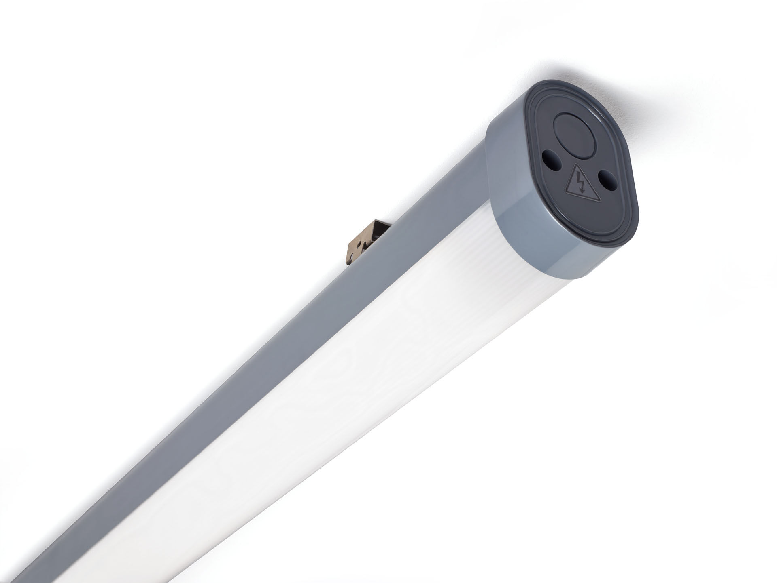
- Industrial dust- and waterproof luminaire. Surge protection 1kV/2kV (for light industrial environments).
- Linear lens optics, polycarbonate (PC), wide-angle light distribution.
- Coextrusion housing. For use in technical spaces and parking lots.
- Dimensions: 880 mm x 56 mm x 80 mm.
- Luminous flux: 3050 lm, Luminous efficacy: 122 lm/W.
- Power: 25.0 W, not dimmable.
- Frequency: 50-60Hz AC.
- Voltage: 220-240V.
- Electrical isolation class: class I.
- LED with very good light maintenance; at 50000 hrs the luminaire retains 99% of it's initial flux (Tq=25°C).
- Correlated colour temperature: 4000 K, Colour rendering ra: 80.
- Standard deviation colour matching satisfy 3 SDCM.
- Photobiological safety IEC/TR 62778: RG1.
- Polycarbonate housing, RAL7037 - dusty grey.
- IP protection level: IP66.
- IK protection level: IK07.
- Replaceable (LED only) light source by a professional. Replaceable control gear by a professional.
- Ambient temperature: -20°C - 35°C.
- Glowwire: 850°C.
- 5 years warranty on luminaire and driver.
- Certifications: CE, ENEC.
- Luminaire with halogen free leads.
- The luminaire has been developed and produced according to standard EN60598-1 in a company that is ISO9001 and ISO14001 certified.

