E7120/LED3N192340ST8

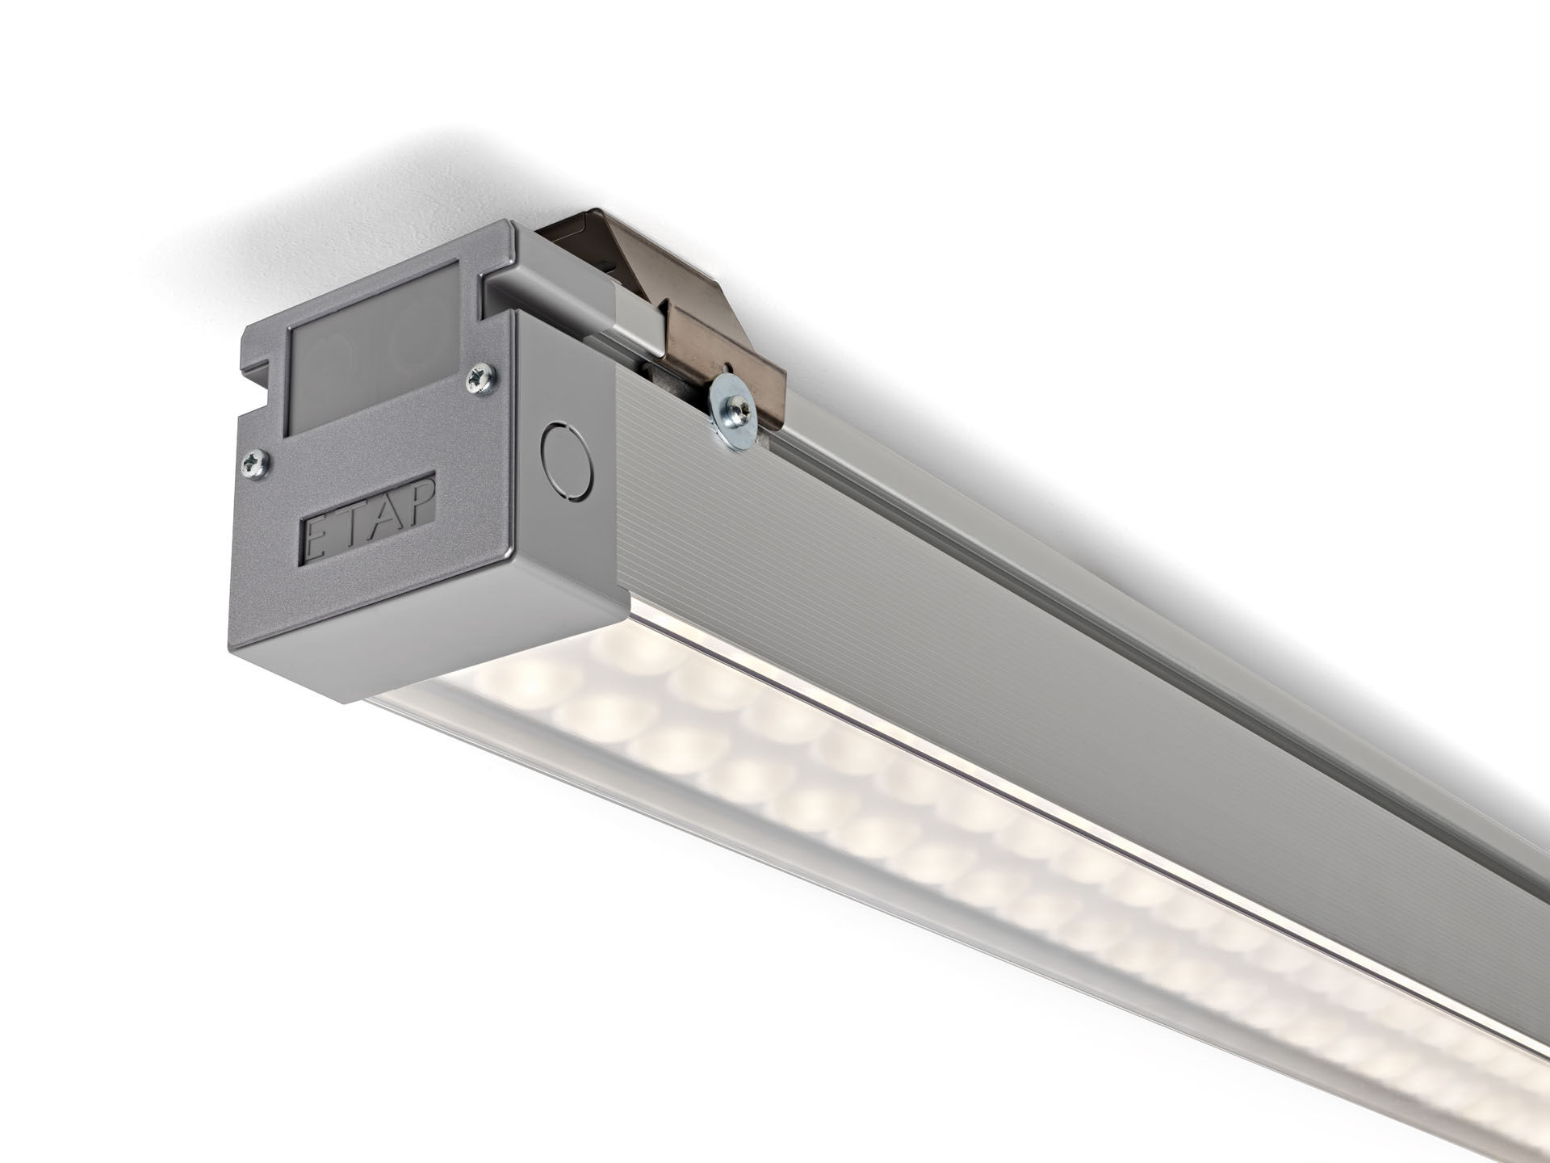
- Ball-proof luminaire with a slender design.
- Led+lens™ optics, polycarbonate (PC) lens and cup, medium wide-angle light distribution.
- For sports halls (conforms DIN 18032-3 / DIN 57710-13).
- Dimensions: 3070 mm x 90 mm x 88 mm.
- LED+LENS™, a combination of high performance LEDs and individual lenses with a patented surface structure. The lenses are recessed in small cups for a comfortable light experience.
- Luminous flux: 35600 lm, Luminous efficacy: 142 lm/W.
- Power: 250.0 W, not dimmable.
- Frequency: 50-60Hz AC.
- Voltage: 220-240V.
- Electrical isolation class: class I.
- LED with very good light maintenance; at 50000 hrs the luminaire retains 99% of it's initial flux (Tq=25°C).
- Correlated colour temperature: 4000 K, Colour rendering ra: 80.
- Standard deviation colour matching satisfy 3 SDCM.
- LED+LENS™ with UGR <= 22 conform norm EN 12464-1 for moderate visual and concentration demands.
- Photobiological safety IEC/TR 62778: RG1.
- Satin-anodised aluminium housing, anodised aluminium.
- IP protection level: IP40.
- IK protection level: IK08.
- Ambient temperature: from 5°C to 35°C.
- Glowwire: 850°C.
- 5 years warranty on luminaire and driver.
- Certifications: CE, ENEC.
- Luminaire with halogen free leads.
- The luminaire has been developed and produced according to standard EN60598-1 in a company that is ISO9001 and ISO14001 certified.
- Mandatory accessoires for mounting the luminaire: E7H151, E7H152, E7H171, E7H172.

