E7B-S104-1C-840-100D

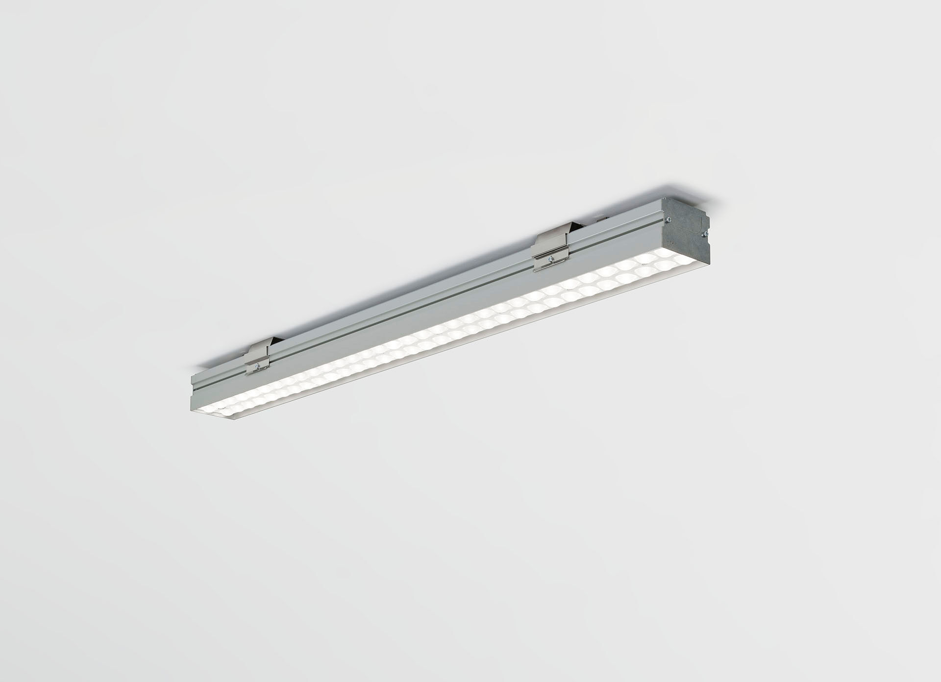
- Industrial luminaire with LED+LENS: optimal visual comfort for high ceilings, with surge protection (LN/PE) 2kV/4kV.
- Led+lens™ optics, polycarbonate (PC) lens and cup, medium wide-angle light distribution.
- Suitable for use in sports halls (ball-proof conform DIN 18032-3 / DIN 57710-13).
- Dimensions: 1005 mm x 90 mm x 65 mm.
- Individual linear
- LED+LENS™, a combination of high performance LEDs and individual lenses with a patented surface structure. The lenses are recessed in small cups for a comfortable light experience.
- Luminous flux: 10000 lm, Luminous efficacy: 156 lm/W.
- Power: 64.0 W, DALI dimmable.
- Frequency: 50/60Hz AC.
- Voltage: 220-240V.
- Electrical isolation class: class I.
- LED with very good light maintenance; at 50000 hrs the luminaire retains 99% of it's initial flux (Tq=25°C).
- Correlated colour temperature: 4000 K, Colour rendering ra: 80.
- Colour consistency (McAdam ellipse): ≤ 3 SDCM.
- LED+LENS™ with UGR <= 22 conform norm EN 12464-1 for moderate visual and concentration demands.
- Photobiological safety IEC/TR 62778: RG1.
- Profile in extruded aluminium housing, anodised.
- IP protection level: IP20.
- IK protection level: IK08.
- Replaceable (LED only) light source by a professional. Replaceable control gear by a professional.
- Energy efficiency class of the light source according to EU regulation 2019/2015: C.
- Ambient temperature: 5°C - 35°C.
- Glowwire: 850°C.
- 5 years warranty on luminaire and driver.
- Certifications: CE, ENEC.
- Luminaire with halogen free leads.
- The luminaire has been developed and produced according to standard EN60598-1 in a company that is ISO9001 and ISO14001 certified.

