E826/2NLDE

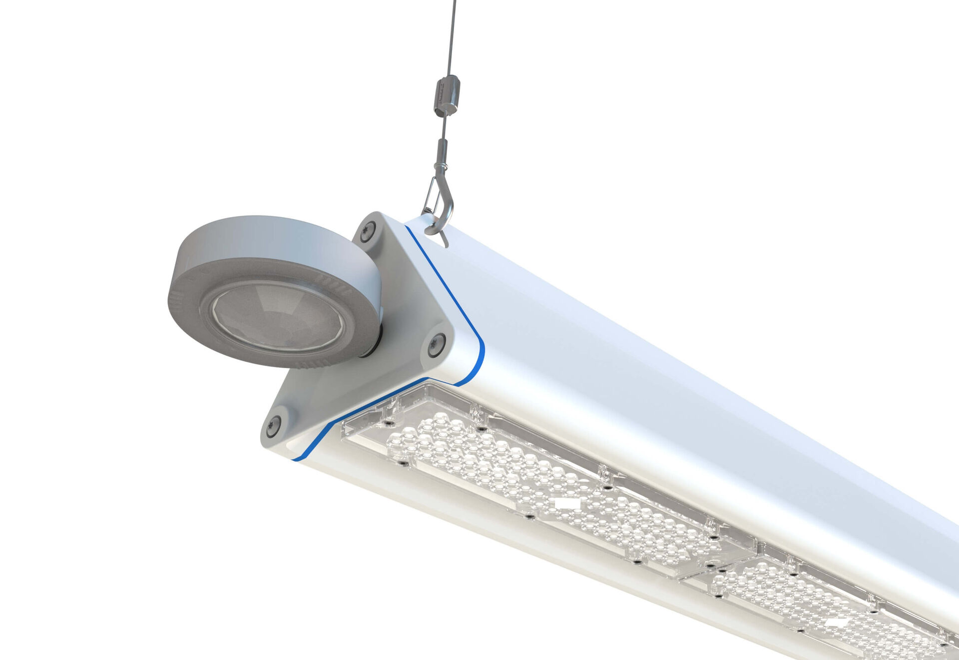
- Highbay with triangular design, and occupancy and daylight sensor. Surge protection (LN/PE) 2kV/4kV.
- Multilens optics, polycarbonate (PC), wide-angle light distribution.
- With reinforced EasyAir occupancy and daylight sensor. Master luminaire for master/slave combination for up to 20 DALI drivers. Optionally available with IP65 RST20i Wieland connector or with two M20 cable glands at the same end for looping-in., Smooth triangular shape without obstrusions or cooling fins, minimizes dust accumulation and allows for easy cleaning. Suitable for use in food-processing companies, with HACCP declaration of conformity.
- Dimensions: 805 mm x 180 mm x 165 mm.
- Luminous flux: 10000 lm, Luminous efficacy: 165 lm/W.
- Power: 60.5 W
- Frequency: 50-60Hz AC/DC.
- Voltage: 220-240V.
- Electrical isolation class: class I.
- LED with very good light maintenance; at 50000 hrs the luminaire retains 91% of it's initial flux (Tq=25°C).
- Correlated colour temperature: 4000 K, Colour rendering ra: 80.
- Standard deviation colour matching satisfy 3 SDCM.
- Photobiological safety IEC/TR 62778: RG1.
- Lacquered aluminium housing, RAL9003 - signal white.
- IP protection level: IP65.
- Replaceable (LED only) light source by a professional. Replaceable control gear by a professional.
- Ambient temperature: -30°C - 50°C.
- Glowwire: 650°C.
- 5 years warranty on luminaire and driver.
- Certifications: CE, ENEC.
- Luminaire with halogen free leads.
- The luminaire has been developed and produced according to standard EN60598-1 in a company that is ISO9001 and ISO14001 certified.

