E8M1/LEDN096235ST1

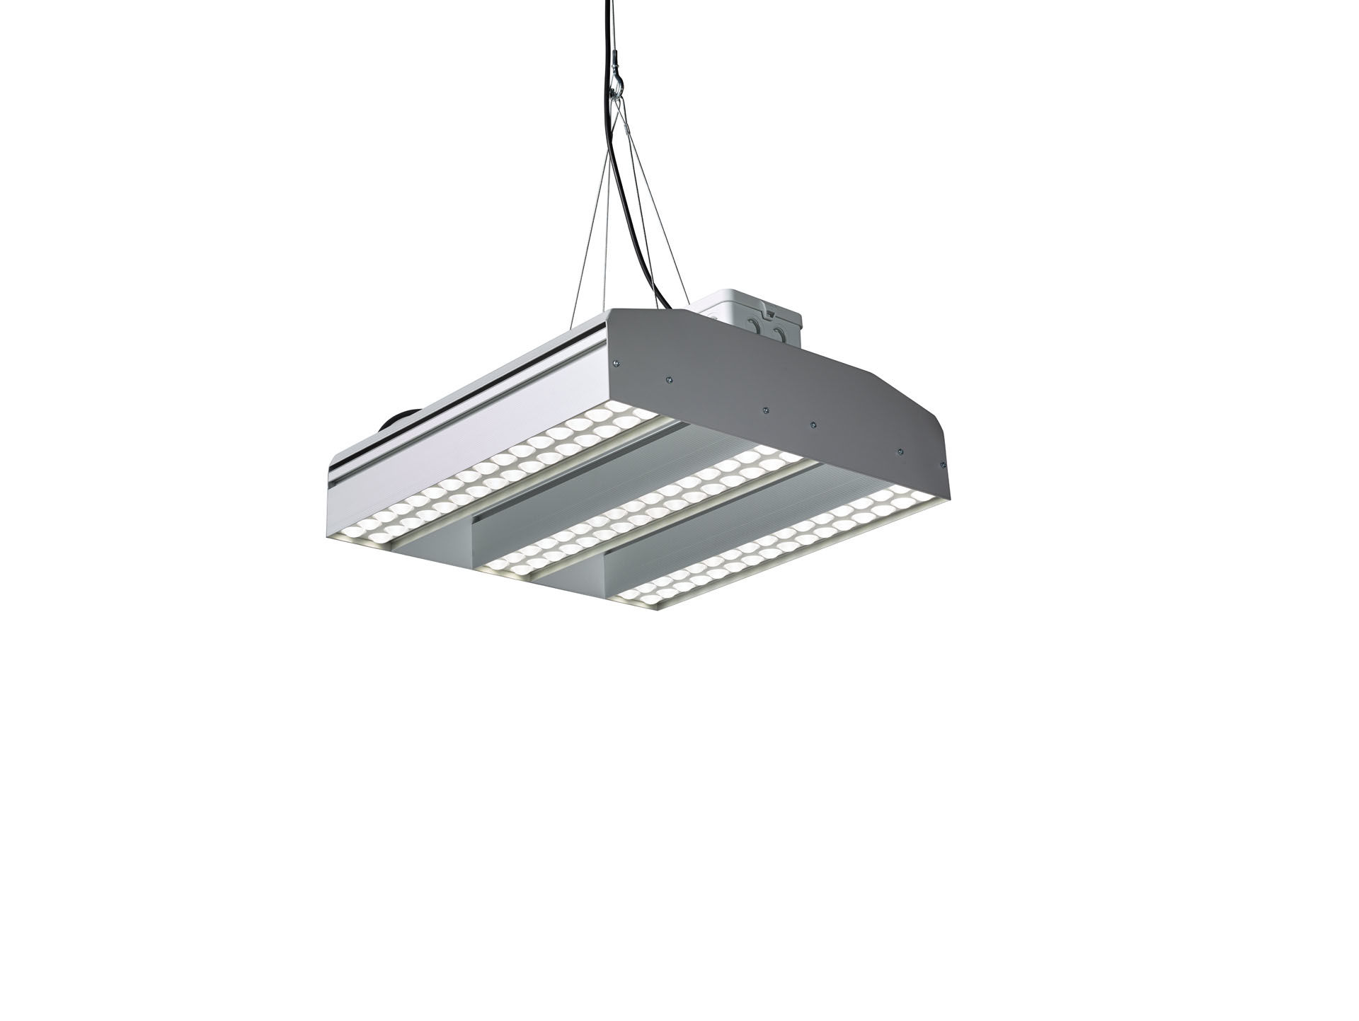
- Square industrial luminaire, LED+LENS™ optics, polycarbonate (PC)
lens and cup, medium wide-angle light distribution.
- Dimensions: 510 mm x 510 mm x 160 mm.
- LED+LENS™, a combination of high-power LEDs and individual lenses
with a patented surface structure. The lenses are recessed in small
cups for a comfortable light experience.
- Luminous flux: 22750 lm, Luminous efficacy: 109 lm/W.
- Power: 208.0 W, not dimmable.
- Frequency: 50-60Hz AC.
- Voltage: 110-240V.
- Electrical isolation class: class I.
- LED with very good light maintenance; at 50000 hrs the luminaire
retains 91% of its initial flux (Tq=25°C).
- Correlated colour temperature: 4000 K, Colour rendering ra: 80.
- Standard deviation colour matching satisfy 3 SDCM.
- Photobiological safety EN 62471: RISK GROUP 1 UNLIMITED.
- Lacquered aluminium housing, .
- IP protection level: IP41.
- IK protection level: IK08.
- Glowwire: 850°C.
- 5 years warranty on luminaire and driver.
- Certifications: CE, ENEC.
- Luminaire with halogen free leads.
- The luminaire has been developed and produced according to standard
EN60598-1 in a company that is ISO9001 and ISO14001 certified.

