FLARE-12/LEDN6S

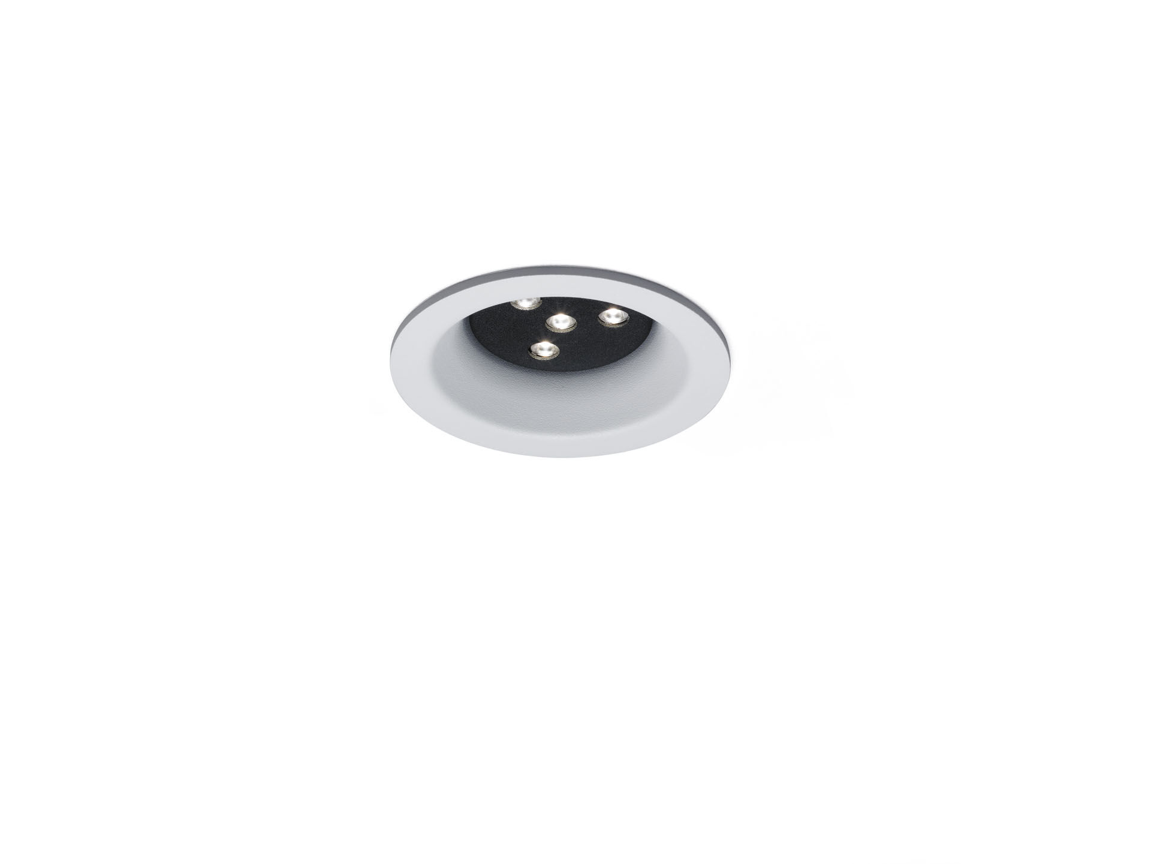
- Architectural spot light.
- Led+lens™ flare optics, polycarbonate (PC) lens, fixed wide-angle light distribution.
- White trim (RAL9003) and black (RAL9005) inner part; other colour combinations possible on demand.
- Dimensions: Ø 98 mm x 63 mm.
- Ceiling cut-out: Ø 81 mm.
- Luminous flux: 780 lm, Luminous efficacy: 104 lm/W.
- Power: 7.5 W, not dimmable.
- Frequency: 50-60Hz AC.
- Voltage: 110-240V.
- Electrical isolation class: class I.
- LED with very good light maintenance; at 50000 hrs the luminaire retains 98% of it's initial flux (Tq=25°C).
- Correlated colour temperature: 4000 K, Colour rendering ra: 80.
- Standard deviation colour matching satisfy 3 SDCM.
- Injection-moulded aluminium housing, .
- IP protection level: IP20.
- 5 years warranty on luminaire and driver.
- Certifications: CE.
- Luminaire with halogen free leads.
- The luminaire has been developed and produced according to standard EN60598-1 in a company that is ISO9001 and ISO14001 certified.

