FLARE-21/LEDW10S

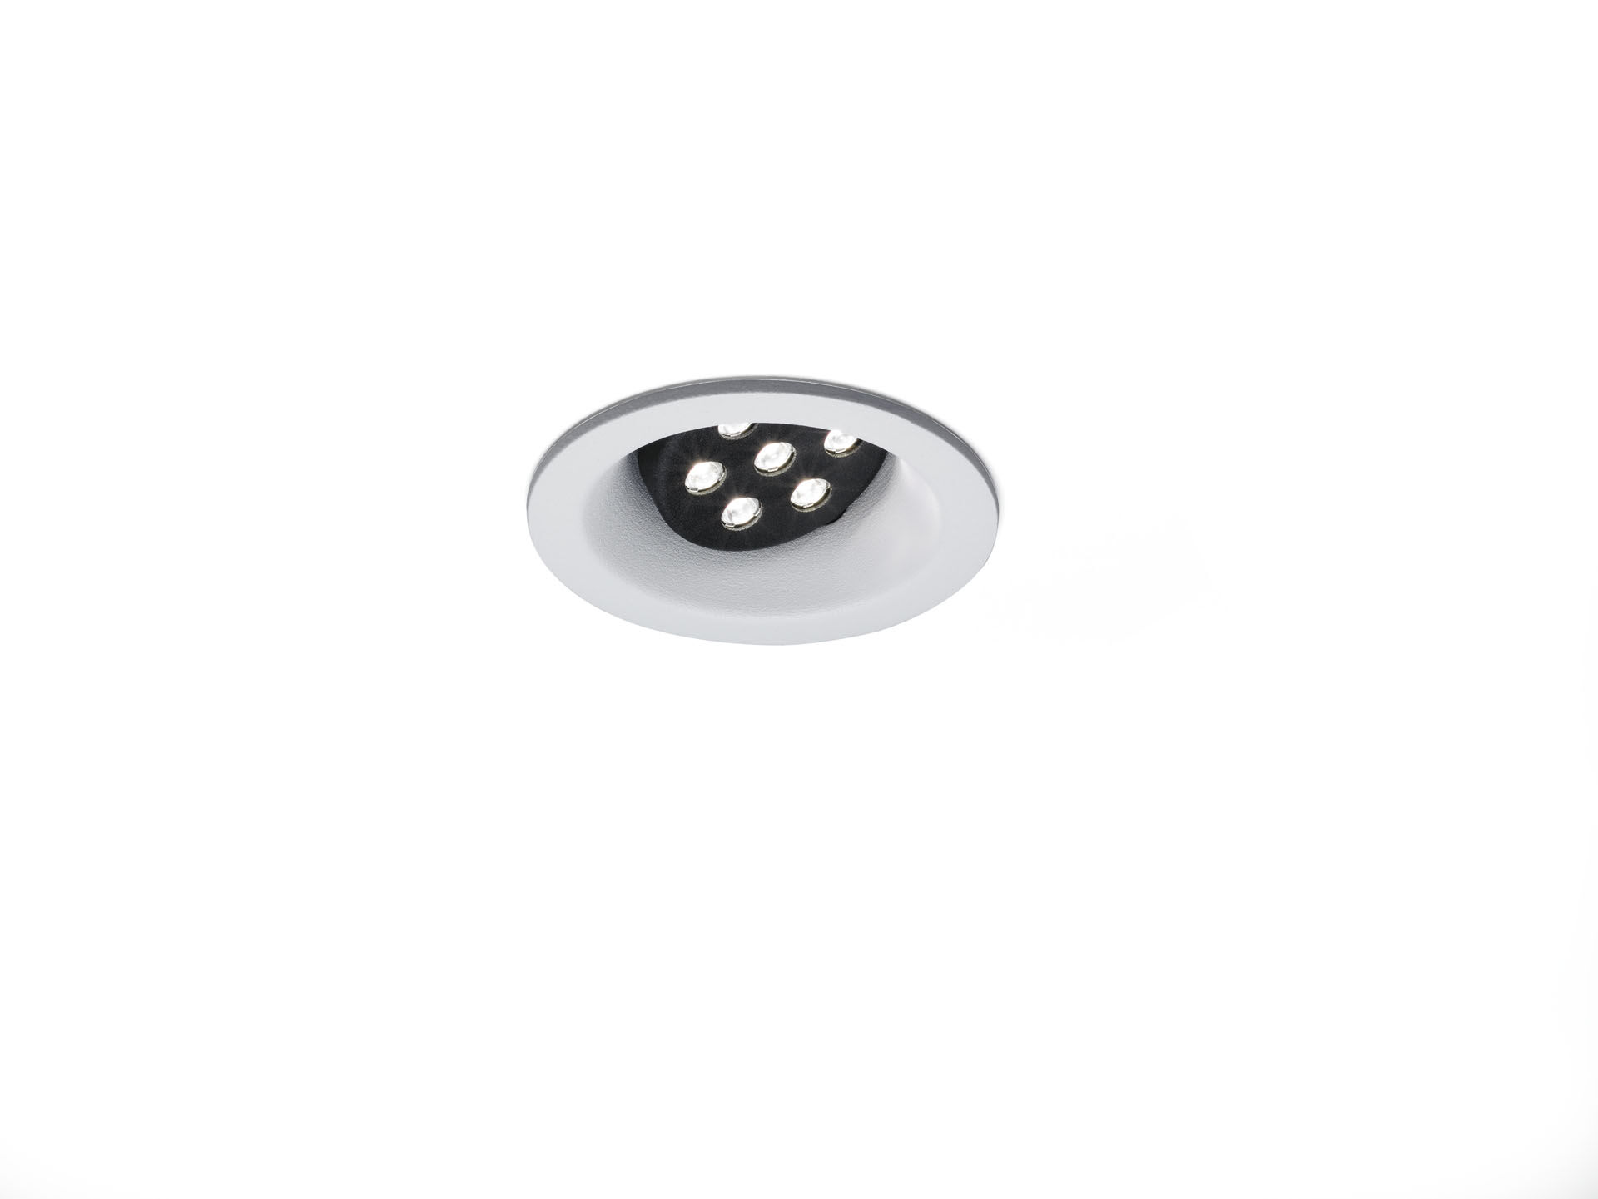
- Architectural spot light.
- Led+lens™ flare optics, polycarbonate (PC) lens, directional medium wide-angle light distribution.
- White trim (RAL9003) and black (RAL9005) inner part; other colour combinations possible on demand.
- Dimensions: Ø 98 mm x 93 mm.
- Individual round, Ceiling cut-out: Ø 86 mm.
- Luminous flux: 905 lm, Luminous efficacy: 107 lm/W.
- Power: 8.4 W, not dimmable.
- Frequency: 50/60Hz AC.
- Voltage: 220-240V.
- Electrical isolation class: class I.
- LED with very good light maintenance; at 50000 hrs the luminaire retains 97% of it's initial flux (Tq=25°C).
- Correlated colour temperature: 3000 K, Colour rendering ra: 80.
- Colour consistency (McAdam ellipse): ≤ 3 SDCM.
- Photobiological safety IEC/TR 62778: RG1.
- Injection-moulded aluminium housing, RAL9003 - white.
- IP protection level: IP20.
- Replaceable (LED only) light source by a professional. Replaceable control gear by a professional.
- 5 years warranty on luminaire and driver.
- Certifications: CE.
- Luminaire with halogen free leads.
- The luminaire has been developed and produced according to standard EN60598-1 in a company that is ISO9001 and ISO14001 certified.

