K11/3N-230C3

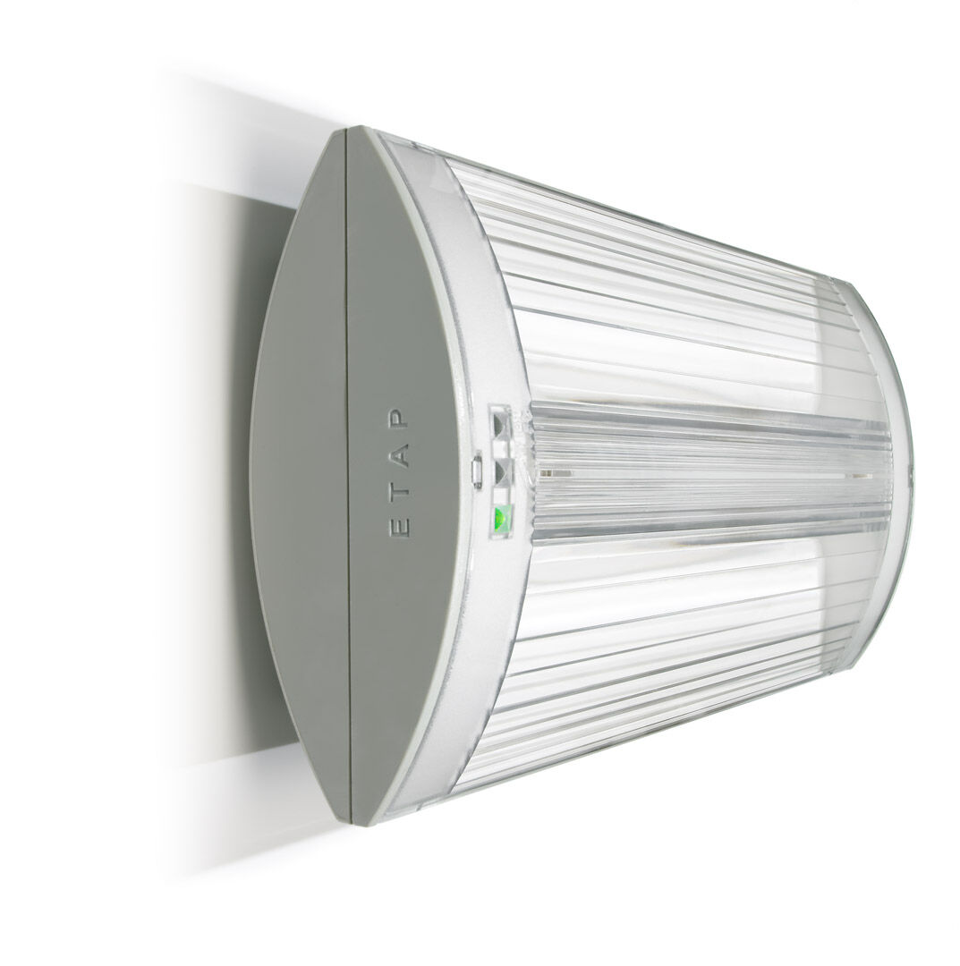
- Emergency luminaire for escape route lighting. Surface mounted.
- For central supply.
- Dimensions: 304 mm x 155 mm x 73 mm.
- Screwless opening, automatic electrical connection (up to 2.5 mm²), optional accessories for recessed mounting.
- Line-shaped light distribution, optimized for 1 lux along the escape route axis.
- Lumen output in emergency mode: 320 lm.
- Power consumption in standby: 5.1 W.
- Interdistance anti-panic: at a mounting height of 2.8 m, the illumination on the floor is 0.5 lux with an interdistance ("b") of 20.9 m. At a mounting height of 2.8 m, the illumination on the floor is 1 lux with an interdistance ("b") of 14.6 m.
- Voltage: 220-230V.
- Contains addressable MSÜ3 communication module, for use with a central battery system.
- Electrical insulation class: class II.
- Photobiological safety IEC/TR 62778: RG0.
- Impact-resistant polycarbonate housing, RAL9018 - papyrus white.
- IP protection level: IP42.
- IK protection level: IK04.
- Ambient temperature: -10°C - 35°C.
- Glowwire: 850°C.
- 5 years warranty on luminaire, light source, driver and battery (for autonomous luminaires).
- Certifications: CE, ENEC.
- The luminaire has been developed and produced according to standard EN60598-1 in a company that is ISO9001 and ISO14001 certified.

