K112/6

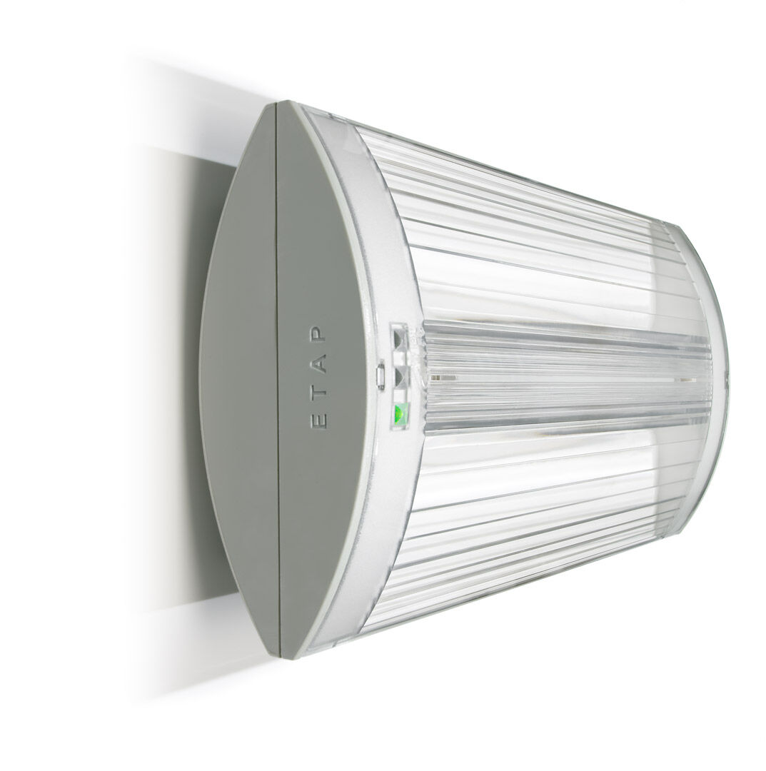
- Emergency luminaire for escape route lighting. Surface mounted.
- Autonomous luminaire (contains battery).
- Dimensions: 304 mm x 155 mm x 73 mm.
- Screwless opening, automatic electrical connection (up to 2.5 mm²), optional accessories for recessed mounting.
- Concentrated light distribution, optimized for high mounting or staircase illumination.
- Lumen output in emergency mode: 575 lm.
- Power consumption in standby: 2.3 W.
- Inderdistance escape route: at a mounting height of 2.8 m, the illumination on the floor is 1 lux with an interdistance ("b") of 17.1 m.
- Interdistance anti-panic: at a mounting height of 2.8 m, the illumination on the floor is 0.5 lux with an interdistance ("b") of 20.9 m. At a mounting height of 2.8 m, the illumination on the floor is 1 lux with an interdistance ("b") of 14.6 m.
- Voltage: 220-230V.
- Battery: 4 x NiMh 1,2V 2,2Ah.
- Automatic functional test every week, duration test every 13 weeks, in accordance to EN 50172 and EN 62034.
- Maintained/non maintained mode selectable, preset for most common application.
- Electrical insulation class: class II.
- Photobiological safety IEC/TR 62778: RG0.
- Impact-resistant polycarbonate housing, RAL9018 - papyrus white.
- IP protection level: IP42.
- IK protection level: IK04.
- Ambient temperature: 5°C - 35°C.
- Glowwire: 850°C.
- 5 years warranty on luminaire, light source, driver and battery (for autonomous luminaires).
- Certifications: CE, ENEC.
- The luminaire has been developed and produced according to standard EN60598-1 in a company that is ISO9001 and ISO14001 certified.

