K14/3-230

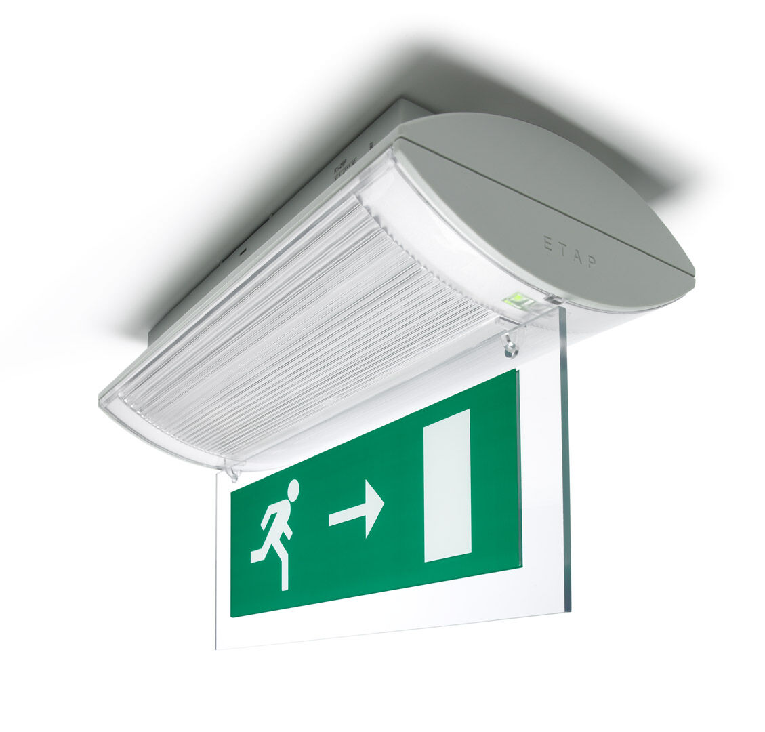
- Emergency luminaire for single or double sided signage. Surface mounted.
- For central supply.
- Dimensions: 304 mm x 155 mm x 73 mm.
- Screwless opening, automatic electrical connection (up to 2.5 mm²) to terminal block, optional accessories for recessed mounting
- Lumen output in emergency mode: 240 lm.
- Power consumption in standby: 4.2 W.
- Voltage: 220-230V.
- The perception distance of the pictogram is 26 m.
- For use with central battery system on 230 V AC/DC.
- Maintained mode of operation.
- Electrical insulation class: class II.
- Photobiological safety IEC/TR 62778: RG0.
- Impact-resistant polycarbonate housing, RAL9018 - papyrus white.
- IP protection level: IP42.
- IK protection level: IK04.
- Ambient temperature: -20°C - 35°C.
- Glowwire: 850°C.
- 5 years warranty on luminaire, light source, driver and battery (for autonomous luminaires).
- Certifications: CE, ENEC.
- The luminaire has been developed and produced according to standard EN60598-1 in a company that is ISO9001 and ISO14001 certified.

