K1M12O

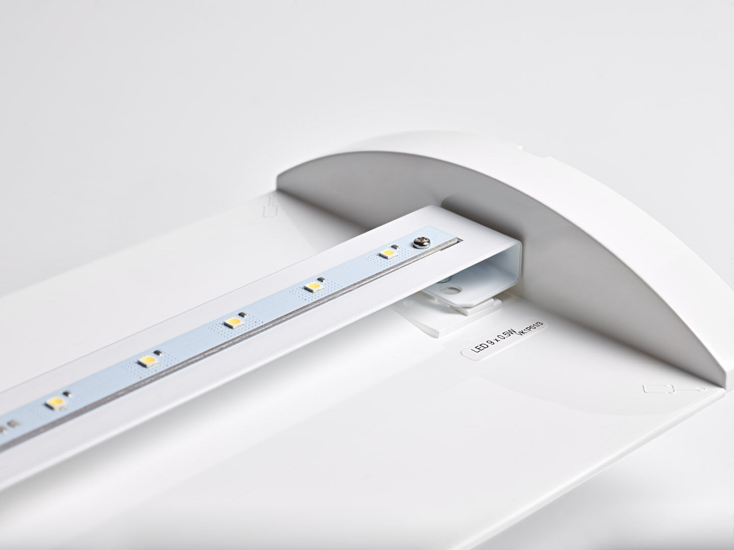
- Renovation module to led for ETAP K1 and K2 fluo emergency lighting
- Autonomous luminaire (contains battery).
- Dimensions: .
- Plug-and-play, screwless replacement of the interior, exterior housing and wiring are kept as-is.
- Lumen output in emergency mode: 320 lm.
- Power consumption in standby: 2.3 W.
- Voltage: 220-230V.
- Autonomy: 60 minutes. The luminaire contains lamp data, battery date and type as required according to EN 60598-2.22.
- Battery: 4 x NiMh 1,2V 1,1Ah.
- Automatic functional test every week, duration test every 13 weeks, in accordance to EN 50172 and EN 62034.
- Maintained/non maintained mode selectable, preset for most common application.
- Electrical insulation class: class II.
- Photobiological safety IEC/TR 62778: RG0.
- .
- Glowwire: 850°C.
- 5 years warranty on luminaire, light source, driver and battery (for autonomous luminaires).
- Certifications: CE.
- The luminaire has been developed and produced according to standard EN60598-1 in a company that is ISO9001 and ISO14001 certified.

