K1R113/3

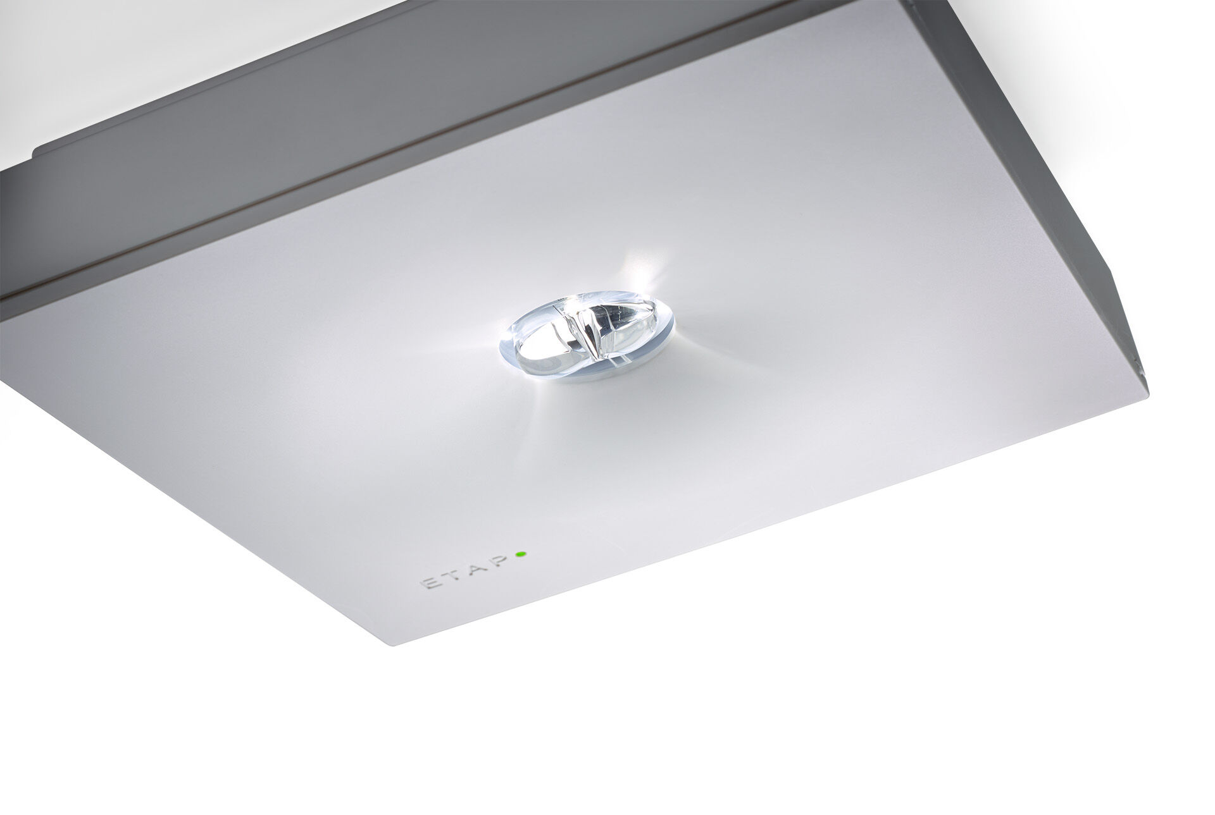
- Square emergency luminaire for escape route lighting. Surface mounted.
- Autonomous luminaire (contains battery).
- Dimensions: 152 mm x 152 mm x 38 mm.
- Polycarbonate housing with sunk optics and flush aspect, screwless opening, automatic electrical connection, screwless wire terminals (up to 2.5 mm²), optional accessories for recessed mounting, four break-out ports Ø13mm.
- Line-shaped light distribution, optimized for 1 lux along the escape route axis.
- Lumen output in emergency mode: 280 lm.
- Power consumption in standby: 0.9 W.
- Inderdistance escape route: at a mounting height of 2.8 m, the illumination on the floor is 1 lux with an interdistance ("b") of 20.7 m.
- Voltage: 220-230V.
- Autonomy: 60 minutes. The luminaire contains lamp data, battery date and type as required according to EN 60598-2.22.
- Battery: 4 x NiMh 1,2V 1,1Ah. Battery lifetime: 8 years.
- Automatic functional test every week, duration every test 13 weeks, in accordance to EN 50172 and EN 62034. Monitoring and control via ESM software for central maintenance. Polarity independent connection via two wire BUS communication.
- Maintained/non maintained mode selectable, preset for most common application.
- Electrical insulation class: class II.
- Photobiological safety IEC/TR 62778: RG1.
- Impact-resistant polycarbonate housing, RAL9003 - signal white.
- IP protection level: IP42.
- IK protection level: IK04.
- Ambient temperature: 5°C - 35°C.
- Glowwire: 850°C.
- 5 years warranty on luminaire, light source, driver and battery (for autonomous luminaires).
- Certifications: CE, ENEC.
- The luminaire has been developed and produced according to standard EN60598-1 in a company that is ISO9001 and ISO14001 certified.

