K1R143/1L3S2

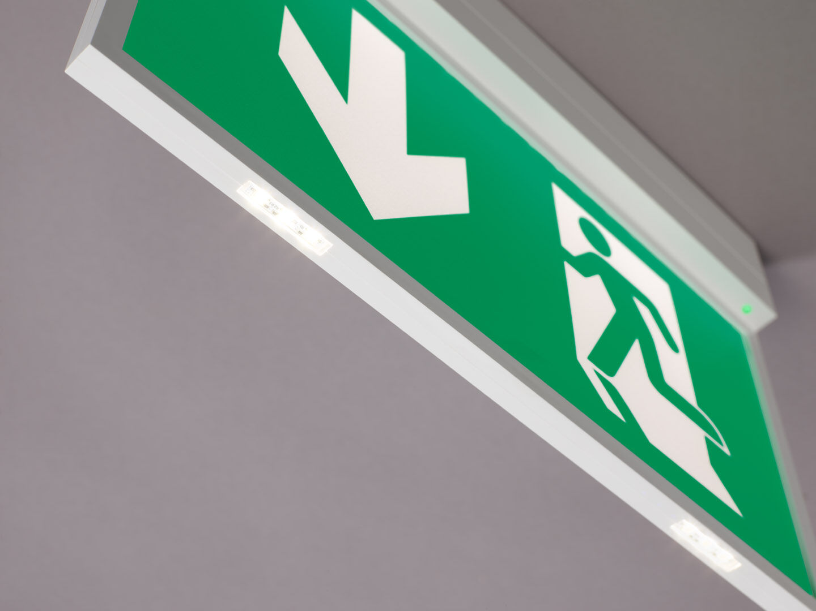
- Emergency luminaire for single- or double-sided signage. Surface mounted.
- Autonomous luminaire (contains battery).
- Dimensions: 315 mm x 33 mm x 219 mm.
- Screwless opening, automatic electrical connection, screwless wire terminals (up to 2.5 mm²), suited for ceiling and wall mounting, optional accessories for recessed or suspended mounting. The K1 pictogram can be fitted with additional LEDs at the bottom of the pictogram (L3 option). In the event of a power outage, the discreetly integrated LEDs provide additional escape route lighting, anti-panic lighting or illuminate the fire extinguishers.
- Lumen output in emergency mode: 210 lm.
- Power consumption in standby: 2.9 W.
- Voltage: 220-230V.
- Autonomy: 180 minutes. The luminaire contains lamp data, battery date and type as required according to EN 60598-2.22.
- Battery: 4 x NiMh 1,2V 2,2Ah. Battery lifetime: 10 years.
- Automatic functional test every week, duration every test 13 weeks, in accordance to EN 50172 and EN 62034. Monitoring and control via ESM software for central maintenance. Polarity independent connection via two wire BUS communication.
- Maintained/non maintained mode selectable, preset for most common application.
- Electrical insulation class: class II.
- Photobiological safety IEC/TR 62778: RG0.
- Impact-resistant polycarbonate housing, RAL9003 - signal white.
- IP protection level: IP42.
- IK protection level: IK04.
- Ambient temperature: 5°C - 35°C.
- Glowwire: 850°C.
- 5 years warranty on luminaire, light source, driver and battery (for autonomous luminaires).
- Certifications: CE, ENEC.
- The luminaire has been developed and produced according to standard EN60598-1 in a company that is ISO9001 and ISO14001 certified.

