K1R15/3-230L2

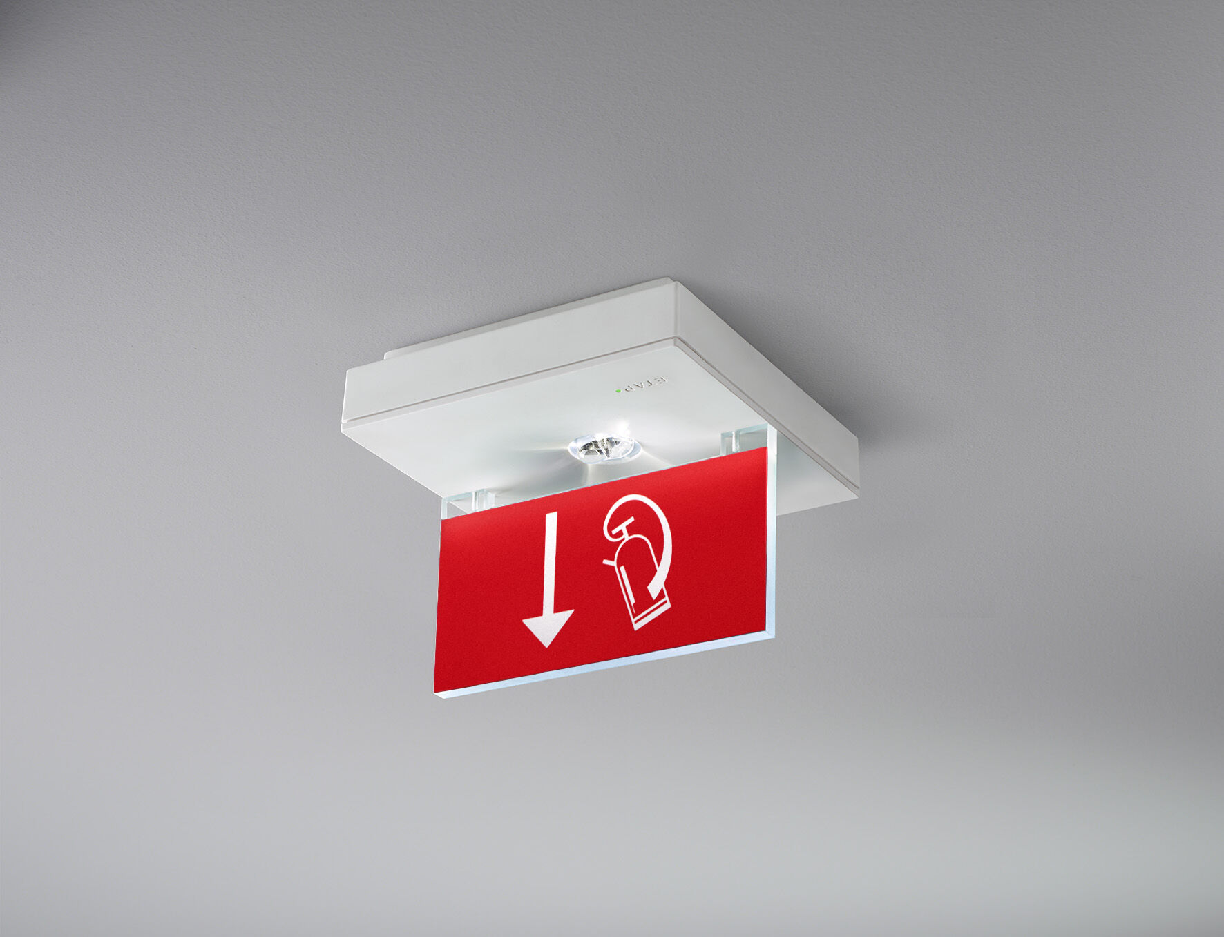
- Square emergency luminaire for single- or double-sided signage. Surface mounted.
- For central supply.
- Dimensions: 152 mm x 152 mm x 38 mm.
- Acrylic signage plate 76 mm with illuminated sides, screwless opening, automatic electrical connection, screwless wire terminals (up to 2.5 mm²), optional accessories for recessed mounting, four break-out ports Ø13mm. High lighting output for the vertical illumination of fire-fighting equipment (5 lux).
- Lumen output in emergency mode: 150 lm.
- Power consumption in standby: 1.2 W.
- Voltage: 220-230V.
- The perception distance of the pictogram is 15 m.
- For use with central battery system on 230 V AC/DC.
- Maintained mode of operation.
- Electrical insulation class: class II.
- Photobiological safety IEC/TR 62778: >1m RG1 ; <1m RG2.
- Impact-resistant polycarbonate housing, RAL9003 - signal white.
- IP protection level: IP42.
- IK protection level: IK04.
- Ambient temperature: -20°C - 35°C.
- Glowwire: 850°C.
- 5 years warranty on luminaire, light source, driver and battery (for autonomous luminaires).
- Certifications: CE, ENEC.
- The luminaire has been developed and produced according to standard EN60598-1 in a company that is ISO9001 and ISO14001 certified.

