K28/2P-230

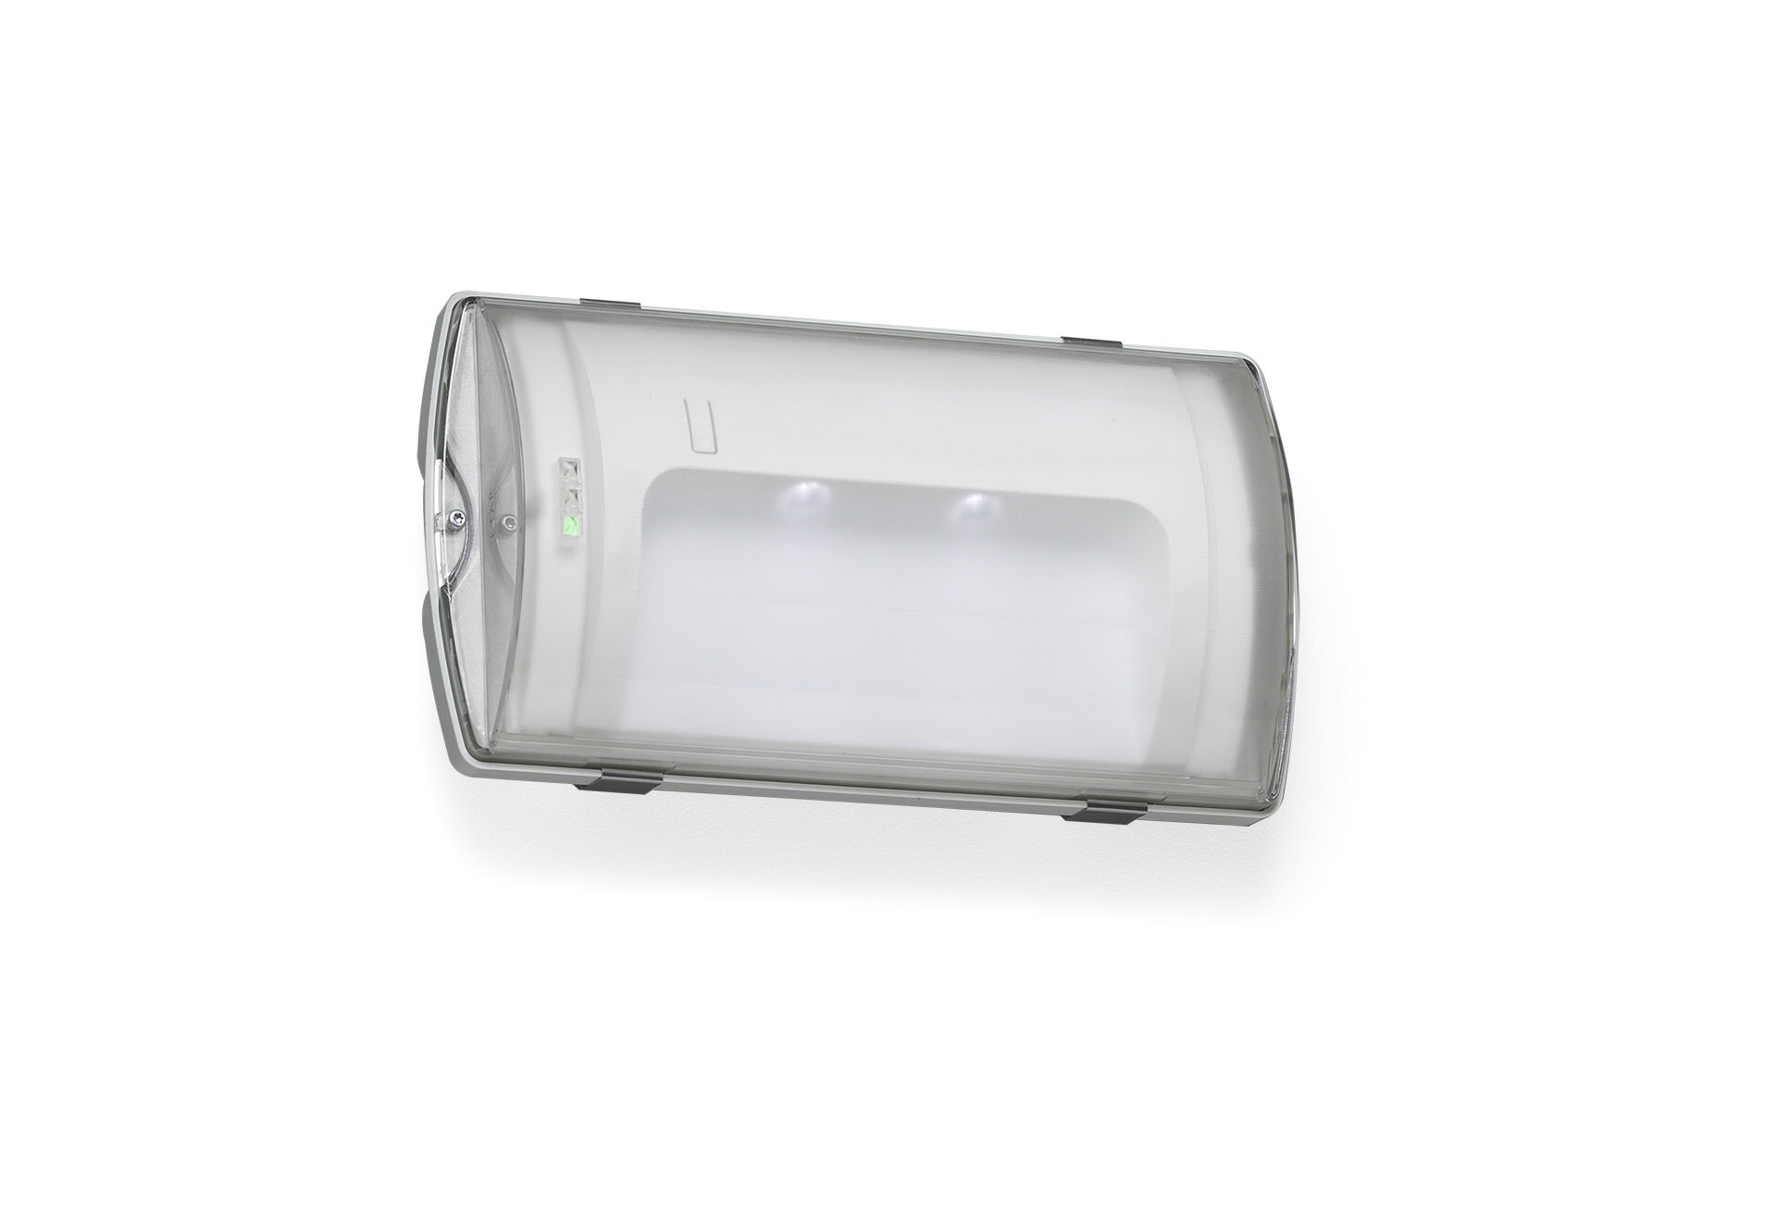
- IP65 emergency luminaire for final exit illumination. Surface mounted.
- For central supply.
- Dimensions: 359 mm x 180 mm x 100 mm.
- Mounted on two stainless steel clamps, automatic electrical connection, screwless wire terminals (up to 2.5 mm²), cable gland included, through-wiring possibility, optional accessories for recessed mounting. With battery heater, allowed ambient temperature -20°C to +35°C.
- Two leds facing towards floor, for 1 lux. Daylight sensor turns off permanent luminaire in daylight.
- Lumen output in emergency mode: 65 lm.
- Power consumption in standby: 3.3 W.
- Voltage: 220-230V.
- For use with central battery system on 230 V AC/DC.
- Maintained mode of operation.
- Electrical insulation class: class II.
- Photobiological safety IEC/TR 62778: RG0.
- Impact-resistant polycarbonate housing, RAL9018 - papyrus white.
- IP protection level: IP65.
- IK protection level: IK10.
- Ambient temperature: -20°C - 35°C.
- Glowwire: 850°C.
- 5 years warranty on luminaire, light source, driver and battery (for autonomous luminaires).
- Certifications: CE, ENEC.
- The luminaire has been developed and produced according to standard EN60598-1 in a company that is ISO9001 and ISO14001 certified.

