K282/2O-A

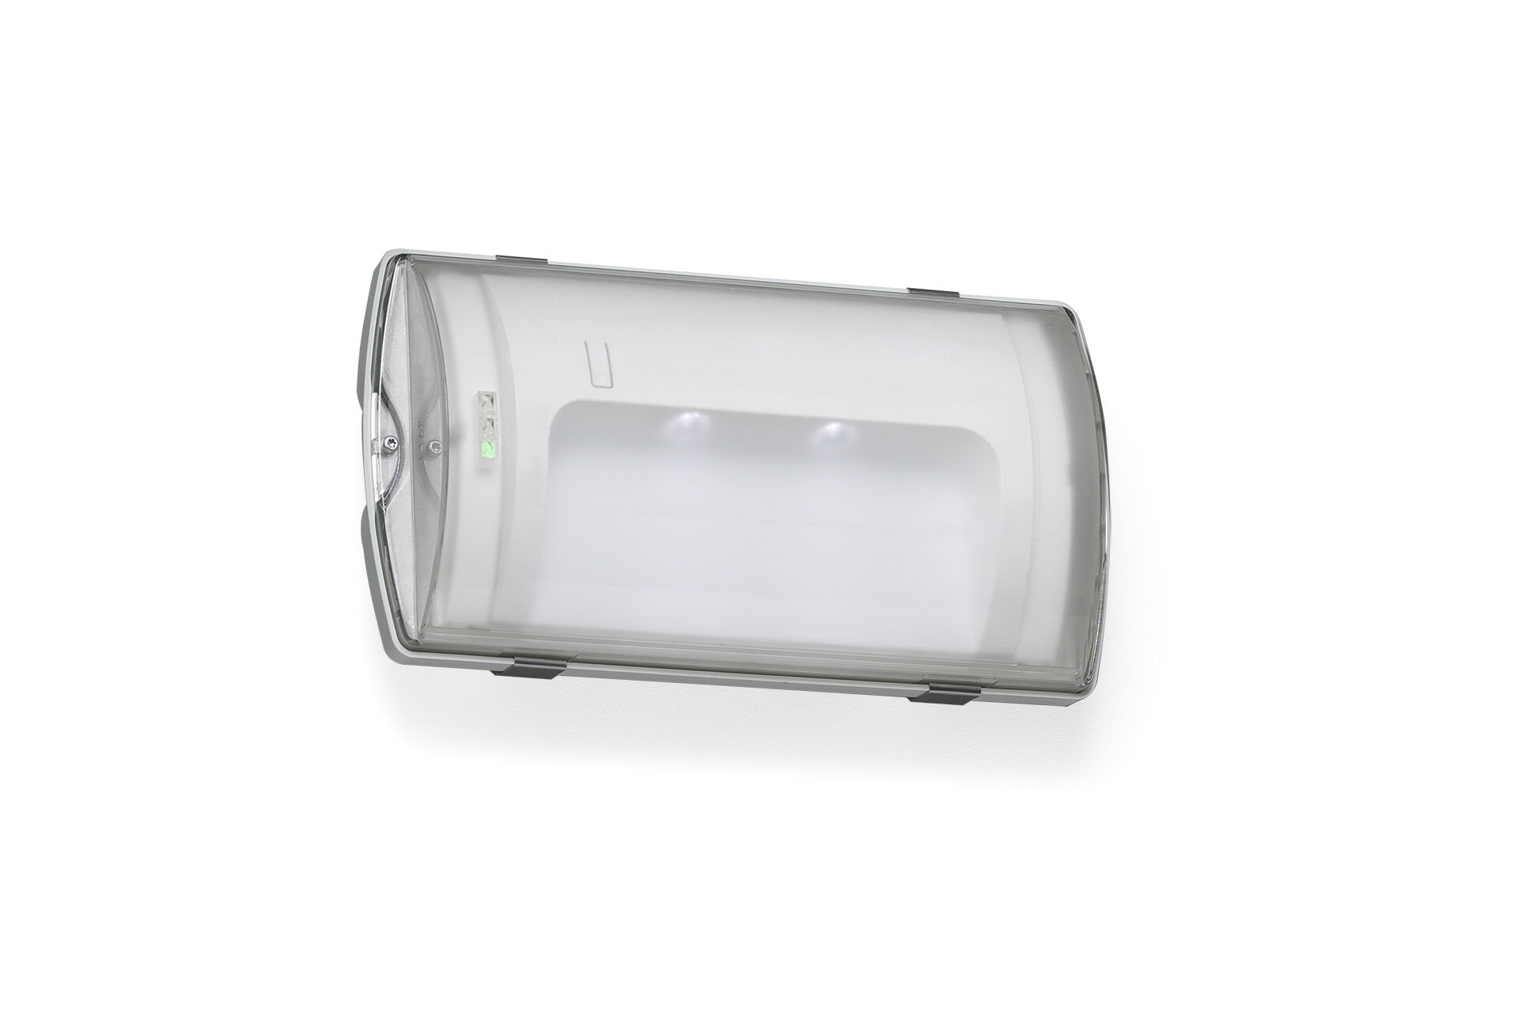
- IP65 emergency luminaire for final exit illumination. Surface mounted.
- Autonomous luminaire (contains battery).
- Dimensions: 359 mm x 180 mm x 100 mm.
- Mounted on two stainless steel clamps, automatic electrical connection, screwless wire terminals (up to 2.5 mm²), cable gland included, through-wiring possibility, optional accessories for recessed mounting. With battery heater, allowed ambient temperature -20°C to +35°C.
- Two leds facing towards floor, for 1 lux.
- Lumen output in emergency mode: 65 lm.
- Power consumption in standby: 2.0 W.
- Voltage: 220-230V.
- The perception distance of the pictogram is m.
- Autonomy: 90 minutes. The luminaire contains lamp data, battery date and type as required according to EN 60598-2.22.
- Battery: 4 x NiMh 1,2V 1,1Ah. Battery lifetime: 10 years.
- Automatic functional test every week, duration test every 13 weeks, in accordance to EN 50172 and EN 62034.
- Maintained/non maintained mode selectable, preset for most common application.
- Electrical insulation class: class II.
- Photobiological safety IEC/TR 62778: RG0.
- RAL9018 - papyrus white.
- IP protection level: IP65.
- IK protection level: IK10.
- Ambient temperature: -20°C - 35°C.
- Glowwire: 850°C.
- 5 years warranty on luminaire, light source, driver and battery (for autonomous luminaires).
- Certifications: CE, ENEC.
- The luminaire has been developed and produced according to standard EN60598-1 in a company that is ISO9001 and ISO14001 certified.

