K3M13S2

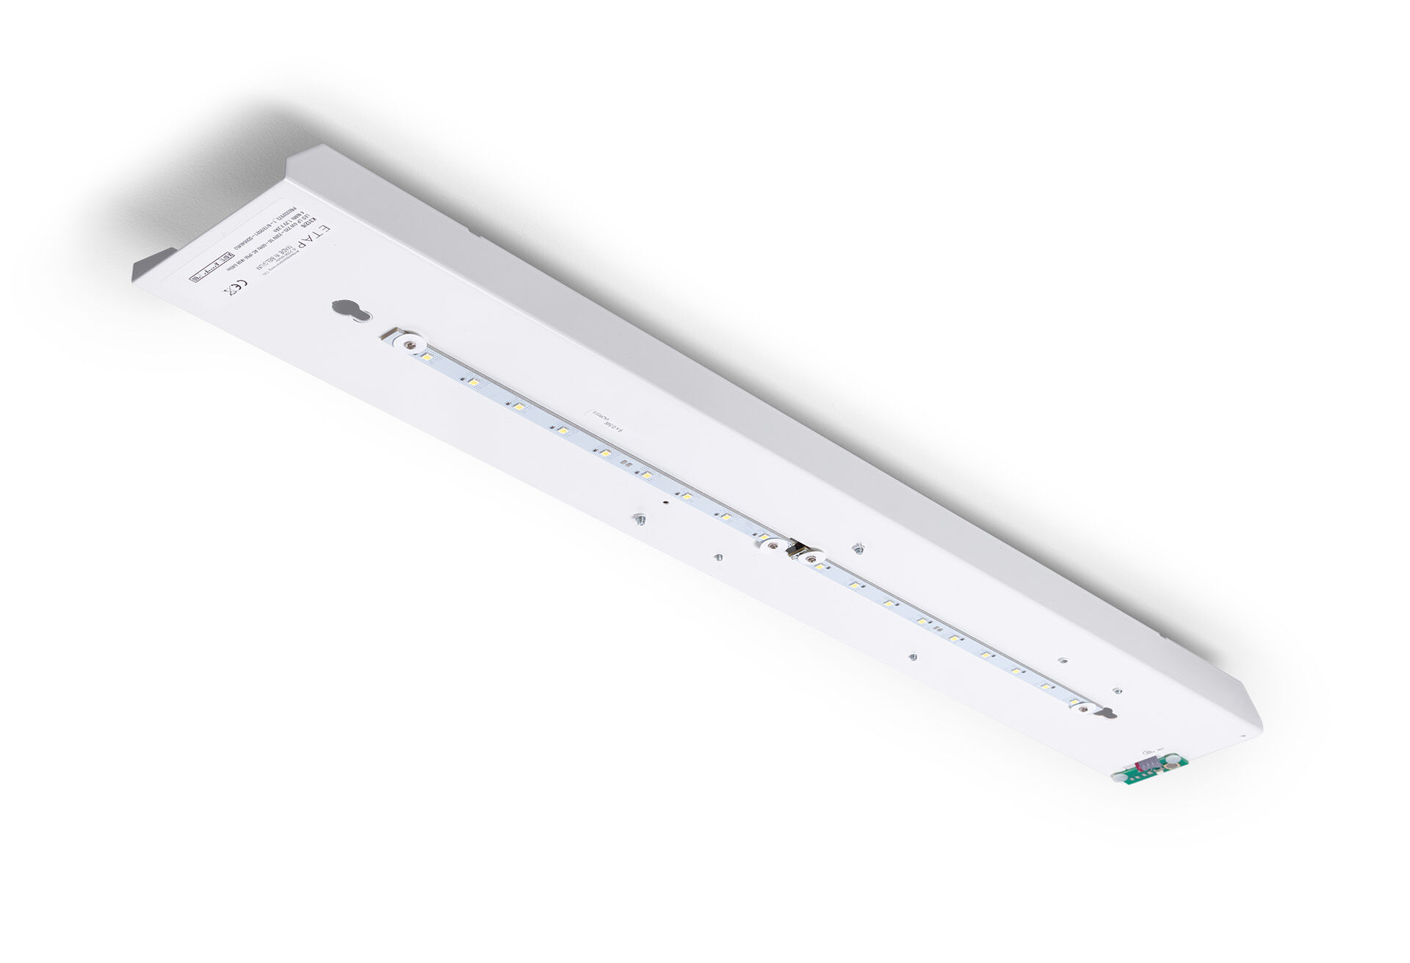
- Renovation module to led for ETAP K3 fluo emergency lighting
- Autonomous luminaire (contains battery).
- Dimensions: .
- Plug-and-play, screwless replacement of the interior. Exterior housing and wiring are kept as-is.
- Lumen output in emergency mode: 530 lm.
- Power consumption in standby: 1.0 W.
- Voltage: 220-230V.
- Autonomy: 180 minutes. The luminaire contains lamp data, battery date and type as required according to EN 60598-2.22.
- Battery: 4 x NiMh 1,2V 4Ah. Battery lifetime: 8 years.
- Automatic functional test every week, duration every test 13 weeks, in accordance to EN 50172 and EN 62034. Monitoring and control via ESM software for central maintenance. Polarity independent connection via two wire BUS communication.
- Maintained/non maintained mode selectable, preset for most common application.
- Electrical insulation class: class I.
- Photobiological safety IEC/TR 62778: RG0.
- .
- Glowwire: 850°C.
- 5 years warranty on luminaire, light source, driver and battery (for autonomous luminaires).
- Certifications: CE.
- The luminaire has been developed and produced according to standard EN60598-1 in a company that is ISO9001 and ISO14001 certified.

