K4A-R30-2M0-20-1L0

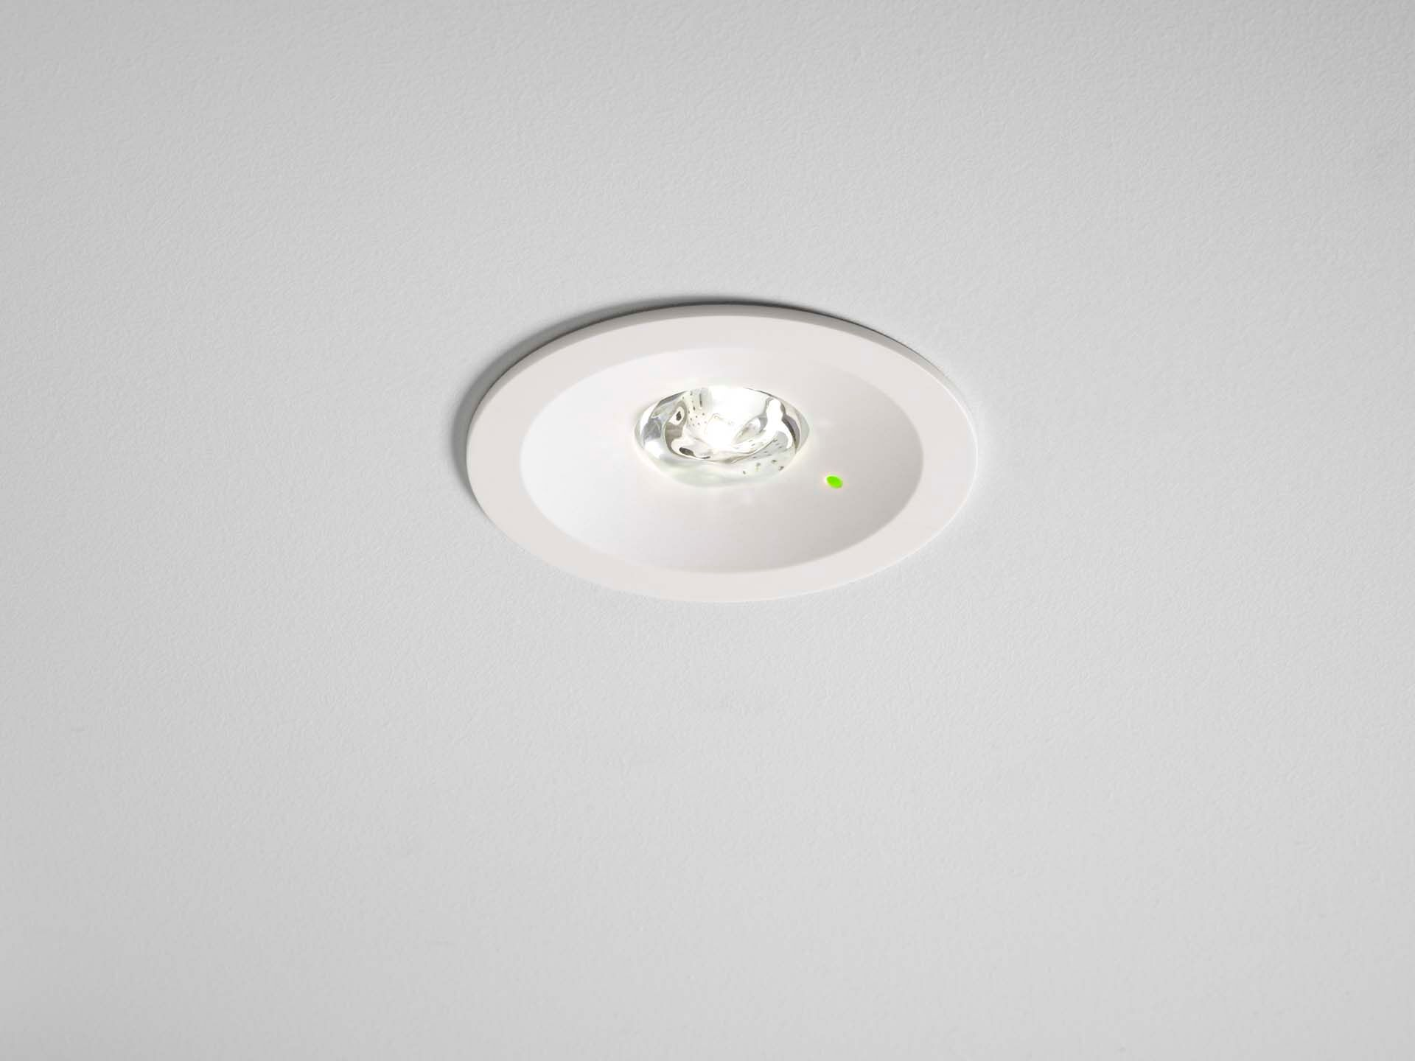
- Round emergency luminaire for anti-panic (open area) lighting. Recessed mounted.&nbsp;
- Autonomous luminaire (contains battery).
- Dimensions: Ø 80 mm x 50 mm.
- Polycarbonate housing with sunk optics and modern aspect. Spring mounted, electronics in separate transparant minimal-additives polycarbonate housing, screwless opening, screwless push-in wire terminals. Installation height 110 mm. Allows for in-and-out wiring with two cables up to 5G2,5mm², or with 4 cables if bus-wires are separate.
- Square light distribution, optimized to avoid dark spots.
- Lumen output in emergency mode: 210 lm.
- Power consumption in standby: 0.2 W.
- Voltage: 220-240V.
- Autonomy: 60 minutes. The luminaire contains lamp data, battery date and type as required according to EN 60598-2.22.
- Battery: 1 x LiFePO4 3,2V 1,5Ah.
- Automatic functional test every week, duration test every 13 weeks, in accordance to EN 50172 and EN 62034.
- Electrical insulation class: class II.
- Photobiological safety IEC/TR 62778: RG1.
- Impact-resistant polycarbonate housing, RAL9003 - white.
- IP protection level: IP42. IP protection level: IP20.
- IK protection level: IK04.
- Ambient temperature: 5°C - 35°C.
- Glowwire: 850°C.
- 5 years warranty on luminaire, light source, driver and battery (for autonomous luminaires).
- Certifications: CE.
- The luminaire has been developed and produced according to standard EN60598-1 in a company that is ISO9001 and ISO14001 certified.

