K9R02/3N-230

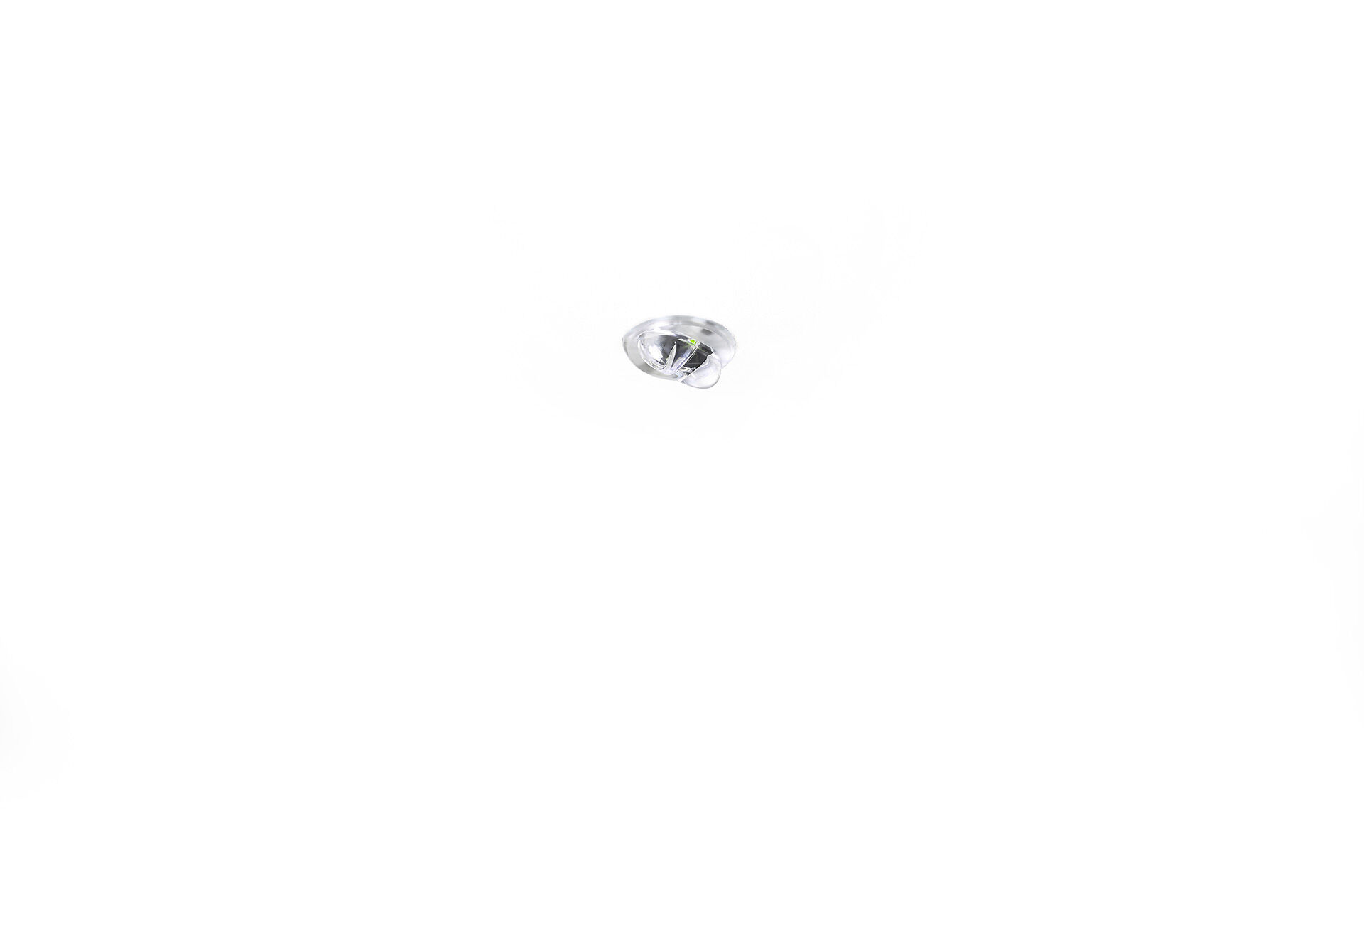
- Mini emergency module for anti-panic lighting. Recessed mounting.
- For central supply.
- Dimensions: Ø 30 mm x 32 mm.
- Discrete dimensions, with extruded aluminium heatsink and optional 5 mm trim, electronics in separate polycarbonate housing with screwless opening, automatic electrical connection, screwless wire terminals (up to 2.5 mm²).
- Square light distribution, optimized to avoid dark spots.
- Lumen output in emergency mode: 220 lm.
- Power consumption in standby: 3.4 W.
- Voltage: 220-230V.
- For use with central battery system on 230 V AC/DC.
- Electrical insulation class: class II.
- Photobiological safety IEC/TR 62778: RG1.
- Heat sink in extruded aluminium housing, RAL9003 - white.
- IP protection level: IP20.
- IK protection level: IK04.
- Ambient temperature: -20°C - 35°C.
- Glowwire: 850°C.
- 5 years warranty on luminaire, light source, driver and battery (for autonomous luminaires).
- Certifications: CE, ENEC.
- The luminaire has been developed and produced according to standard EN60598-1 in a company that is ISO9001 and ISO14001 certified.

