K9R11/3N-23-AX1-D800A25

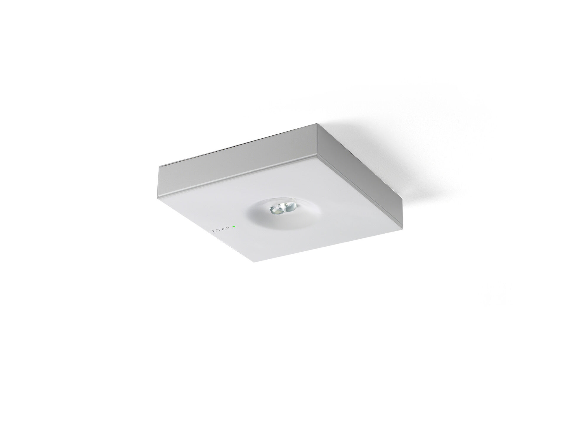
- Minimalistic design square emergency luminaire for escape route lighting. Surface mounted.
- For central supply.
- Dimensions: 152 mm x 152 mm x 32 mm.
- Powder coated zamak cover with sunk optics and flush aspect, polycarbonate base, screwless opening, automatic electrical connection, screwless wire terminals (up to 2.5 mm²).
- Line-shaped light distribution, optimized for 1 lux along the escape route axis.
- Lumen output in emergency mode: 280 lm.
- Power consumption in standby: 3.9 W.
- Inderdistance escape route: at a mounting height of 2.8 m, the illumination on the floor is 1 lux with an interdistance ("b") of 20.7 m.
- Voltage: 220-230V.
- For use with central battery system on 230 V AC/DC.
- Electrical insulation class: class II.
- Powder coated die-cast zamak housing, RAL9003 - white (textured).
- IP protection level: IP42.
- IK protection level: IK04.
- Ambient temperature: -20°C - 35°C.
- Glowwire: 850°C.
- 5 years warranty on luminaire, light source, driver and battery (for autonomous luminaires).
- Certifications: CE, ENEC.
- The luminaire has been developed and produced according to standard EN60598-1 in a company that is ISO9001 and ISO14001 certified.

