K9R212/3-AX1-D800A25

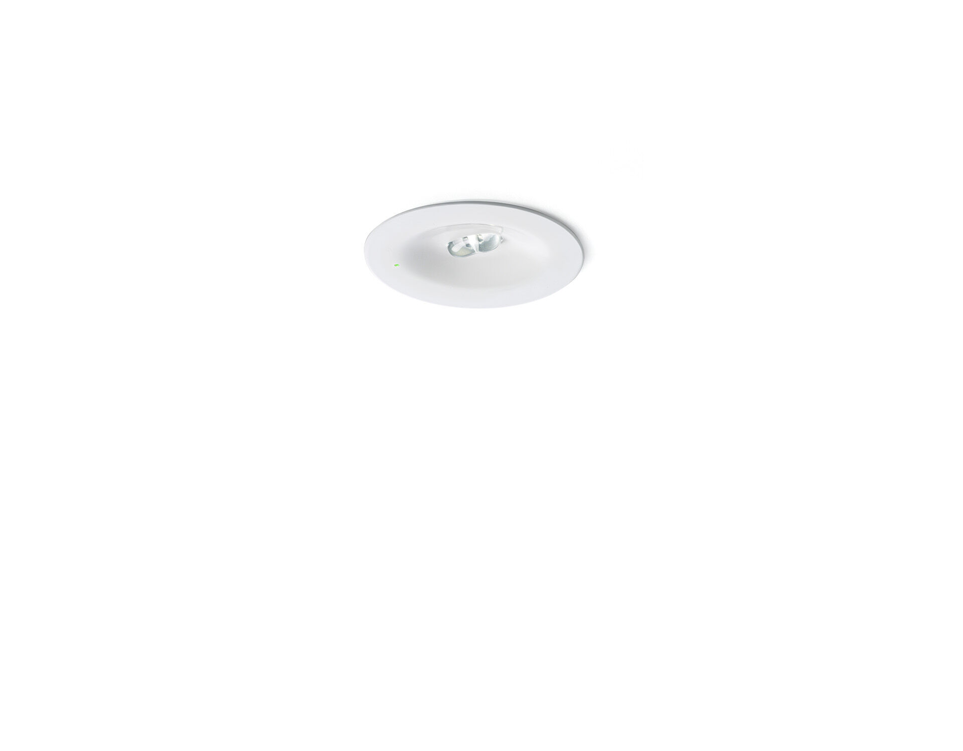
- Minimalistic design round emergency luminaire for escape route lighting. Recessed mounted. C0:C90 value of this luminaire: D800:A25.
- Autonomous luminaire (contains battery).
- Dimensions: Ø 90 mm x 37 mm.
- Powder coated zamak housing with sunk optics and flush aspect with spring mounting, electronics in separate polycarbonate housing with screwless opening, automatic electrical connection, screwless wire terminals (up to 2.5 mm²).
- Line-shaped light distribution, optimized for 1 lux along the escape route axis.
- Lumen output in emergency mode: 280 lm.
- Power consumption in standby: 0.9 W.
- Inderdistance escape route: at a mounting height of 2.8 m, the illumination on the floor is 1 lux with an interdistance ("b") of 20.7 m.
- Voltage: 220-230V.
- Autonomy: 90 minutes. The luminaire contains lamp data, battery date and type as required according to EN 60598-2.22.
- Battery: 4 x NiMh 1,2V 2,2Ah. Battery lifetime: 8 years.
- Automatic functional test every week, duration test every 13 weeks, in accordance to EN 50172 and EN 62034.
- Maintained/non maintained mode selectable, preset for most common application.
- Electrical insulation class: class II.
- Photobiological safety IEC/TR 62778: RG1.
- Powder coated die-cast zamak housing, RAL9003 - white.
- IP protection level: IP42.
- IK protection level: IK04.
- Ambient temperature: 5°C - 35°C.
- Glowwire: 850°C.
- 5 years warranty on luminaire, light source, driver and battery (for autonomous luminaires).
- Certifications: CE, ENEC.
- The luminaire has been developed and produced according to standard EN60598-1 in a company that is ISO9001 and ISO14001 certified.

