K9R22/3N-230X1C3

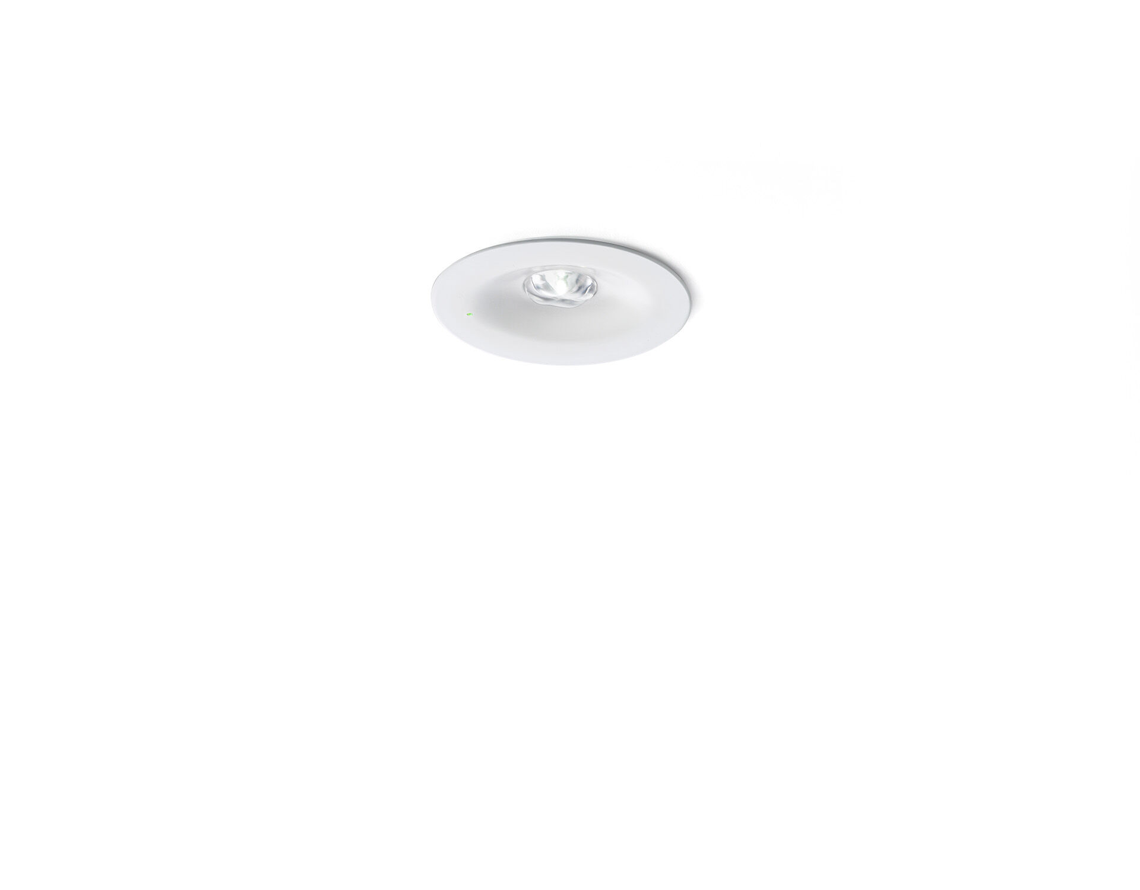
- Minimalistic design round emergency luminaire for anti-panic lighting. Recessed mounted.
- For central supply.
- Dimensions: Ø 90 mm x 37 mm.
- Powder coated zamak housing with sunk optics and flush aspect with spring mounting, electronics in separate polycarbonate housing with screwless opening, automatic electrical connection, screwless wire terminals (up to 2.5 mm²).
- Square light distribution, optimized to avoid dark spots.
- Lumen output in emergency mode: 300 lm.
- Power consumption in standby: 4.8 W.
- Interdistance anti-panic: at a mounting height of 2.8 m, the illumination on the floor is 0.5 lux with an interdistance ("b") of 12.0 m. At a mounting height of 2.8 m, the illumination on the floor is 1 lux with an interdistance ("b") of 12.0 m.
- Voltage: 220-230V.
- Contains addressable MSÜ3 communication module, for use with a central battery system.
- Electrical insulation class: class II.
- Powder coated die-cast zamak housing, RAL9003 - white.
- IP protection level: IP42.
- IK protection level: IK04.
- Ambient temperature: -10°C - 35°C.
- Glowwire: 850°C.
- 5 years warranty on luminaire, light source, driver and battery (for autonomous luminaires).
- Certifications: CE, ENEC.
- The luminaire has been developed and produced according to standard EN60598-1 in a company that is ISO9001 and ISO14001 certified.

