K9R43/1-230X1C3

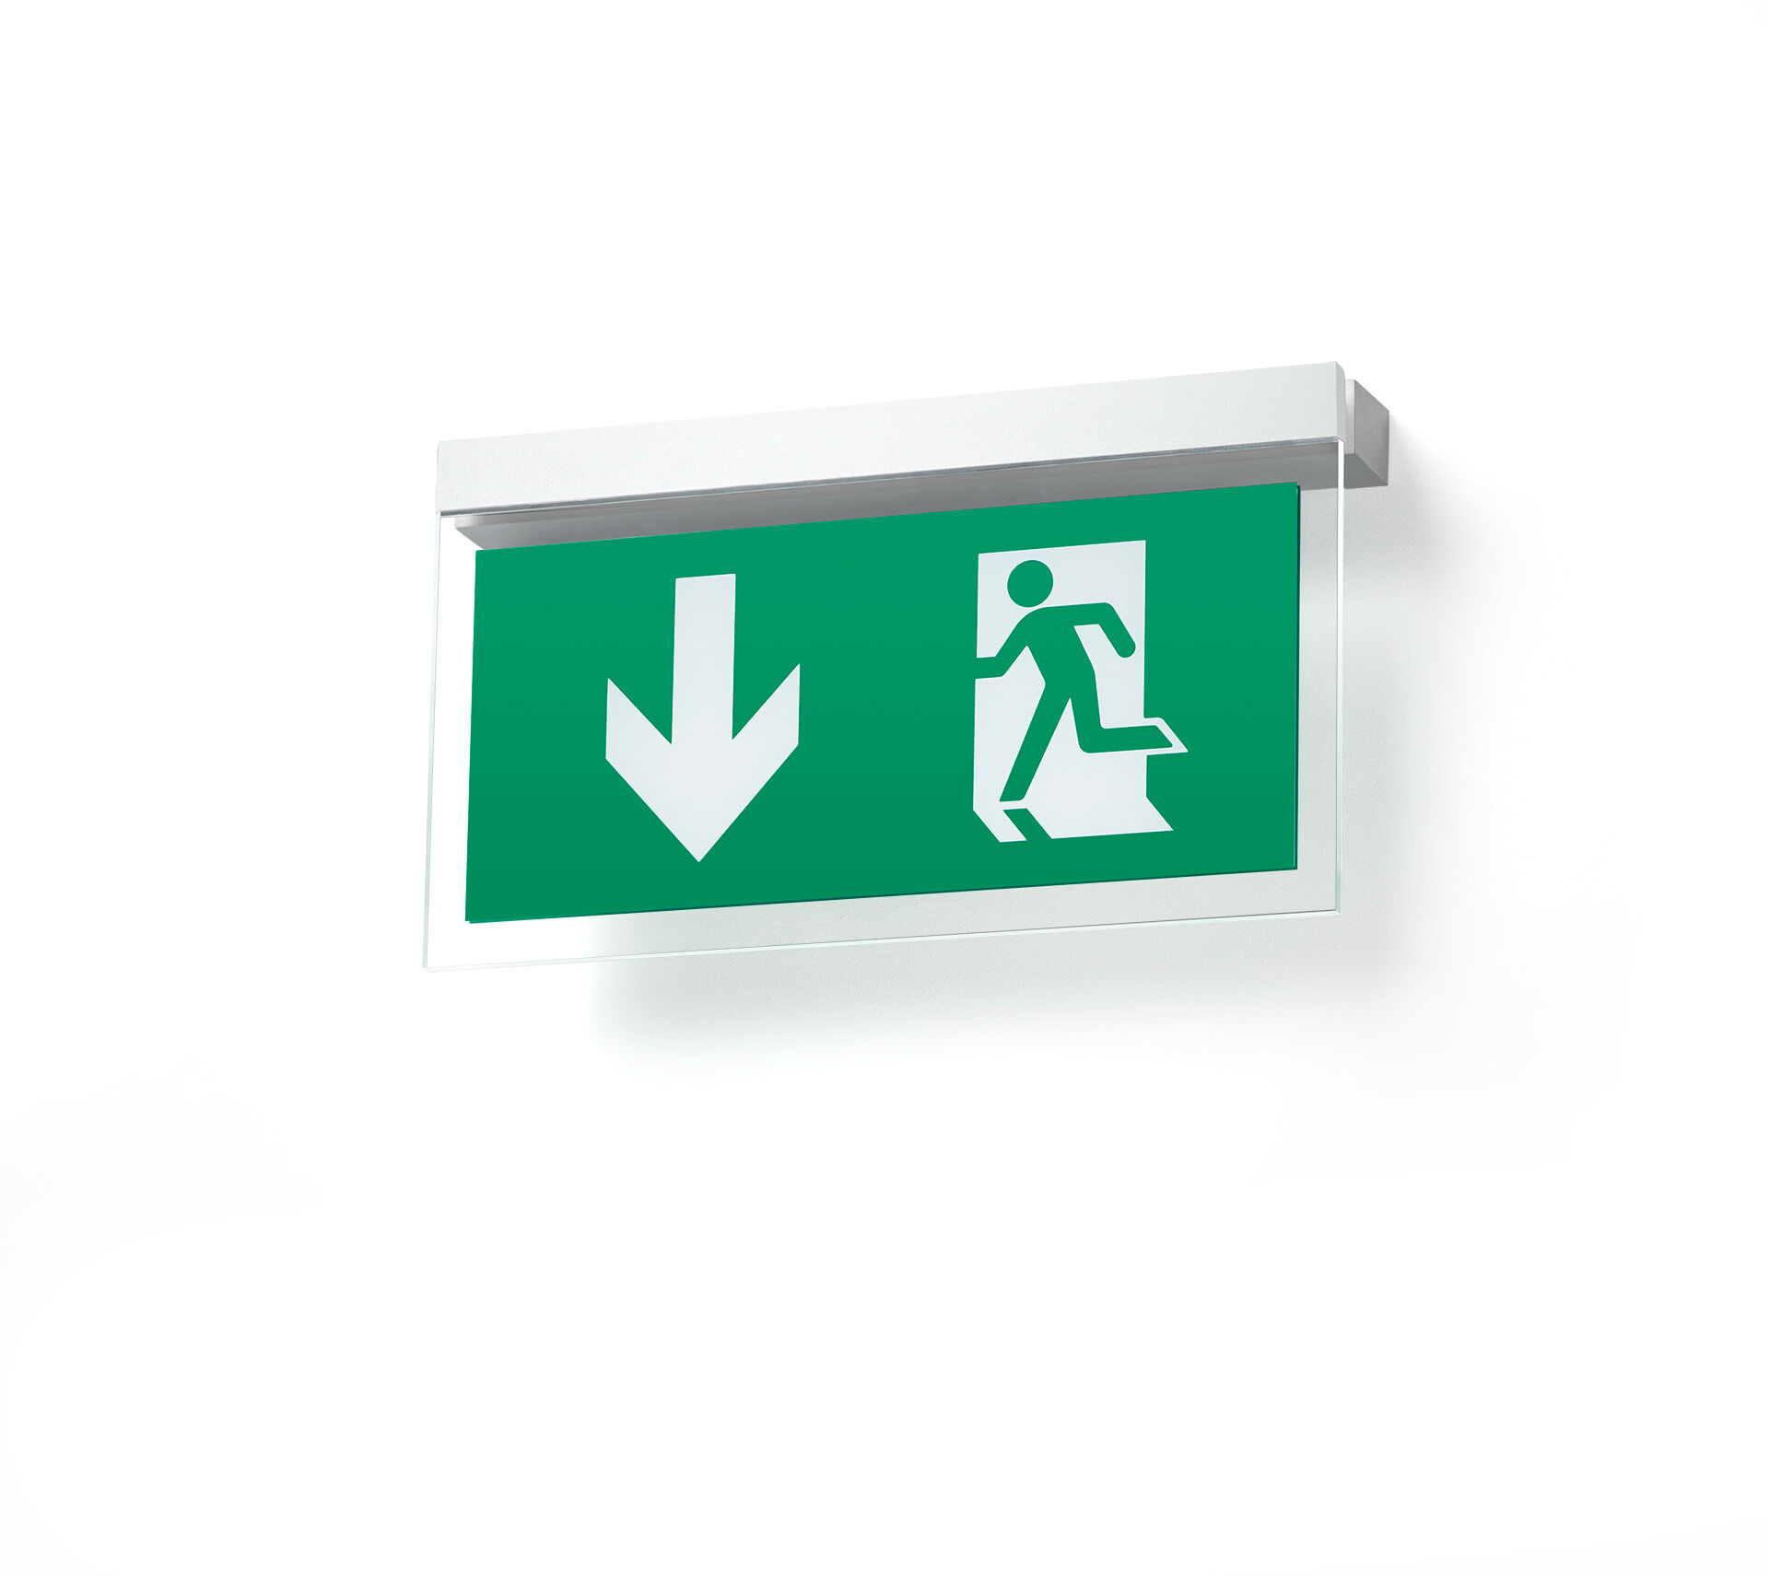
- Minimalistic design emergency luminaire for single sided signage. Parallel to wall mounting.
- For central supply.
- Dimensions: 324 mm x 58 mm x 26 mm.
- Powder coated zamak housing, screwless opening, automatic electrical connection, screwless wire terminals (up to 2.5 mm²). Signage plate with illuminated borders.
- Lumen output in emergency mode: 100 lm.
- Power consumption in standby: 4.6 W.
- Voltage: 220-230V.
- The perception distance of the pictogram is 26 m.
- Contains addressable MSÜ3 communication module, for use with a central battery system.
- Maintained mode of operation.
- Electrical insulation class: class II.
- Photobiological safety IEC/TR 62778: RG0.
- Powder coated die-cast zamak housing, RAL9003 - white.
- IP protection level: IP40.
- IK protection level: IK04.
- Ambient temperature: -10°C - 35°C.
- Glowwire: 850°C.
- 5 years warranty on luminaire, light source, driver and battery (for autonomous luminaires).
- Certifications: CE, ENEC.
- The luminaire has been developed and produced according to standard EN60598-1 in a company that is ISO9001 and ISO14001 certified.

