KE21/6N-230-ATEX1

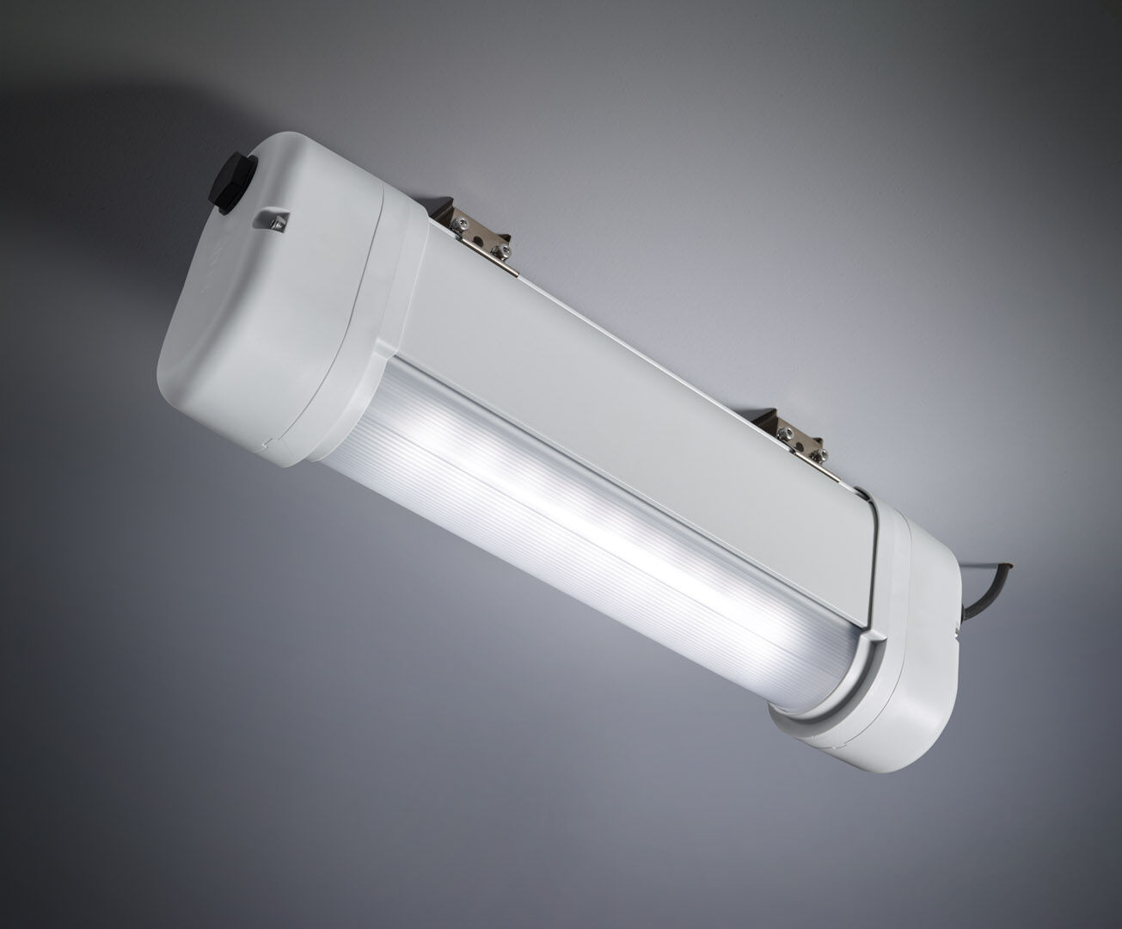
- Emergency luminaire for anti-panic lighting in ATEX environments.
- For central supply.
- Dimensions: 423 mm x 80 mm x 135 mm.
- Aluminum housing, PBT endcaps, sealed polycarbonate optics. Mounted on two stainless steel springs.
- Line-shaped light distribution, optimized for 1 lux along the escape route axis.
- Lumen output in emergency mode: 550 lm.
- Power consumption in standby: 7.5 W.
- Inderdistance escape route: at a mounting height of 2.8 m, the illumination on the floor is 1 lux with an interdistance ("b") of 12.1 m.
- Interdistance anti-panic: at a mounting height of 2.8 m, the illumination on the floor is 0.5 lux with an interdistance ("b") of 14.2 m. At a mounting height of 2.8 m, the illumination on the floor is 1 lux with an interdistance ("b") of 11.3 m.
- Voltage: 220-240V.
- For use with central battery system on 230 V AC/DC.
- Electrical insulation class: class I.
- Photobiological safety IEC/TR 62778: RG0.
- Lacquered aluminium housing, RAL7035 - light grey.
- IP protection level: IP66.
- IK protection level: IK07.
- Ambient temperature: -20°C - 40°C.
- ATEX classification: II 2D Ex tb IIIC T80°C Db, II 3G Ex ec IIC T4 Gc.
- Glowwire: 850°C.
- 5 years warranty on luminaire, light source, driver and battery (for autonomous luminaires).
- Certifications: CE, ATEX, ENEC.
- The luminaire has been developed and produced according to standard EN60598-1 in a company that is ISO9001 and ISO14001 certified.

