KE212/6O-ATEX1

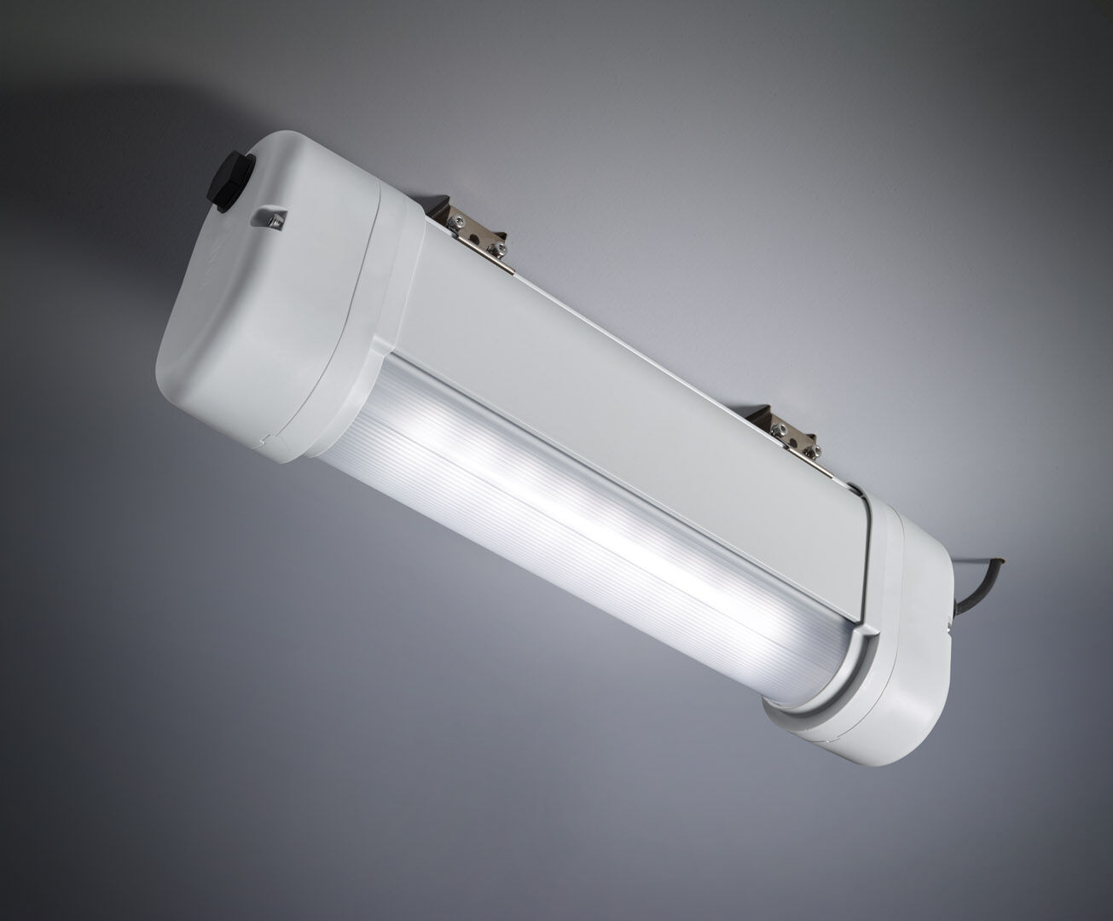
- Emergency luminaire for anti-panic lighting in ATEX environments.
- Autonomous luminaire (contains battery).
- Dimensions: 423 mm x 80 mm x 135 mm.
- Aluminum housing, PBT endcaps, sealed polycarbonate optics. Mounted on two stainless steel springs. With battery heater, allowed ambient temperature -20°C to +35°C.
- Line-shaped light distribution, optimized for 1 lux along the escape route axis.
- Lumen output in emergency mode: 520 lm.
- Power consumption in standby: 2.4 W.
- Inderdistance escape route: at a mounting height of 2.8 m, the illumination on the floor is 1 lux with an interdistance ("b") of 12.1 m.
- Interdistance anti-panic: at a mounting height of 2.8 m, the illumination on the floor is 0.5 lux with an interdistance ("b") of 14.2 m. At a mounting height of 2.8 m, the illumination on the floor is 1 lux with an interdistance ("b") of 11.3 m.
- Voltage: 220-240V.
- Autonomy: 60 minutes. The luminaire contains lamp data, battery date and type as required according to EN 60598-2.22.
- Battery: 4 x NiMh 1,2V 2,1Ah. Battery lifetime: 5 years.
- Automatic functional test every week, duration test every 13 weeks, in accordance to EN 50172 and EN 62034.
- Maintained/non maintained mode selectable, preset for most common application.
- Electrical insulation class: class I.
- Photobiological safety IEC/TR 62778: RG0.
- Lacquered aluminium housing, RAL7035 - light grey.
- IP protection level: IP66.
- IK protection level: IK07.
- Ambient temperature: -20°C - 40°C.
- ATEX classification: II 2D Ex tb IIIC T80°C Db, II 3G Ex ec IIC T4 Gc.
- Glowwire: 850°C.
- 5 years warranty on luminaire, light source, driver and battery (for autonomous luminaires).
- Certifications: CE, ATEX, ENEC.
- The luminaire has been developed and produced according to standard EN60598-1 in a company that is ISO9001 and ISO14001 certified.

