KE213/6S2-ATEX1

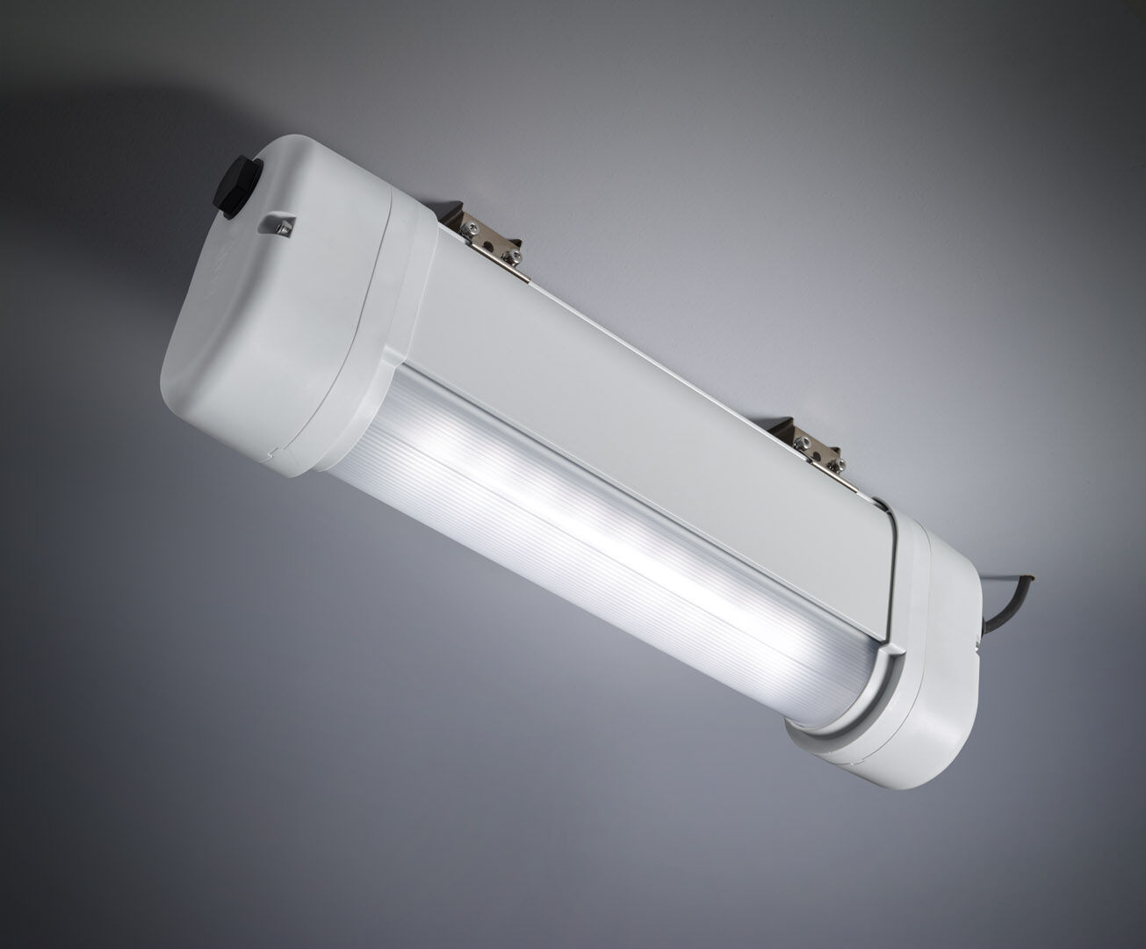
- Emergency luminaire for anti-panic lighting in ATEX environments.
- Autonomous luminaire (contains battery).
- Dimensions: 423 mm x 80 mm x 135 mm.
- Aluminum housing, PBT endcaps, sealed polycarbonate optics. Mounted on two stainless steel springs.
- Line-shaped light distribution, optimized for 1 lux along the escape route axis.
- Lumen output in emergency mode: 210 lm.
- Power consumption in standby: 0.9 W.
- Inderdistance escape route: at a mounting height of 2.8 m, the illumination on the floor is 1 lux with an interdistance ("b") of 9.1 m.
- Interdistance anti-panic: at a mounting height of 2.8 m, the illumination on the floor is 0.5 lux with an interdistance ("b") of 10.8 m. At a mounting height of 2.8 m, the illumination on the floor is 1 lux with an interdistance ("b") of 8.6 m.
- Voltage: 220-240V.
- Autonomy: 180 minutes. The luminaire contains lamp data, battery date and type as required according to EN 60598-2.22.
- Battery: 4 x NiMh 1,2V 2,2Ah. Battery lifetime: 8 years.
- Automatic functional test every week, duration every test 13 weeks, in accordance to EN 50172 and EN 62034. Monitoring and control via ESM software for central maintenance. Polarity independent connection via two wire BUS communication.
- Maintained/non maintained mode selectable, preset for most common application.
- Electrical insulation class: class I.
- Photobiological safety IEC/TR 62778: RG0.
- Lacquered aluminium housing, RAL7035 - light grey.
- IP protection level: IP66.
- IK protection level: IK07.
- Ambient temperature: 5°C - 40°C.
- ATEX classification: II 2D Ex tb IIIC T80°C Db, II 3G Ex ec IIC T4 Gc.
- Glowwire: 850°C.
- 5 years warranty on luminaire, light source, driver and battery (for autonomous luminaires).
- Certifications: CE, ATEX, ENEC.
- The luminaire has been developed and produced according to standard EN60598-1 in a company that is ISO9001 and ISO14001 certified.

