R710R1/LEDN1820DX2

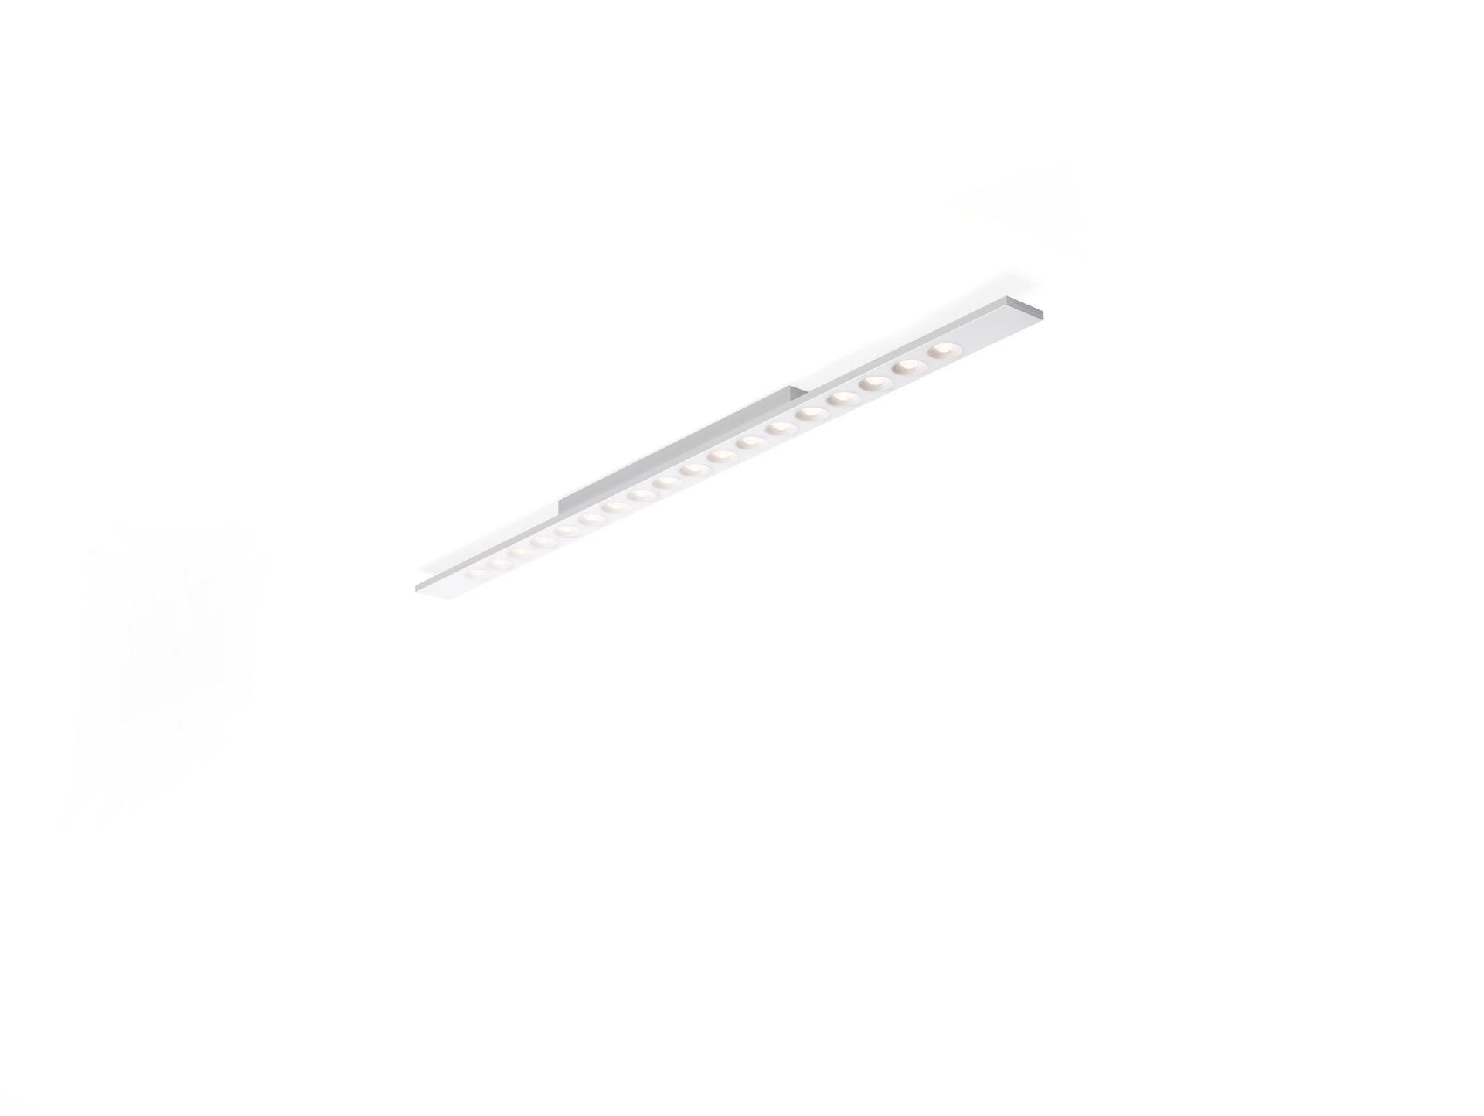
- Linear surface-mounted luminaire, LED+LENS™ optics, polycarbonate
(PC) lens and cup, medium wide-angle light distribution.
- Dimensions: 1500 mm x 75 mm x 50 mm.
- Housing with a visible height of 15 mm and seamless square corners.
Lenses recessed in circular cups.
- LED+LENS™, a combination of high-power LEDs and individual lenses
with a patented surface structure. The lenses are recessed in small
cups for a comfortable light experience.
- Luminous flux: 2400 lm, Luminous efficacy: 126 lm/W.
- Power: 19.0 W, DALI dimmable.
- Frequency: 50-60Hz AC.
- Voltage: 220-240V.
- Electrical isolation class: class I.
- LED with very good light maintenance; at 50000 hrs the luminaire
retains 98% of its initial flux (Tq=25°C).
- Correlated colour temperature: 4000 K, Colour rendering ra: 80.
- Standard deviation colour matching satisfy 3 SDCM.
- LED+LENS™ for glare-free light distribution with UGR <= 16 and
luminances @ 65° 1000 Cd/m² conform norm EN 12464-1 for very high
visual demands, e.g. quality control, precision tasks.
- Photobiological safety EN 62471: RISK GROUP 1 UNLIMITED.
- Lacquered sheet steel housing, RAL9006 - white aluminium (textured).
- IP protection level: IP20.
- Glowwire: 850°C.
- 5 years warranty on luminaire and driver.
- Certifications: CE, ENEC.
- Luminaire with halogen free leads.
- The luminaire has been developed and produced according to standard
EN60598-1 in a company that is ISO9001 and ISO14001 certified.

