R710R1/LEDW2430DEX1

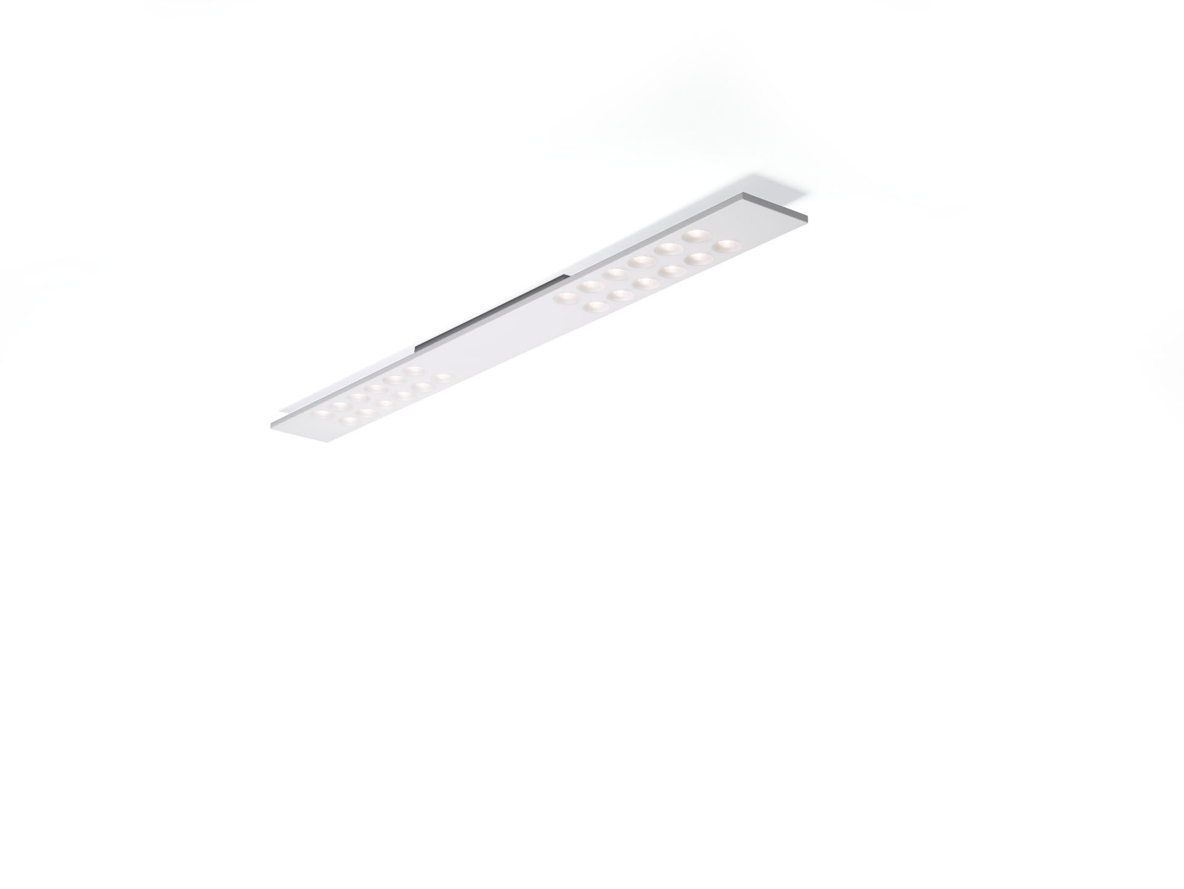
- Surface-mounted or suspended LED+LENS luminaire.
- Led+lens™ optics, polycarbonate (PC) lens and cup, medium wide-angle light distribution.
- Housing with a visible height of 15 mm and seamless square corners. Lenses recessed in circular cups.
- Dimensions: 1500 mm x 150 mm x 50 mm.
- LED+LENS™, a combination of high performance LEDs and individual lenses with a patented surface structure. The lenses are recessed in small cups for a comfortable light experience.
- Luminous flux: 3150 lm, Luminous efficacy: 126 lm/W.
- Power: 25.0 W, DALI driver controlled by integrated sensor.
- Frequency: 50-60Hz AC.
- Voltage: 220-240V.
- Electrical isolation class: class I.
- LED with very good light maintenance; at 50000 hrs the luminaire retains 98% of it's initial flux (Tq=25°C).
- Correlated colour temperature: 3000 K, Colour rendering ra: 80.
- Standard deviation colour matching satisfy 3 SDCM.
- LED+LENS™ for glare-free light distribution with UGR <= 16 and luminances @ 65° 1000 Cd/m² conform norm EN 12464-1 for very high visual demands, e.g. quality control, precision tasks.
- Lacquered sheet steel housing, RAL9003 - white (textured).
- IP protection level: IP20.
- Glowwire: 850°C.
- 5 years warranty on luminaire and driver.
- Certifications: CE, ENEC.
- Luminaire with halogen free leads.
- The luminaire has been developed and produced according to standard EN60598-1 in a company that is ISO9001 and ISO14001 certified.

