R750R1/LEDW3645DX1

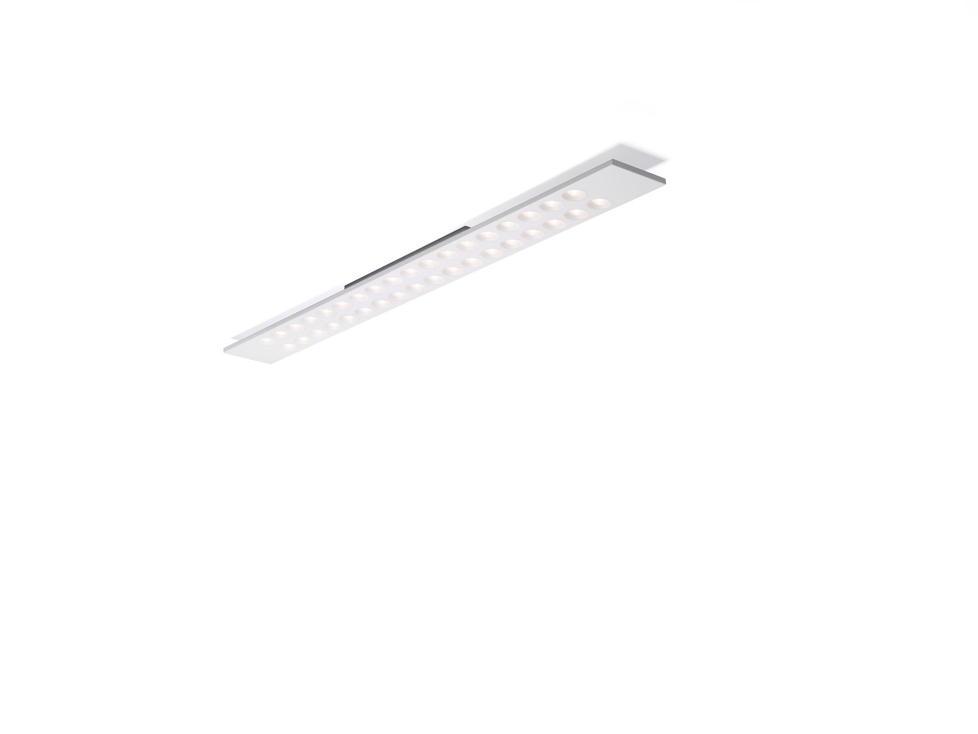
- Surface-mounted LED+LENS luminaire.
- Led+lens™ optics, polycarbonate (PC) lens and cup, asymmetric light distribution.
- Housing with a visible height of 15 mm and seamless square corners. Lenses recessed in circular cups.
- Dimensions: 1500 mm x 150 mm x 50 mm.
- Individual linear
- LED+LENS™, a combination of high performance LEDs and individual lenses with a patented surface structure. The lenses are recessed in small cups for a comfortable light experience.
- Luminous flux: 4700 lm, Luminous efficacy: 132 lm/W.
- Power: 35.5 W, DALI dimmable.
- Frequency: 50/60Hz AC.
- Voltage: 220-240V.
- Electrical isolation class: class I.
- LED with very good light maintenance; at 50000 hrs the luminaire retains 98% of it's initial flux (Tq=25°C).
- Correlated colour temperature: 3000 K, Colour rendering ra: 80.
- Colour consistency (McAdam ellipse): ≤ 3 SDCM.
- Photobiological safety IEC/TR 62778: RG1.
- Lacquered sheet steel housing, RAL9003 - white.
- IP protection level: IP20.
- Replaceable (LED only) light source by a professional. Replaceable control gear by a professional.
- Energy efficiency class of the light source according to EU regulation 2019/2015: E.
- Glowwire: 850°C.
- 5 years warranty on luminaire and driver.
- Certifications: CE, ENEC.
- Luminaire with halogen free leads.
- The luminaire has been developed and produced according to standard EN60598-1 in a company that is ISO9001 and ISO14001 certified.

