U23I1R1/NMDT1

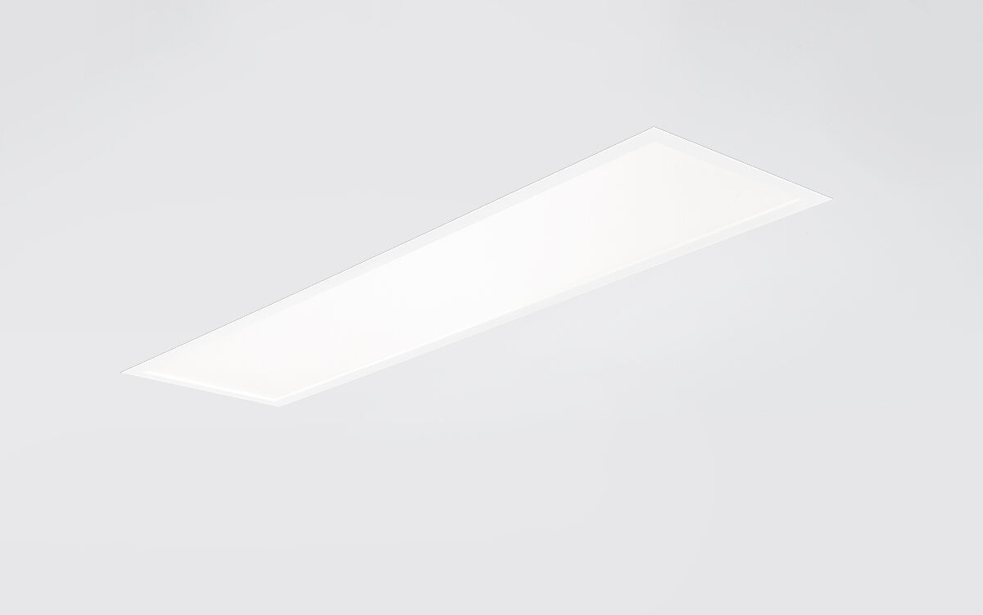
- U23 is a recessed diffuser flatpanel
- Diffuser optics, acrylic (PMMA) microprism with diffuser foil, wide-angle light distribution.
- Low recessed height.
- Dimensions: 1195 mm x 295 mm x 25 mm.
- M300, installation as pure lay-in luminaire for modular ceilings with basic exposed TEE grid system.
- Flat panel diffuser for bright and uniform illumination.
- Luminous flux: 3750 lm, Luminous efficacy: 119 lm/W.
- Power: 31.5 W, DALI dimmable.
- Frequency: 50-60Hz AC/DC.
- Voltage: 220-240V.
- Electrical isolation class: class II.
- LED with very good light maintenance; at 50000 hrs the luminaire retains 90% of it's initial flux (Tq=25°C).
- Correlated colour temperature: 4000 K
- Standard deviation colour matching satisfy 3 SDCM.
- Photobiological safety IEC/TR 62778: RG0.
- Lacquered sheet steel housing, RAL9016 - traffic white (textured).
- IP protection level: IP20.
- IK protection level: IK03.
- IP from below: IP44 from below.
- Ambient temperature: from -20°C to 35°C.
- Glowwire: 650°C.
- 5 years warranty on luminaire and driver.
- Certifications: CE, ENEC.
- Luminaire with halogen free leads.
- The luminaire has been developed and produced according to standard EN60598-1 in a company that is ISO9001 and ISO14001 certified.

