U2B-M110-MI-840-025S

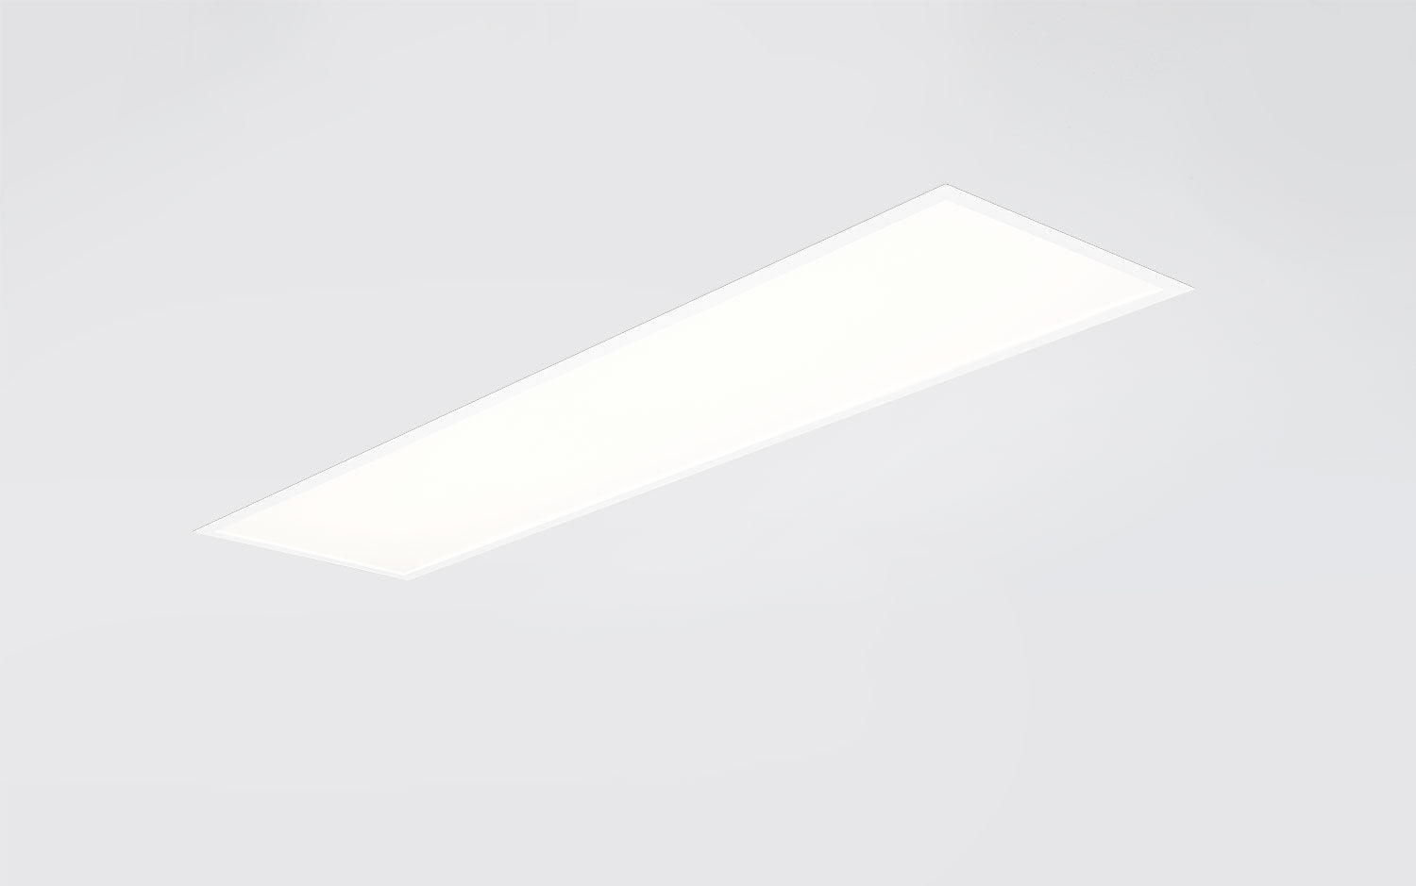
- Recessed diffusor with maximum efficiency.
- Micro-optical foil optics, opal acrylic (PMMA), diffuse, optical deglaring foil light distribution.
- High luminous flux and efficiency.
- Dimensions: 1195 mm x 295 mm x 77 mm.
- M300, installation as pure lay-in luminaire for modular ceilings with basic exposed TEE grid system.
- Flat panel diffuser with a Micro-optical foil on a clear glass layer for a bright and uniform illumination with wide interdistances.
- Luminous flux: 2500 lm, Luminous efficacy: 143 lm/W.
- Power: 17.5 W, not dimmable.
- Frequency: 50-60Hz AC/DC.
- Voltage: 220-240V.
- Electrical isolation class: class II.
- LED with very good light maintenance; at 50000 hrs the luminaire retains 95% of it's initial flux (Tq=25°C).
- Correlated colour temperature: 4000 K, Colour rendering ra: 80.
- Standard deviation colour matching satisfy 3 SDCM.
- Photobiological safety IEC/TR 62778: RG0.
- Lacquered sheet steel housing, RAL9003 - signal white.
- IP protection level: IP20/IP40.
- IK protection level: IK03.
- Replaceable (LED only) light source by a professional. Replaceable control gear by a professional.
- Glowwire: 650°C.
- 5 years warranty on luminaire and driver.
- Certifications: CE, ENEC.
- Luminaire with halogen free leads.
- The luminaire has been developed and produced according to standard EN60598-1 in a company that is ISO9001 and ISO14001 certified.

