U3111/LEDW440DE

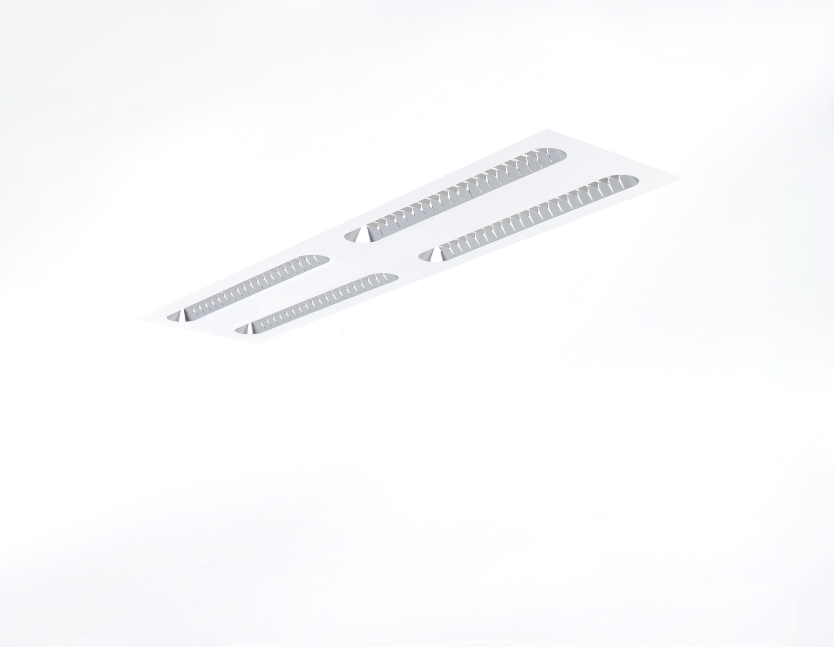
- Recessed luminaire with Shielded Lens optics.
- Shielded lens optics, polycarbonate (PC) with aluminium thin film, medium wide-angle light distribution.
- Shielding units with rounded ends.
- Dimensions: 1196 mm x 296 mm x 58 mm.
- M300, installation as pure lay-in luminaire for modular ceilings with basic exposed TEE grid system.
- Shielded lens: the light source is hidden from view by shielding units, the light distribution is made with a lens. Two lenses per shield cavity.
- Luminous flux: 4200 lm, Luminous efficacy: 140 lm/W.
- Power: 30.0 W, DALI driver controlled by integrated sensor.
- Frequency: 50-60Hz AC.
- Voltage: 220-240V.
- Electrical isolation class: class I.
- LED with very good light maintenance; at 50000 hrs the luminaire retains 98% of it's initial flux (Tq=25°C).
- Correlated colour temperature: 3000 K, Colour rendering ra: 80.
- Standard deviation colour matching satisfy 3 SDCM.
- Shielded lens for glare-free light distribution with UGR <= 19 and luminances @ 65° conform norm EN 12464-1 for high visual demands, e.g. display screen equipment.
- Photobiological safety IEC/TR 62778: RG1.
- Lacquered sheet steel housing, RAL9003 - white (textured).
- IP protection level: IP20.
- Glowwire: 650°C.
- 5 years warranty on luminaire and driver.
- Certifications: CE, ENEC.
- Luminaire with halogen free leads.
- The luminaire has been developed and produced according to standard EN60598-1 in a company that is ISO9001 and ISO14001 certified.

