US3140/LEDN20D

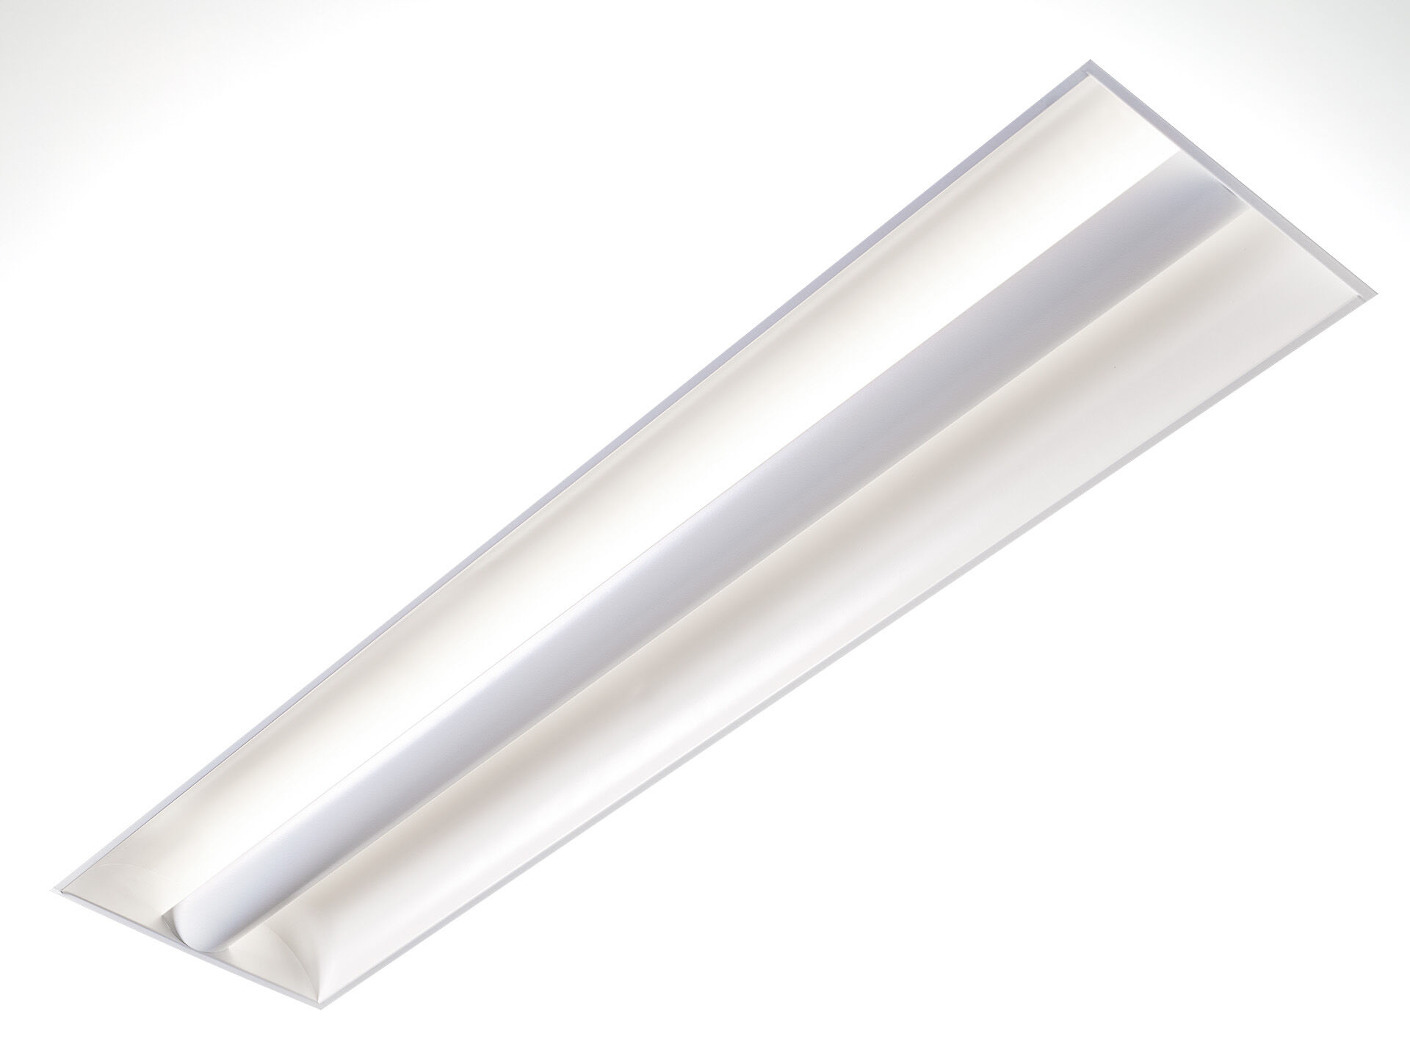
- Softlight with 100% indirect lighting.
- Softlight optics, closed lamp shielding, wide-angle light distribution.
- White sheet metal lamp shield with arched shape and two curved sheet metal side reflectors, 100% indirect light.
- Dimensions: 1195 mm x 295 mm x 95 mm.
- M300, installation as pure lay-in luminaire for modular ceilings with basic exposed TEE grid system.
- The lamp shield masks the light source which prevents direct view, the light is reflected by the side reflectors resulting in uniform and bright light distribution.
- Luminous flux: 2350 lm, Luminous efficacy: 118 lm/W.
- Power: 20.0 W, DALI dimmable.
- Frequency: 50-60Hz AC.
- Voltage: 220-240V.
- Electrical isolation class: class I.
- LED with very good light maintenance; at 50000 hrs the luminaire retains 98% of it's initial flux (Tq=25°C).
- Correlated colour temperature: 4000 K, Colour rendering ra: 80.
- Standard deviation colour matching satisfy 3 SDCM.
- Softlight for glare-free light distribution with UGR <= 22 and luminances @ 65° (value) cd/m² conform norm EN 12464-1 for moderate visual and concentration demands.
- Photobiological safety IEC/TR 62778: RG0.
- Lacquered sheet steel housing, specular white.
- IP protection level: IP20.
- IK protection level: IK03.
- Glowwire: 650°C.
- 5 years warranty on luminaire and driver.
- Certifications: CE, ENEC.
- Luminaire with halogen free leads.
- The luminaire has been developed and produced according to standard EN60598-1 in a company that is ISO9001 and ISO14001 certified.

