V3RS10M/N3M0D0X1

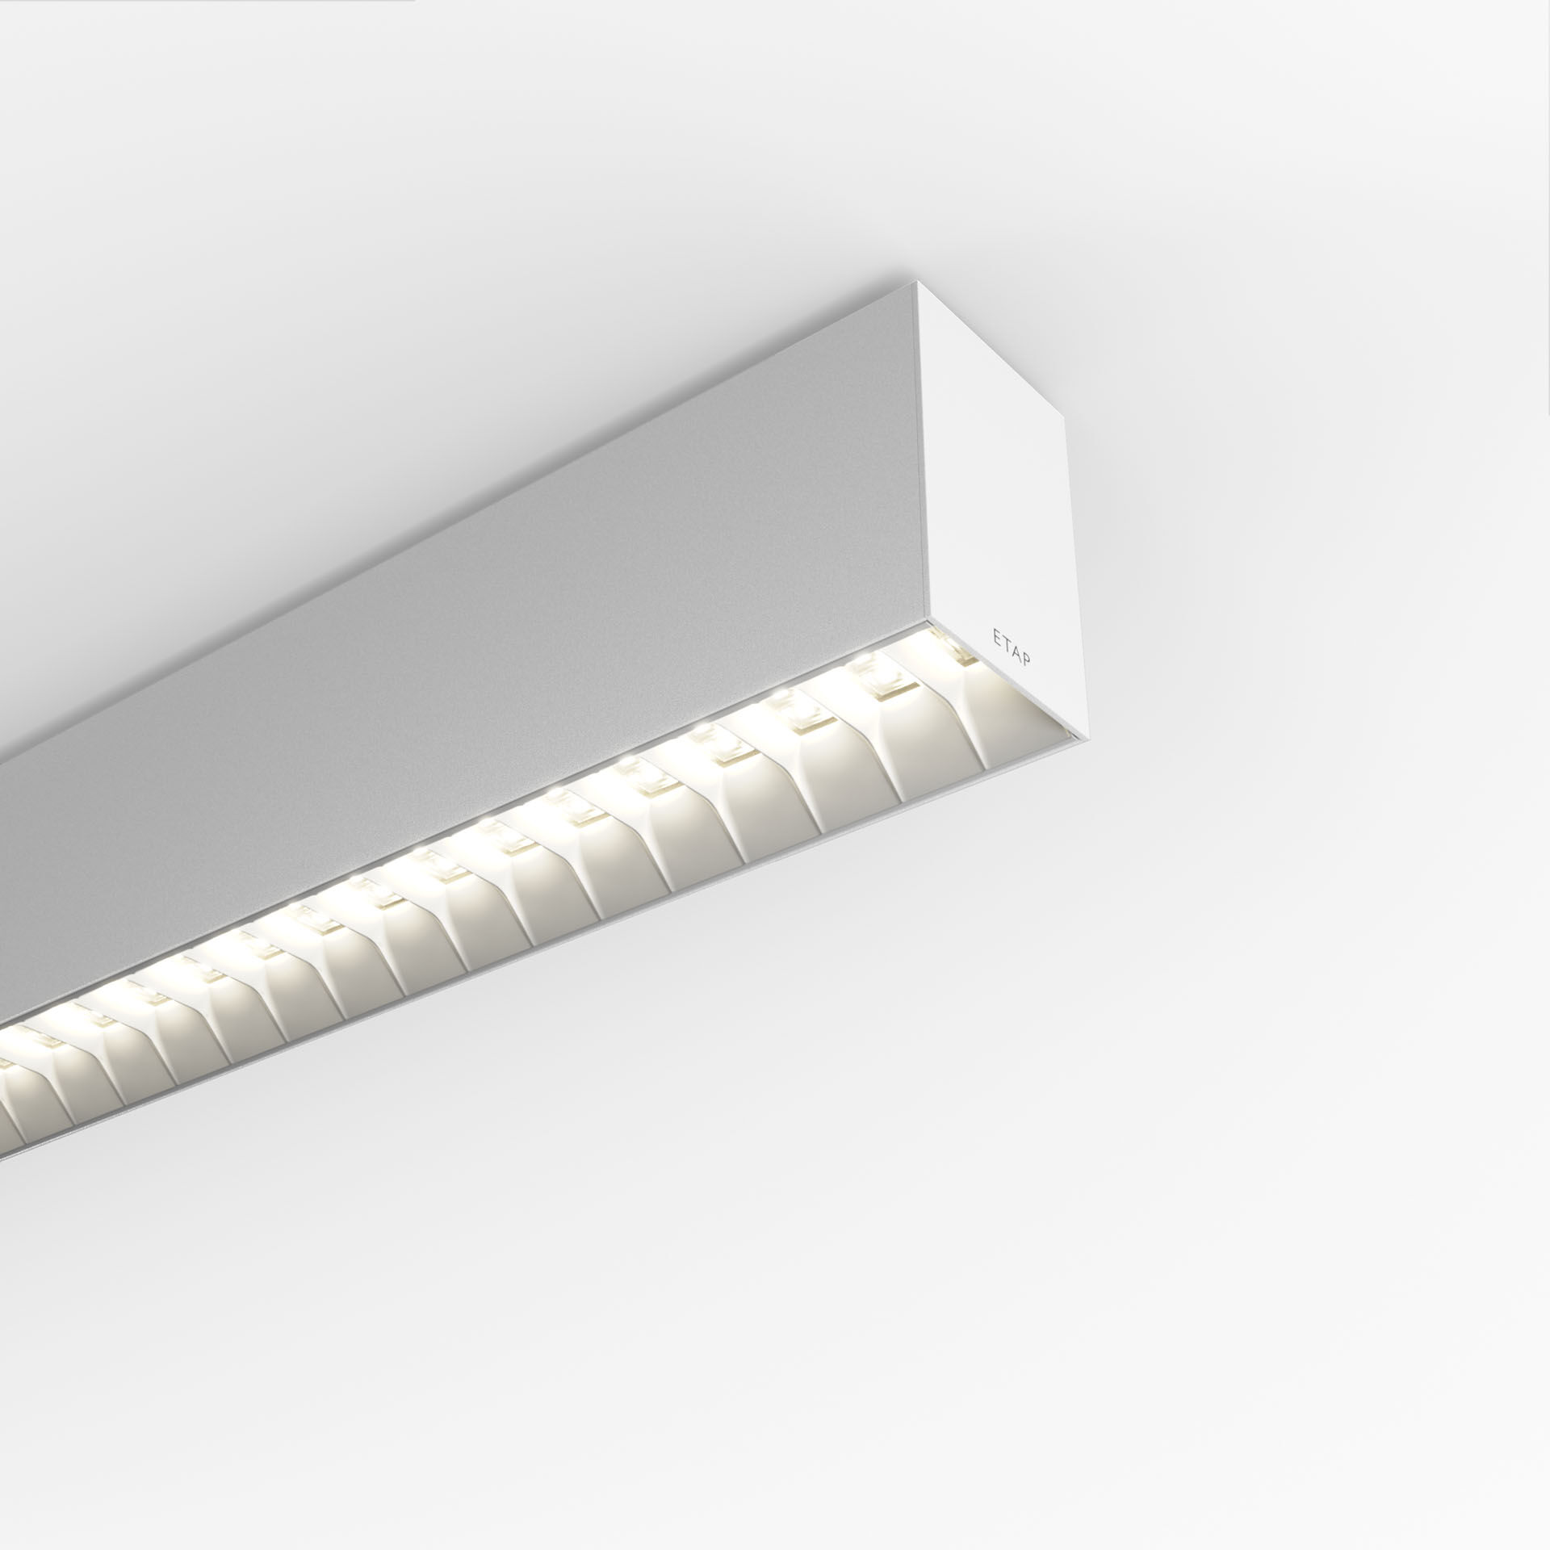
- Architectural light line luminaire.
- Shielded lens optics, white polycarbonate (PC), medium wide-angle light distribution.
- Dimensions: 1371 mm x 60 mm x 90 mm.
- Shielded lens: the light source is hidden from view by shielding units, the light distribution is made with a lens. Two lenses per shield cavity.
- Luminous flux: 2850 lm, Luminous efficacy: 138 lm/W.
- Power: 20.7 W, DALI dimmable.
- Frequency: 50-60Hz AC.
- Voltage: 220-240V.
- Electrical isolation class: class I.
- LED with very good light maintenance; at 50000 hrs the luminaire retains 96% of it's initial flux (Tq=25°C).
- Correlated colour temperature: 4000 K, Colour rendering ra: 80.
- Standard deviation colour matching satisfy 3 SDCM.
- Shielded lens for glare-free light distribution with UGR <= 19 and luminances @ 65° 3000 Cd/m² conform norm EN 12464-1 for high visual demands, e.g. display screen equipment.
- Photobiological safety IEC/TR 62778: RG1.
- Lacquered aluminium housing, RAL9003 - white (textured).
- IP protection level: IP20.
- IK protection level: IK07.
- Glowwire: 650°C.
- 5 years warranty on luminaire and driver.
- Certifications: CE, ENEC.
- Luminaire with halogen free leads.
- The luminaire has been developed and produced according to standard EN60598-1 in a company that is ISO9001 and ISO14001 certified.
- Mandatory accessoires for mounting the luminaire: V3H2500, V3H9900, V3H9960.

