V3SDJ0M/W5LLD0X1

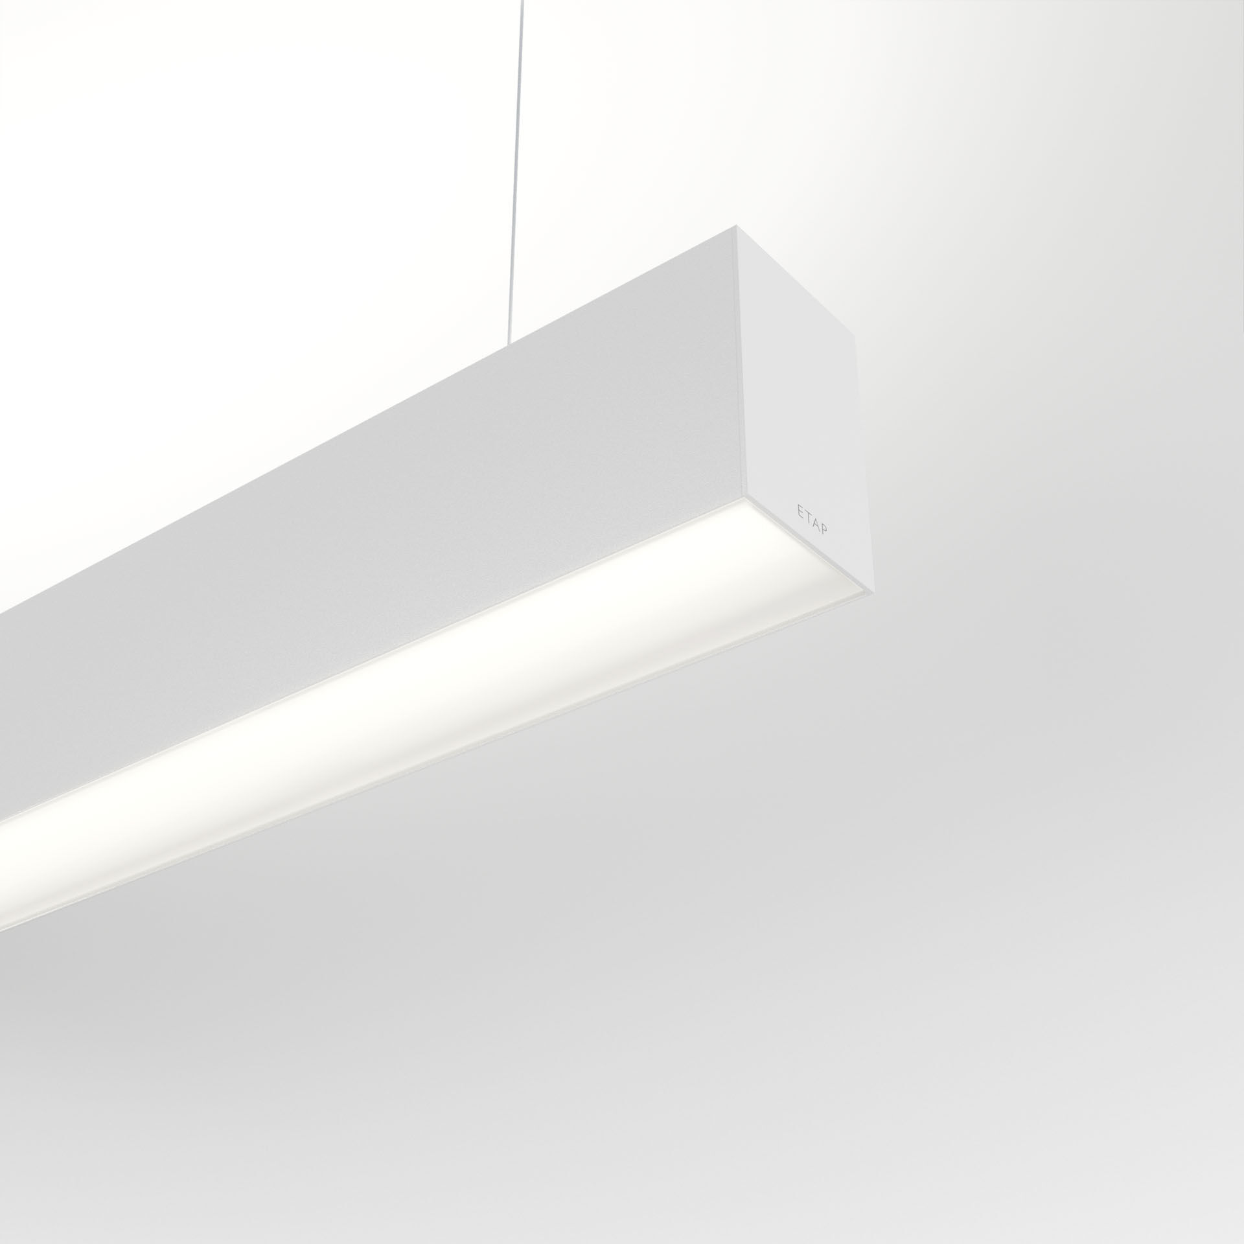
- Architectural light line luminaire.
- Diffuser optics, opal acrylic (PMMA), wide-angle light distribution.
- Dimensions: 1403 mm x 60 mm x 90 mm.
- Flat panel diffuser for bright and uniform illumination.
- Luminous flux: 4900 lm, Luminous efficacy: 130 lm/W.
- Power: 37.8 W, DALI dimmable.
- Frequency: 50-60Hz AC.
- Voltage: 220-240V.
- Electrical isolation class: class I.
- LED with very good light maintenance; at 50000 hrs the luminaire retains 97% of it's initial flux (Tq=25°C).
- Correlated colour temperature: 3000 K, Colour rendering ra: 80.
- Standard deviation colour matching satisfy 3 SDCM.
- Photobiological safety IEC/TR 62778: RG1.
- Lacquered aluminium housing, RAL9003 - white (textured).
- IP protection level: IP20.
- IK protection level: IK07.
- Glowwire: 850°C.
- 5 years warranty on luminaire and driver.
- Certifications: CE, ENEC.
- Luminaire with halogen free leads.
- The luminaire has been developed and produced according to standard EN60598-1 in a company that is ISO9001 and ISO14001 certified.
- Mandatory accessoires for mounting the luminaire: ACC-HI00-X01, V3-HI01-5P-1500, V3-HI02-5P-1500.

